**Assignment 2 Report Shengguo Zhou**

**URL:**

<https://github.com/Shengguo-Zhou/CS6650_Distributed_System/tree/main/assignment-2>

**Description of design:**

In this report, we will document the steps taken to complete Assignment 2, which builds on Assignment 1 by implementing simple business logic in the server and posting the result to a queue for subsequent consumption and processing.

Client would send 500k messages to the server, but the load balancer would deal with it, it will distribute the messages to 2 servers, to make it work in a balance way. And all the servers would deliver the messages to rabbit mq, and two consumers would consume the data inside the rabbitmq.

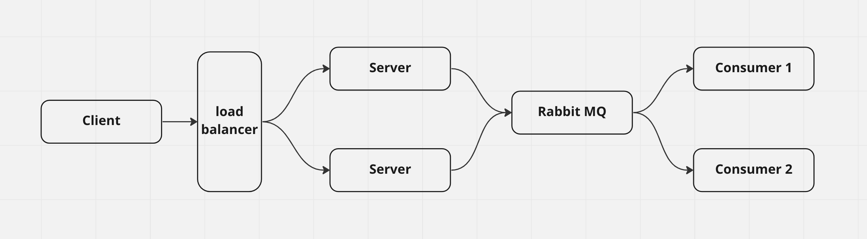

**Client:**

Main function is in “MultiThread” class. Inside this class:

First step, I created a queue and put 500k request inside it. And the queue is a global variable.

Nest step, I use a for loop to generate 200 threads to achieve multiply-thread. For each of thread, whenever this thread is started, it will pull a request from the queue. If the queue is empty, it will pull nothing, which means this thread would do nothing. So which thread is started first, which one may be tasked with more sending request tasks. Therefore, within this step, there would be 500k requests in total, and the 200 threads need to send it to the local or EC2 server. When all the requests are sent, which means the queue is empty, the 200 threads would then have a rest.

Last step, there would be some other global variable that would count the successful request number and the failed one, the lasting time and so on.

RunInOneThread.java: This class is designed for each one of the thread, I need to send the data through *api.swipeWithHttpInfo*. Inside the run function, the detail of each thread is implemted, queue is the global passed from the main function, when a new thread is created, it will get a request body from the queue. And it won’t stop until the queue is empty. There are another two parameters to count the number of successful and failed sending tasks. In the sentEvent function, it will try at most 5 times to sent one request, if it is successful within 5 times of try, success will plus one. When it is failed, this request will be abandoned and failure will plus one.

SwipeEvent.java inside the event file and BodyList.java and GenerateSingleBody.java is the helper function for main and singe-thread functions. For each of the request, I have packaged the info within the request and named it to a event class. When all the 500k request body is generated, it would be put into the list, to be specific, it is the queue that I have mentioned.

For this counting time part, I added nothing but result data processing class and a csv output file class. Inside the RunInOneThread.java class, when a new request is successfully sent, I will put the success info into another global list to store it. When all the requests are sent, I will get a list of 500k success info. And then I can sort this list by certain criteria. Like I can sort it by the delay time, then I can get the result of minimum, maximum, medium, 99%percentage response time. And like this, if I sort it by its start time, I can plot the chart by its beginning time to know for each of a certain second, how many requests would be sent. But I remove the csv output part from this client, because it won’t be needed.

**Server:**

In general, the server for assignment2 is pretty similar to the one in assignment1, we still need to get messages from client, but we also need to deliver these messages to rabbit mq. And in order to achieve that, in the function “basicPubish”, I published the message to the rabbit mq. And the rabbit mq will build the channel to deal with these messages

To implement the doPost() method in the servlet to fully validate the URL and JSON payload, format the incoming Swipe data, and send it as a payload to a remote queue. I chose to use RabbitMQ as our queue technology, and deployed it on its own EC2 instance. I tested with a relatively small number of messages and cleared out the queues regularly using the RMQ management console.

**RabbitMQ:**

The Rabbitmq is installed in my local PC Mac and AWS Ubantu. For Mac PC I used homebrew to install it, I have to make sure that homebrew is installed in the correct path, which is inside the opt file, and this part took me a lot of part. And if I don’t do that, the calling of the rabbitmq api interface would cause a segement error. To install it in AWS Ubantu, I created a new instance to install the Rabbitmq, if I want to use the rabbitmq inside the aws ubantu, I have to know the ip address of is, which would change each time I restart the virtual machine, it will need me to change the .war file of server each time.

RabbitMQ is a message broker that implements the Advanced Message Queuing Protocol (AMQP) to handle messaging between applications. In this assignment, RabbitMQ is used to post the swipe data payload from the server to a remote queue for subsequent consumption and processing by the consumers.

**Consumer:**

Use two ConcurrentMap to record all of the messages

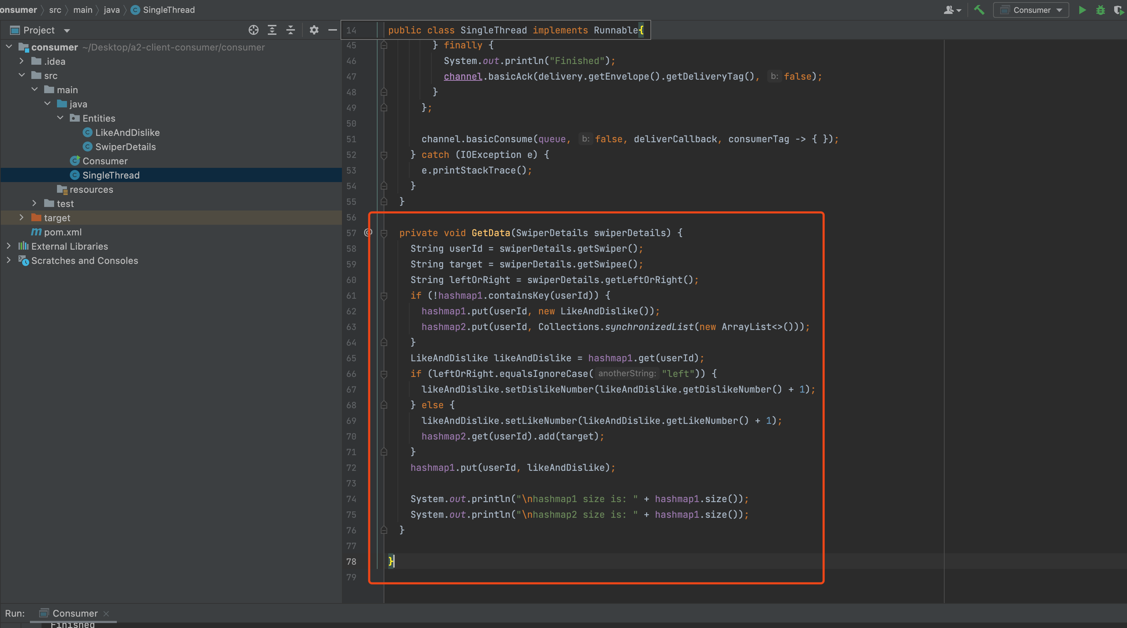

Consumers are separate Java programs that pull messages off the queue and store them in data structures that support the two different access patterns described in the requirements. Each consumer needs to consume every published message, which means that they need to be multithreaded to handle the messages as quickly as they are produced. It is important to make the data structures thread-safe to avoid any concurrency issues.

The consumers should run on separate or a single (not recommended for load testing) instance, connecting remotely to the broker queue. The aim of the consumers is to consume messages as quickly as they are produced to achieve the best throughput on RabbitMQ. The production and consumption rates need to be balanced to keep the queue length as close to zero as possible to ensure the system performs predictably and reliably. The RabbitMQ management console can be used to track the number of messages in the queue, as well as the producers and consumer rates.

The optimal number of consumer threads needed to keep the queue size as close to zero as possible will depend on the specific requirements of the assignment, and can be determined through load testing. It is important to ensure that the queue length doesn't continually grow and shrink, as this can lead to a 'pointy' queue length profile. A plateau in the queue length is fine, as long as it is less than around a 1000. The aim is to balance the production and consumption rates such that they are roughly equal, which will minimize queueing delays and maximize system throughput.

And it would be deployed on AWS by generating a .jar file.

**Result:**

On the Local Side:

Start Local PC Rabbitmq:

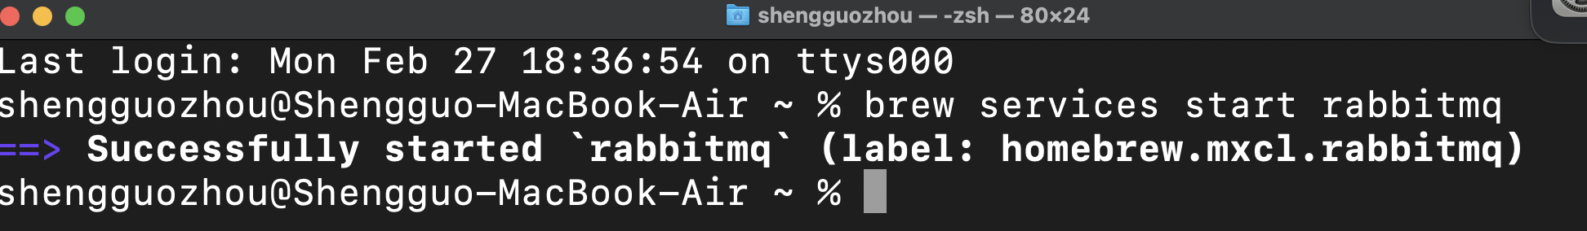

Server:

Start the local server: Local username: guest, password guest. Queue name: ResultMQ

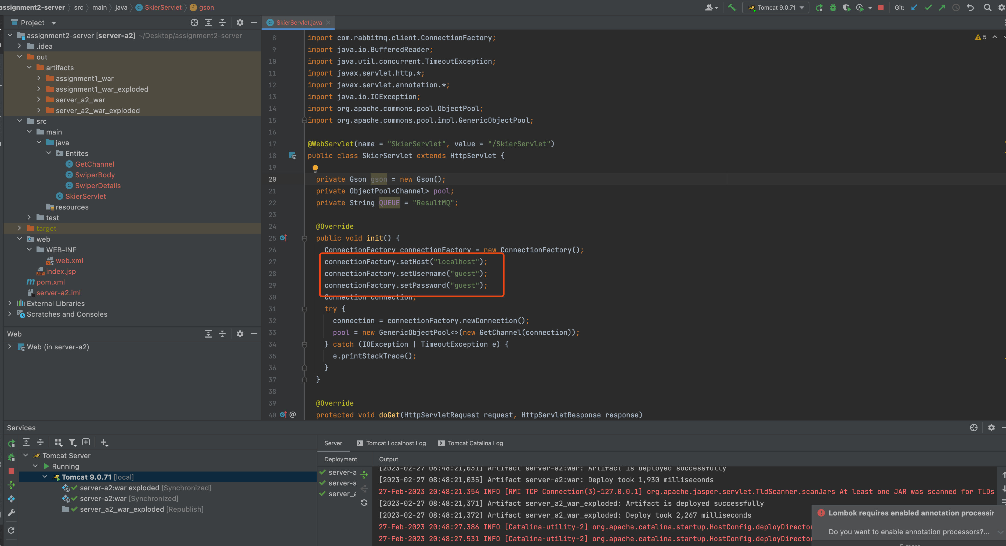

Postman is able to get the message back after sending it

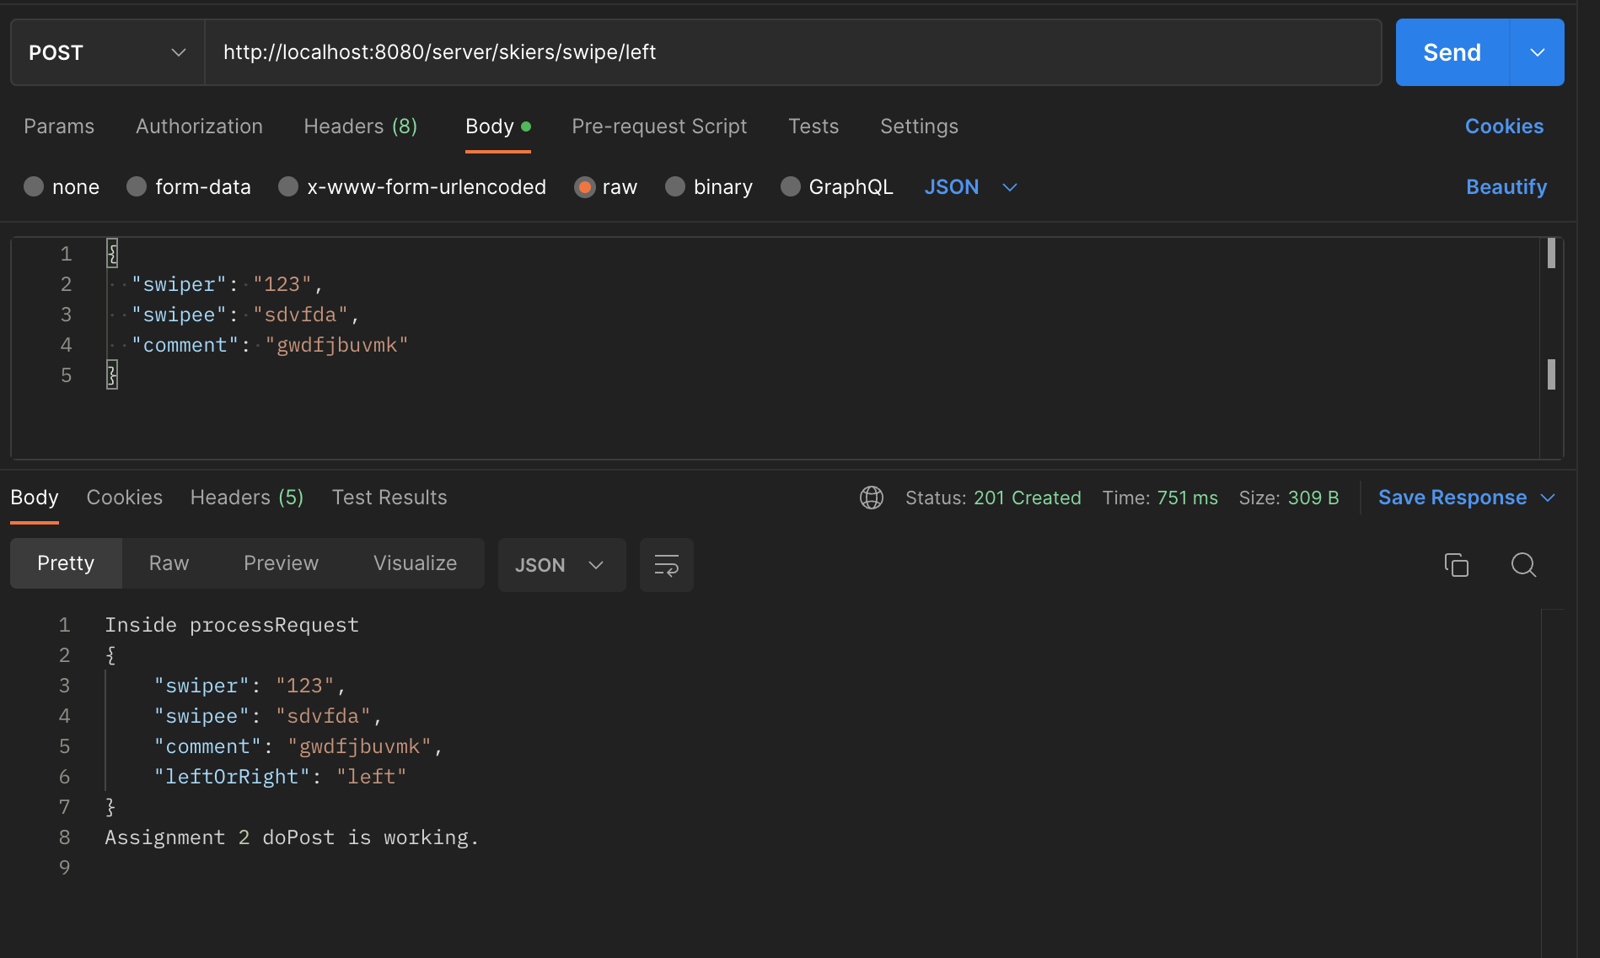

Local host 10 threads and 50 messages

Client:

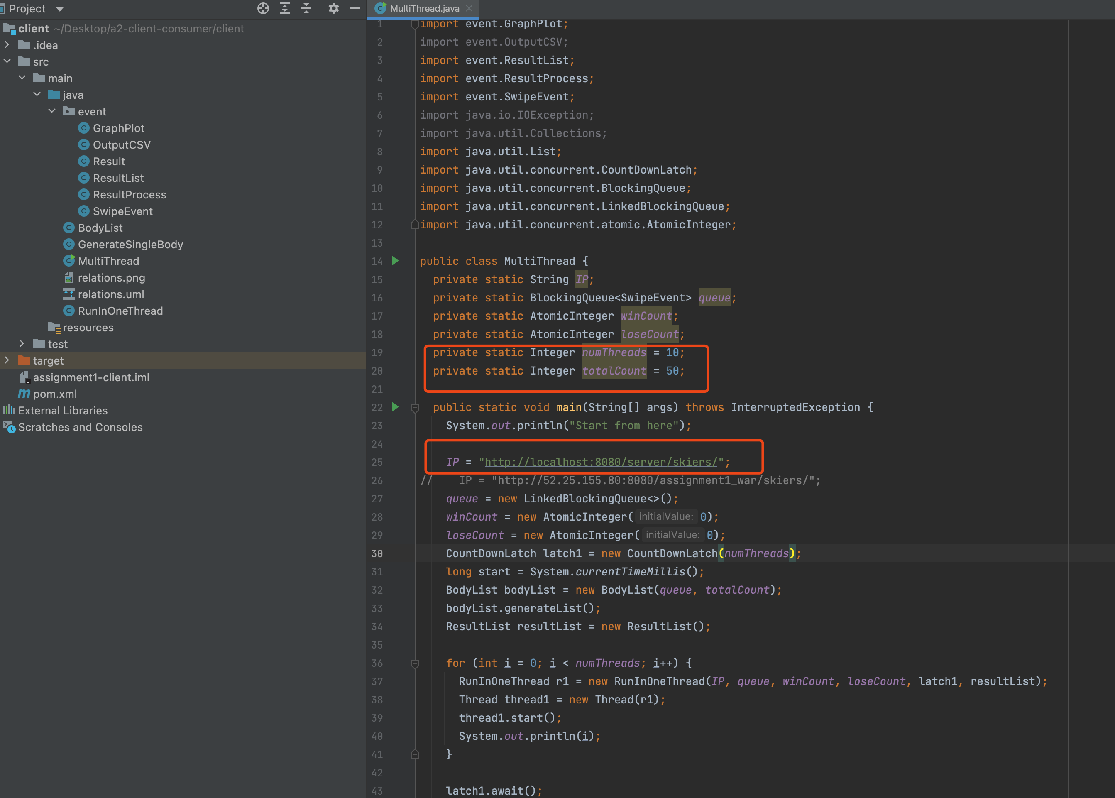

Consumer: 10 corresponding threads, and to ping local host

Local Rabbitmq username: guest, password: guest

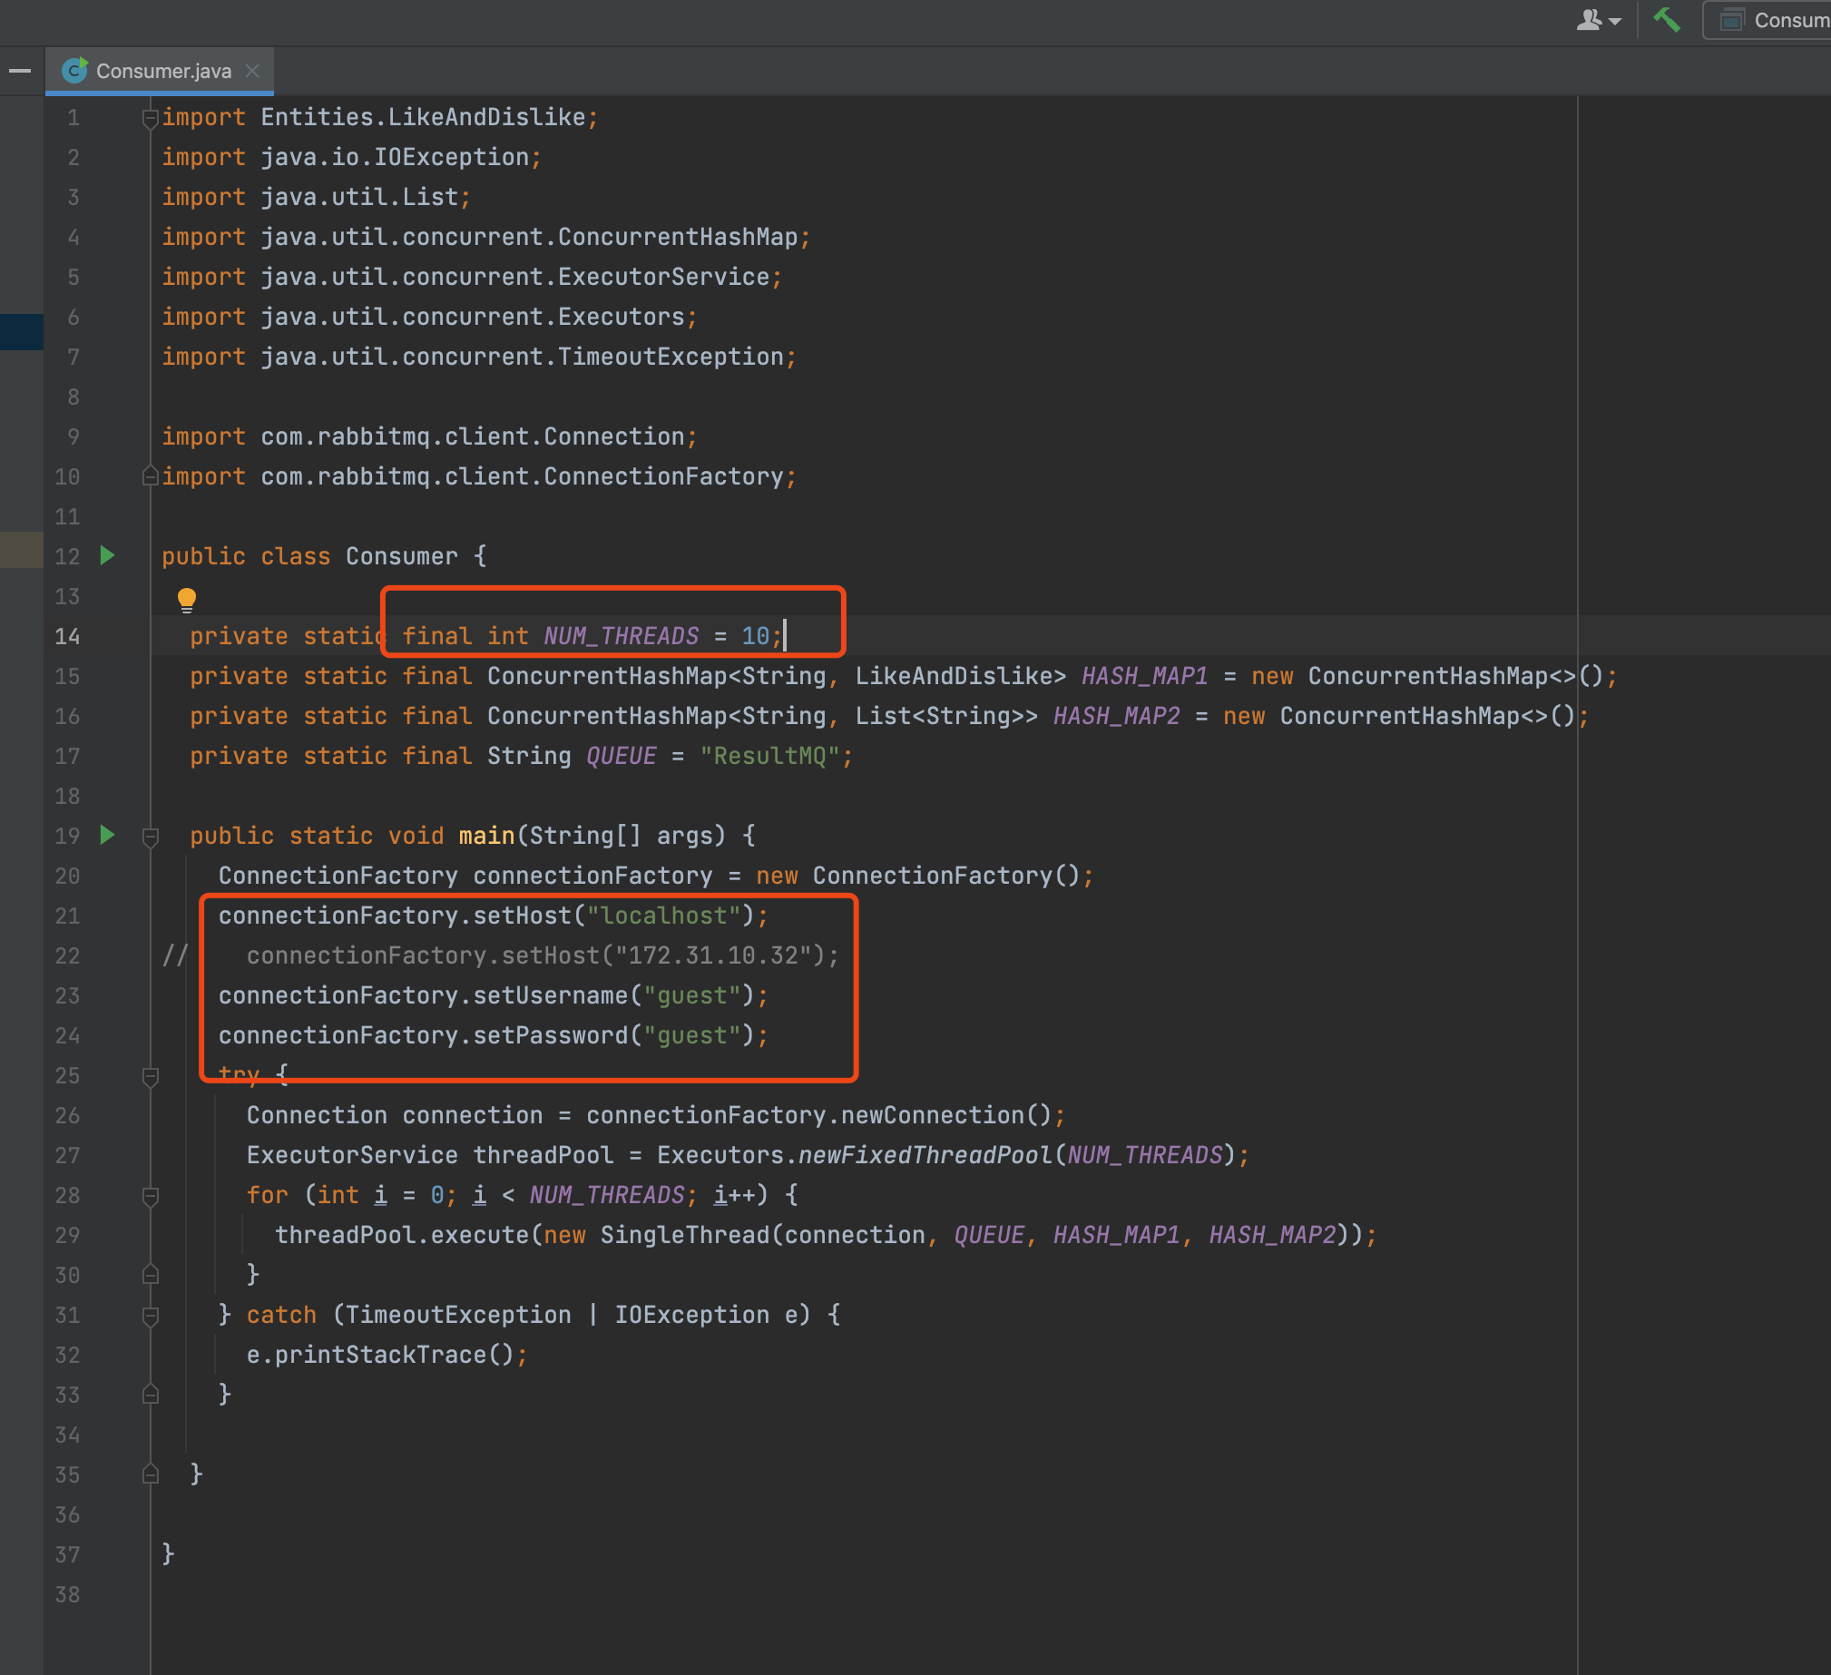

At first rabbitmq is empty

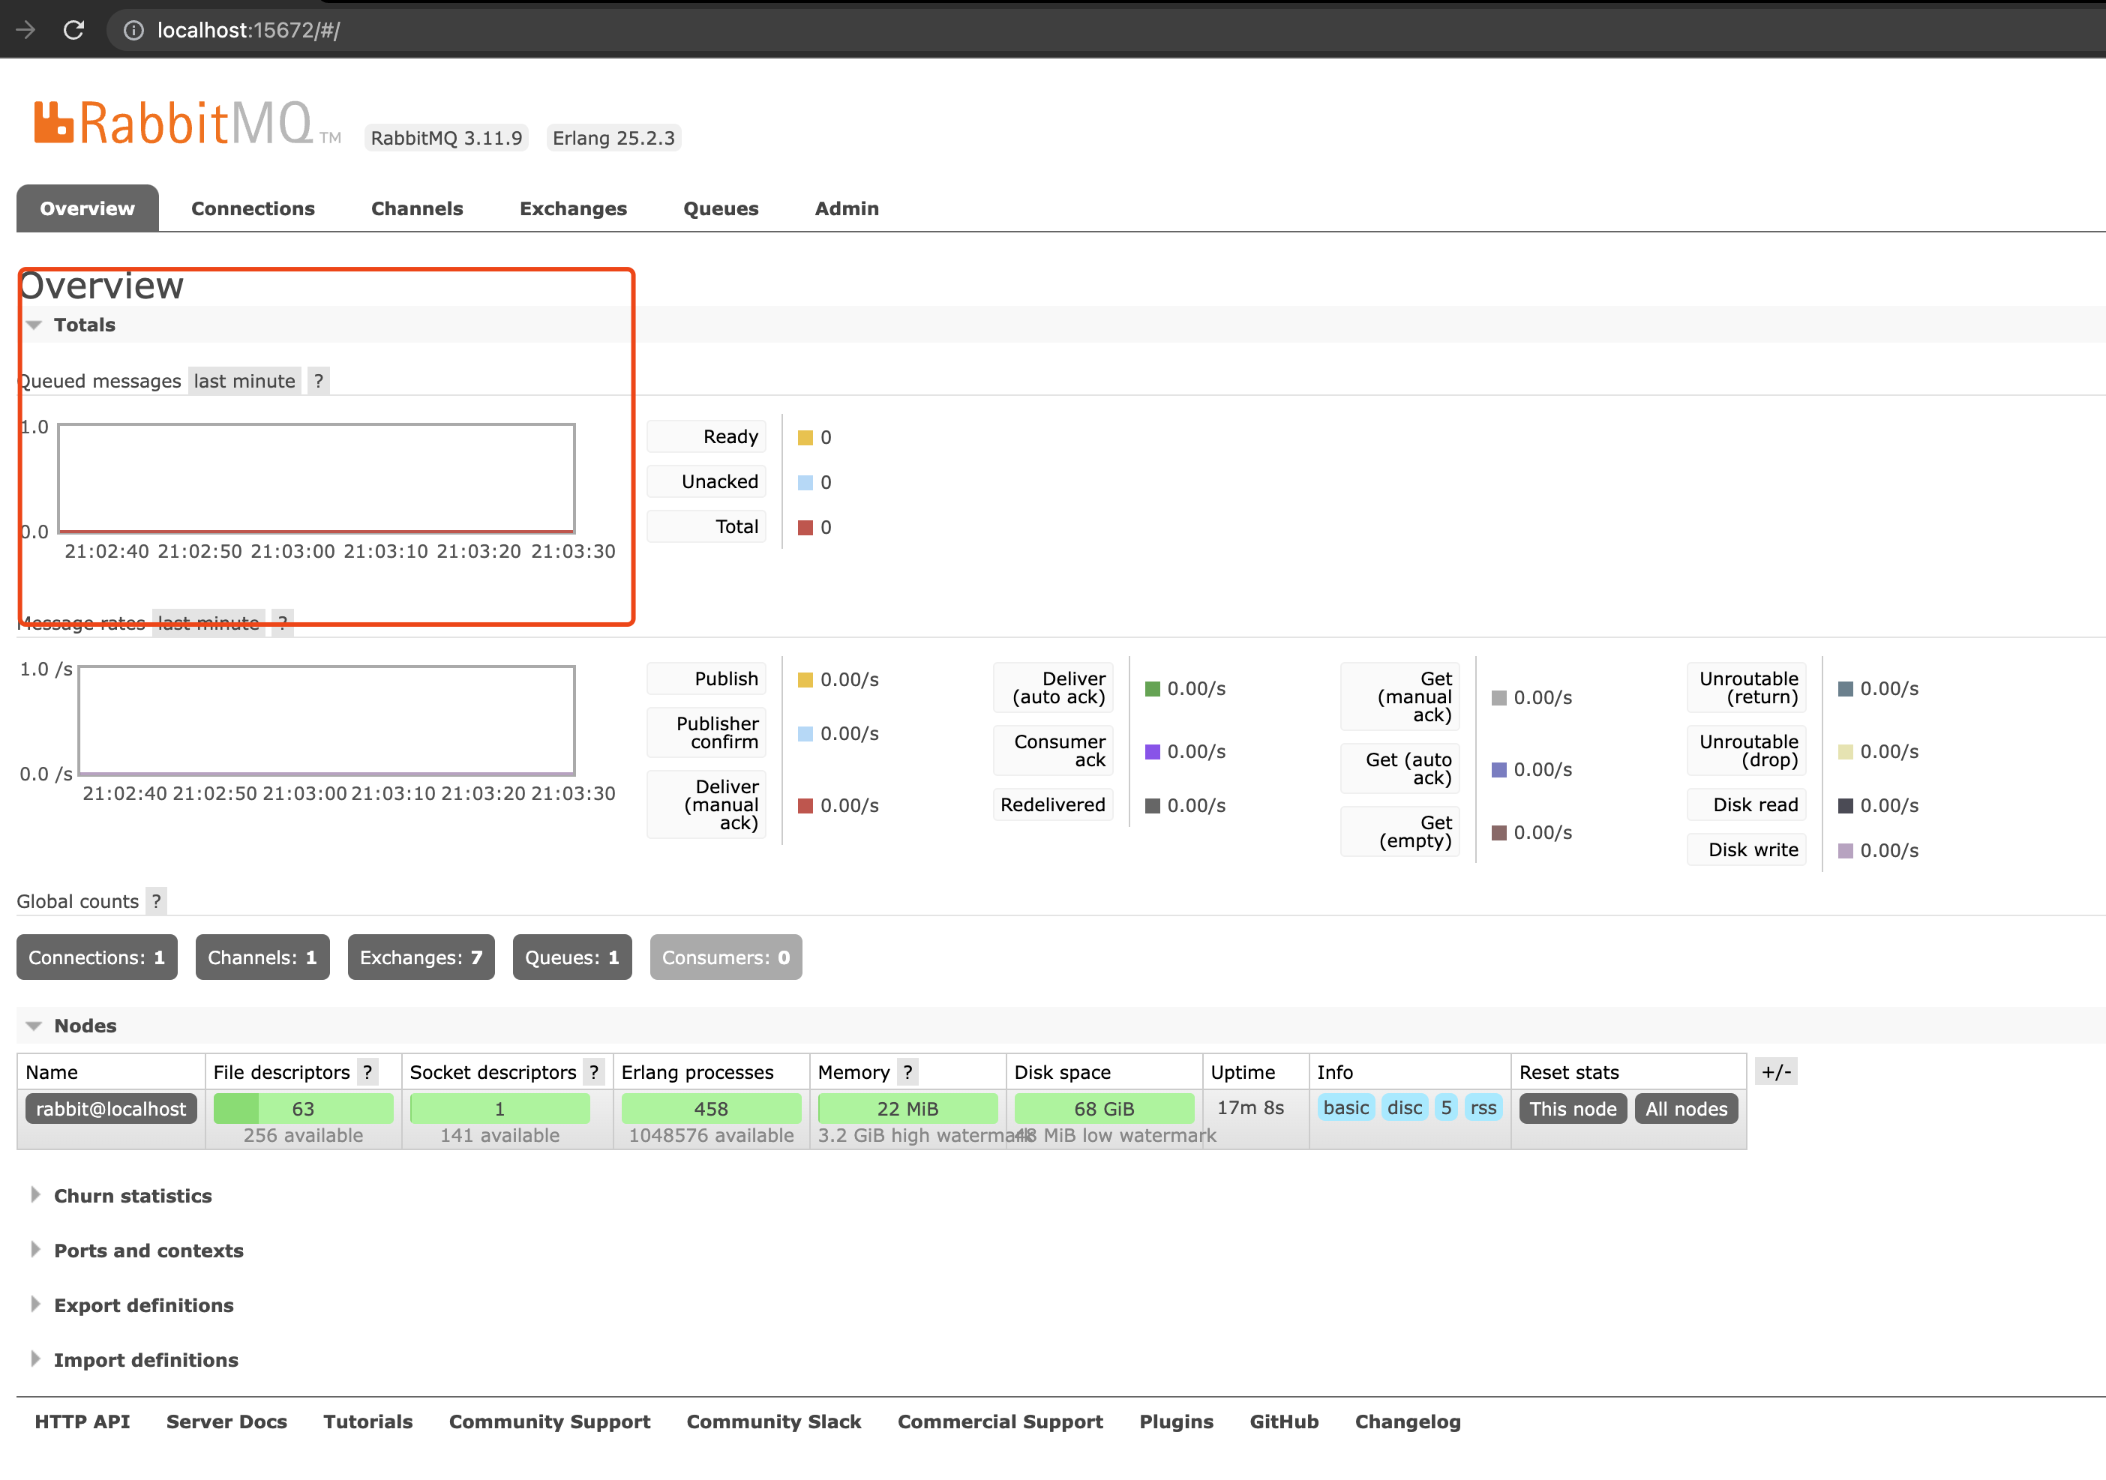

And Send 50 requests through 10 threads:

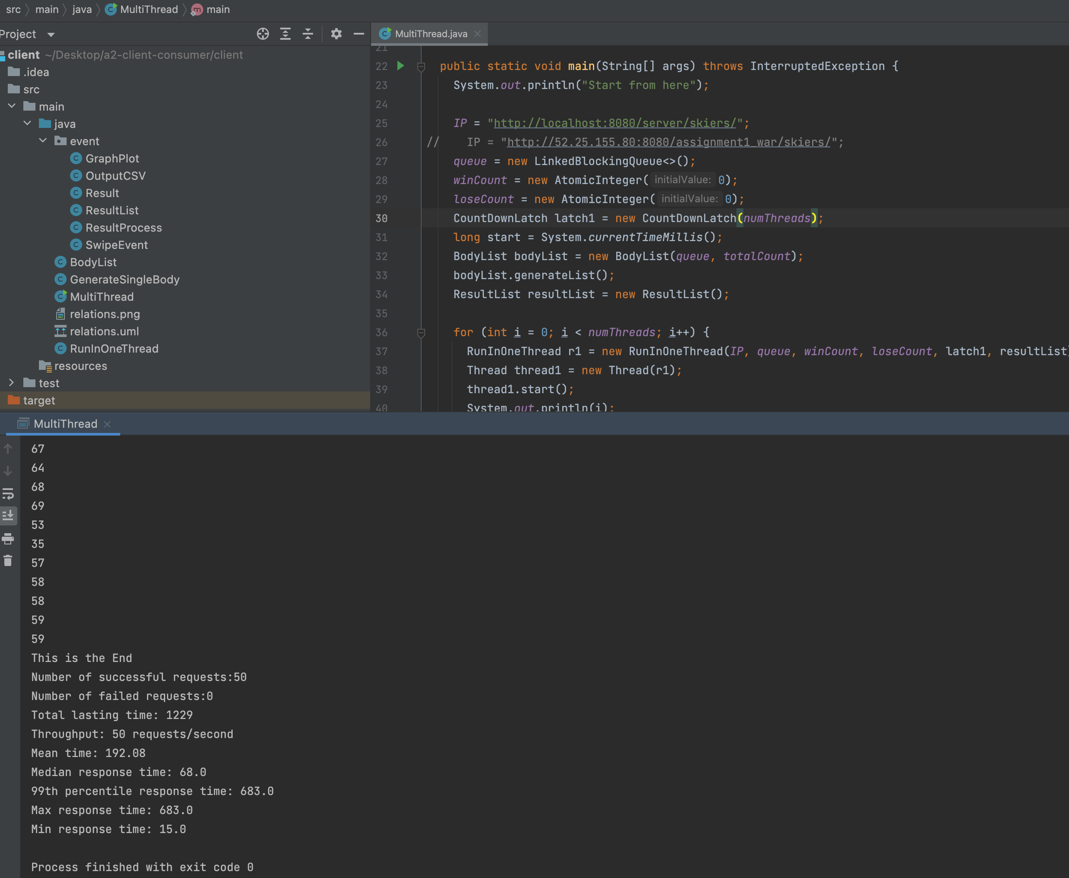

Rabbitmq get the messages:

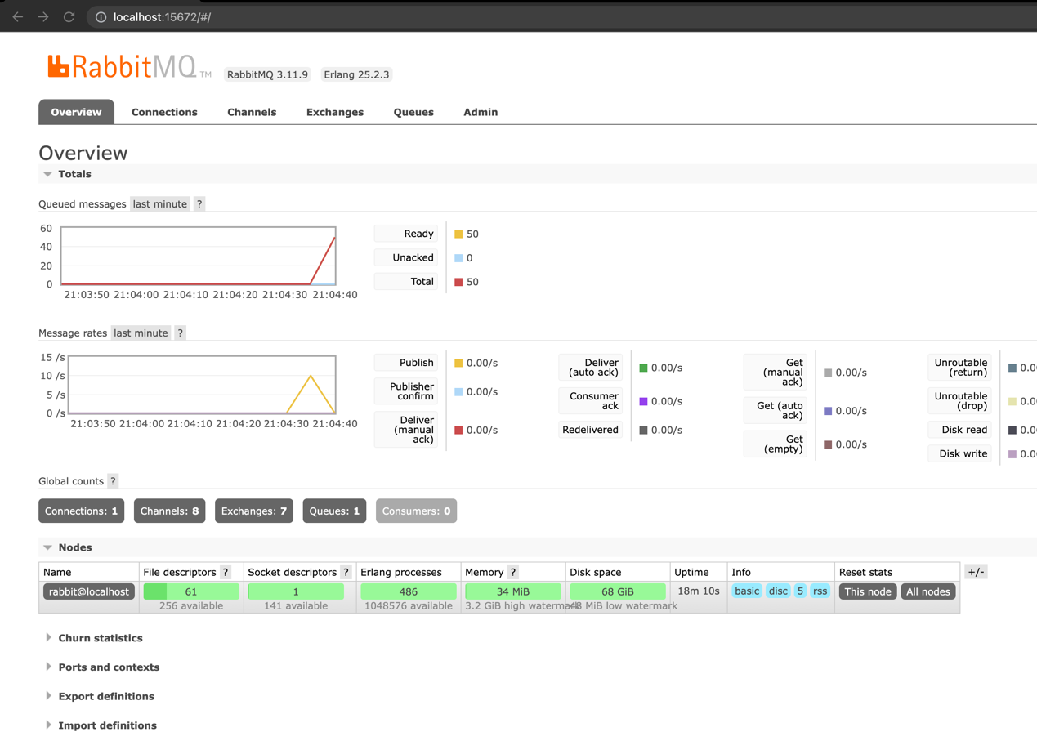

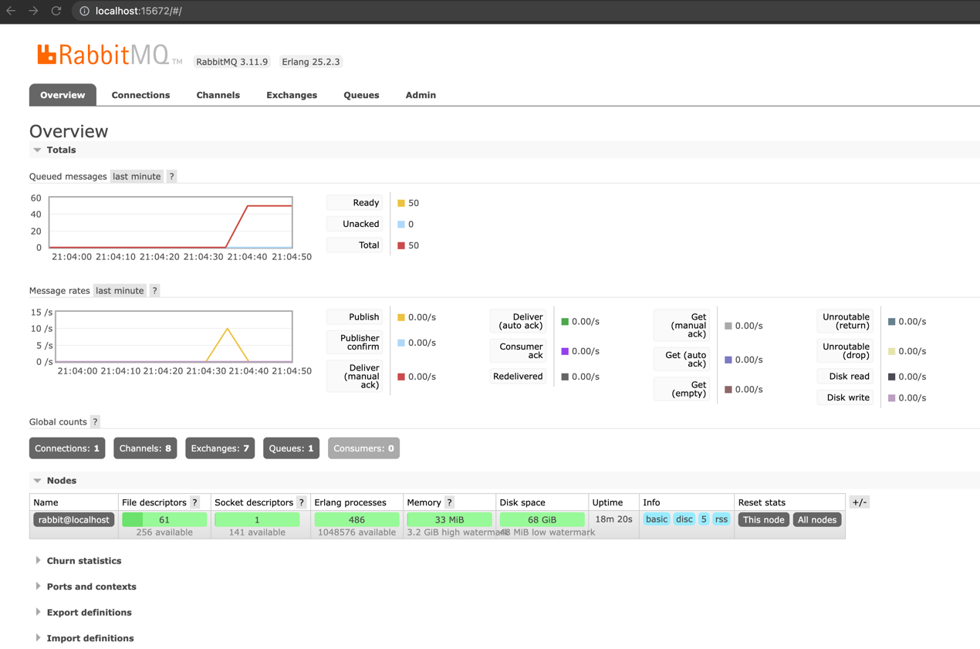

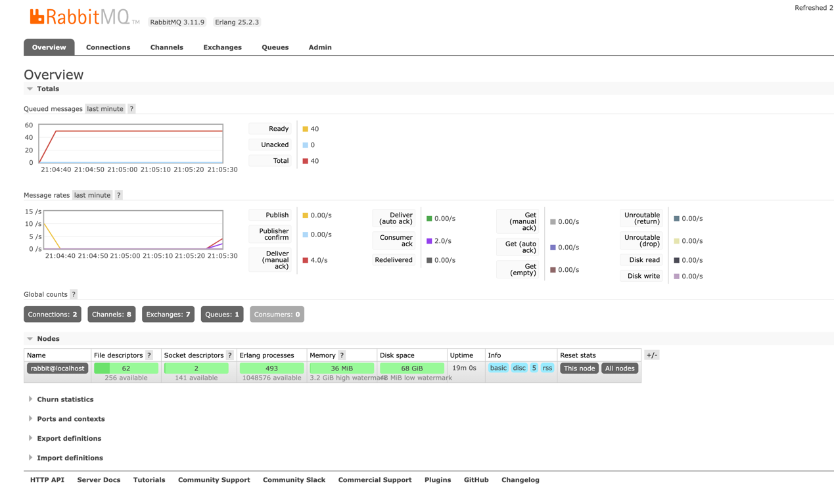

Then Consumer get it and consumes it.

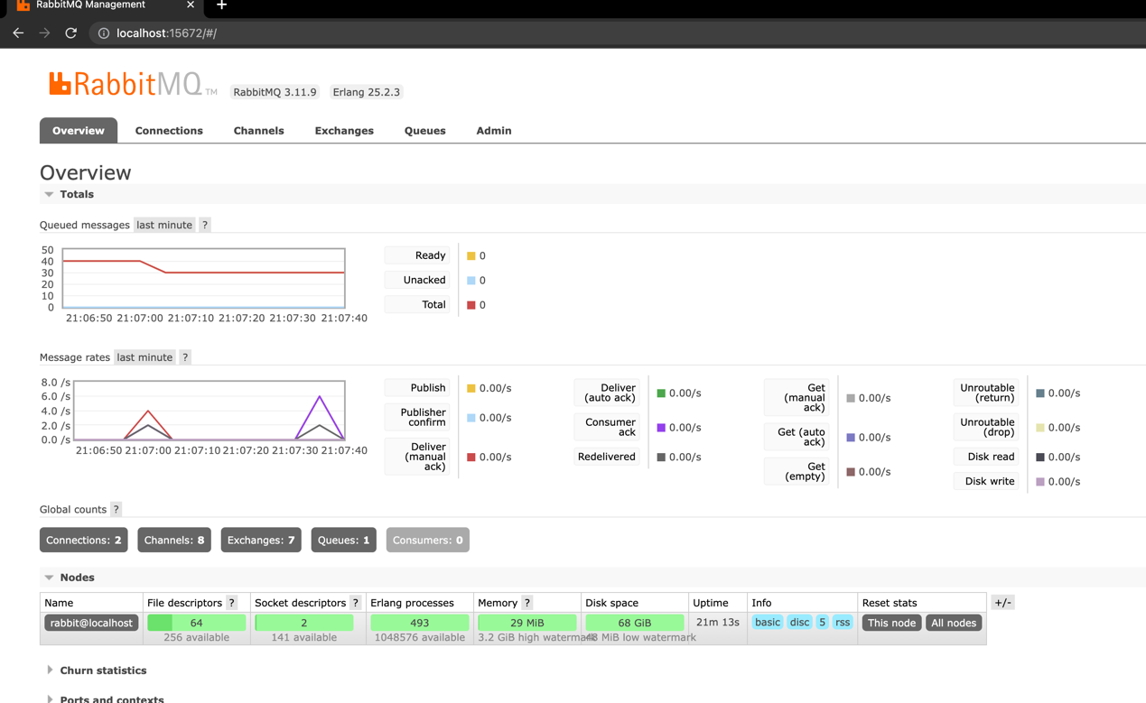

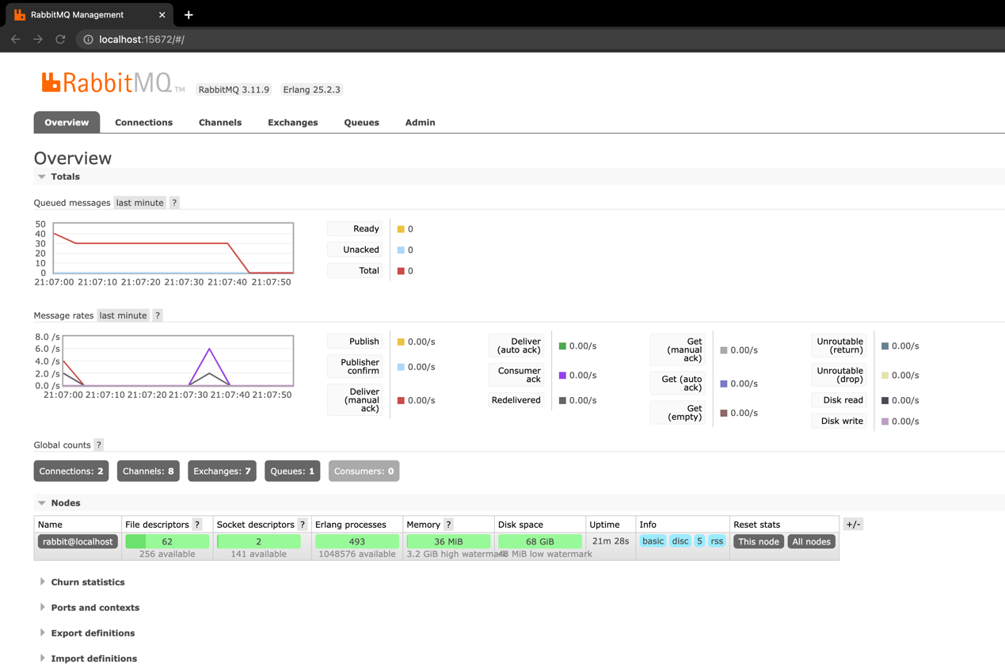

At last, all the messages are consumed.

And we got all the data and stored inside the hashmap

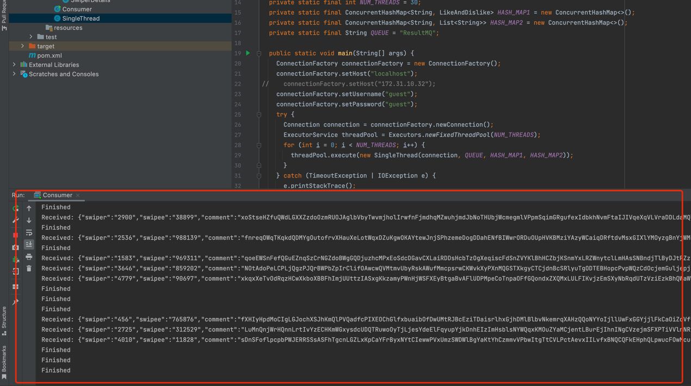

All the messages:

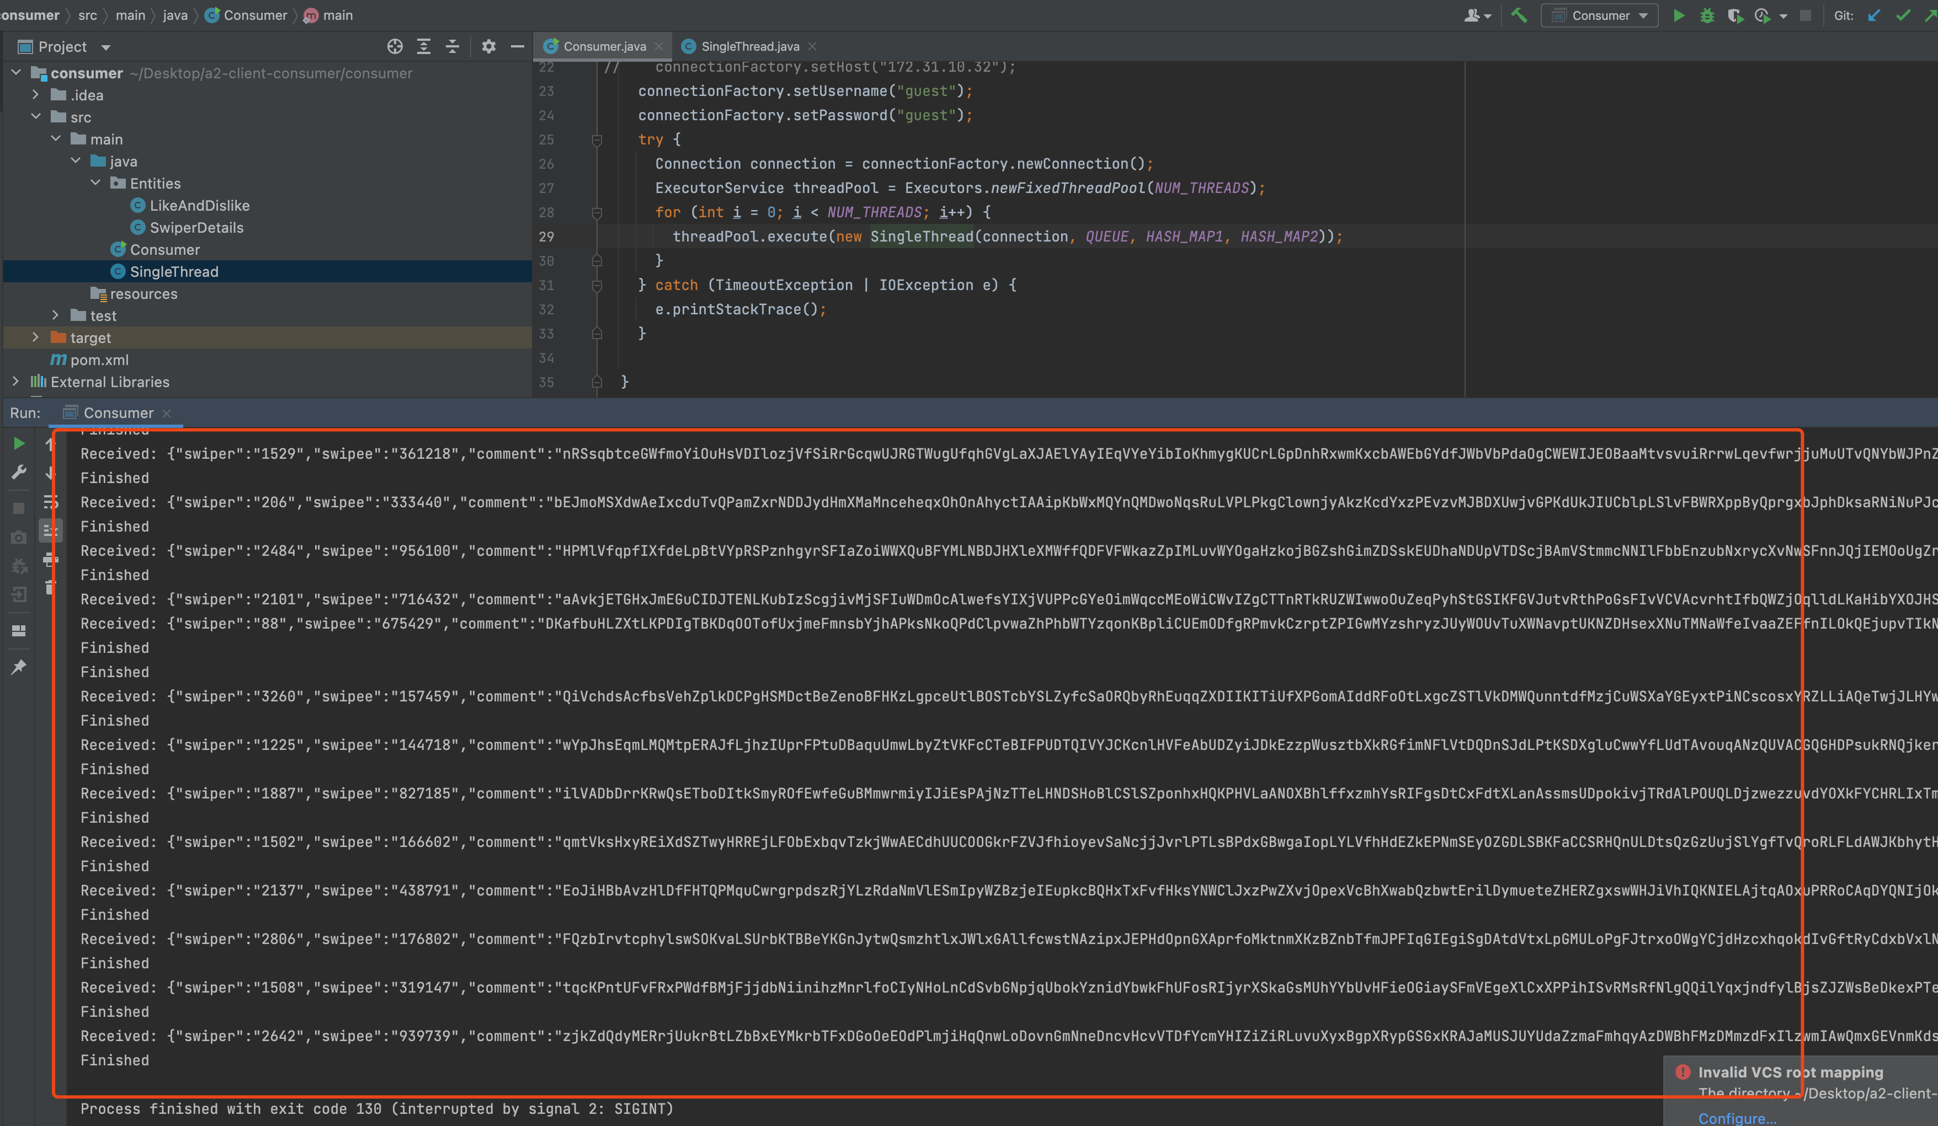

Again, if we improve the messages number to 1000, and still 10 threads in local.

Before we get started:

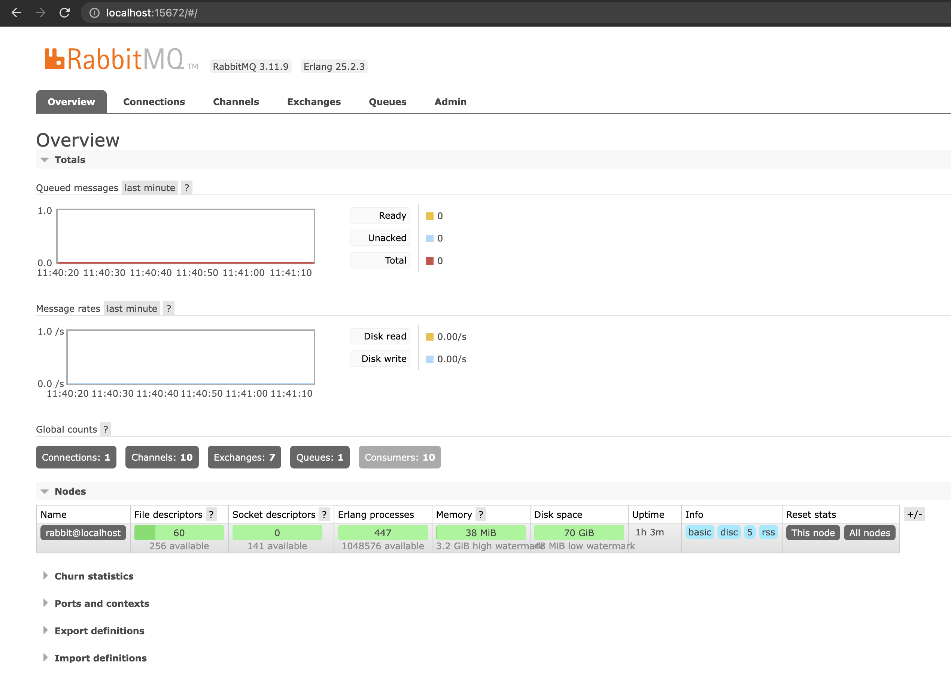

The rabbitmq is receiving the data

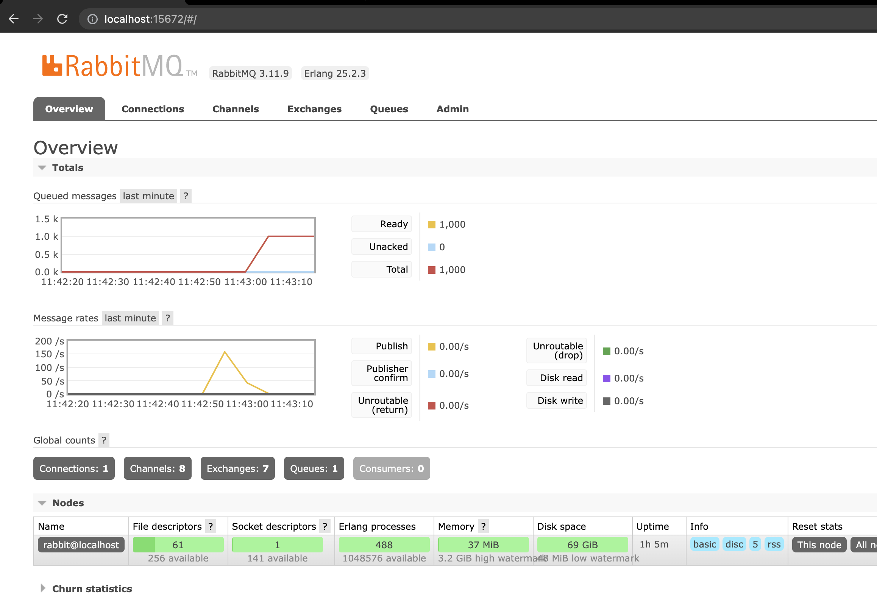

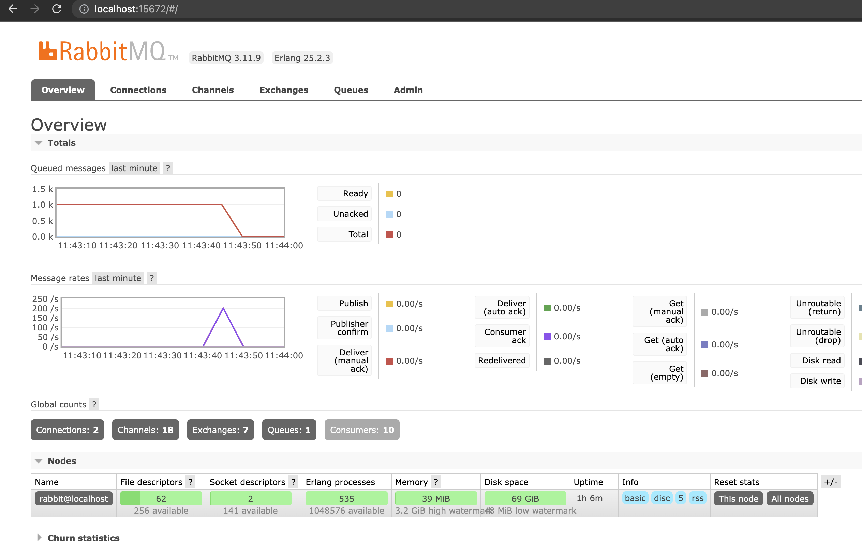

All the messages received:

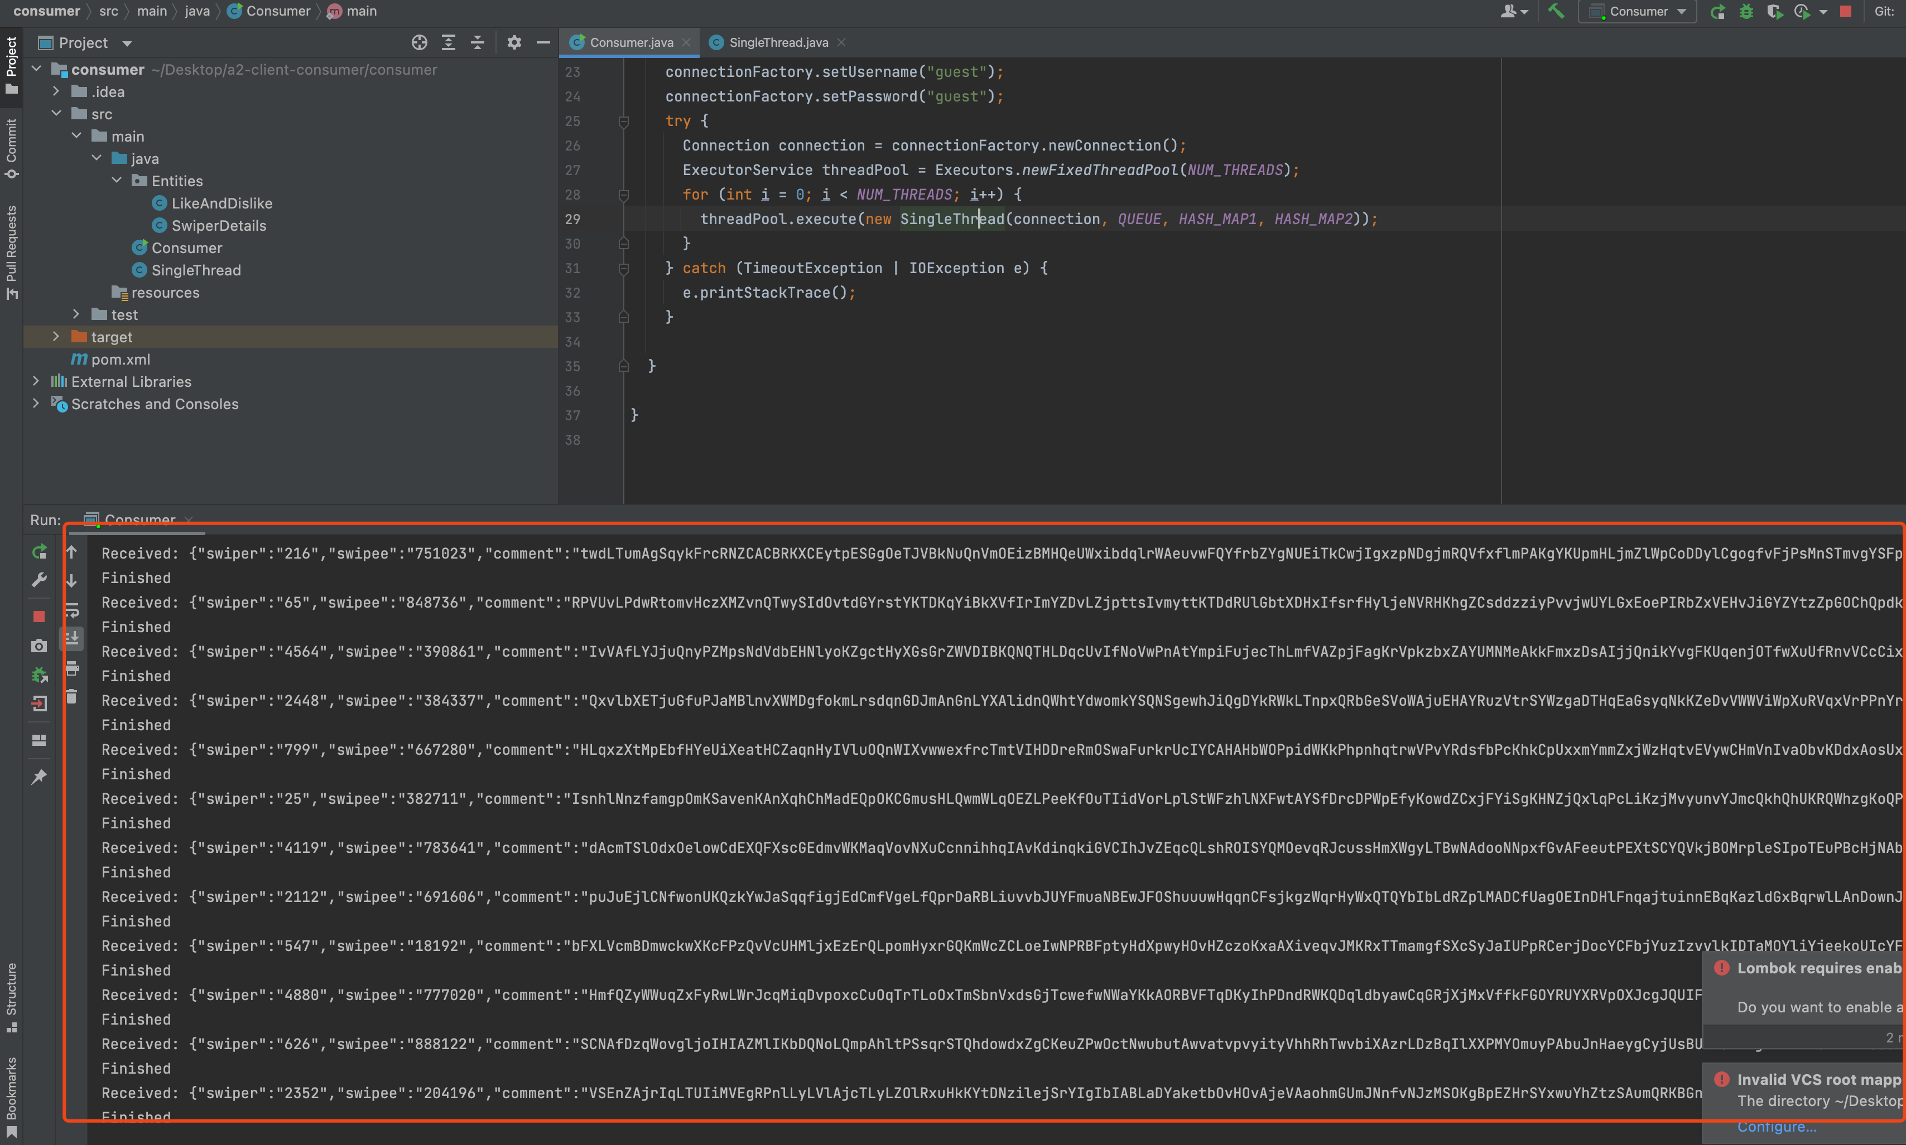

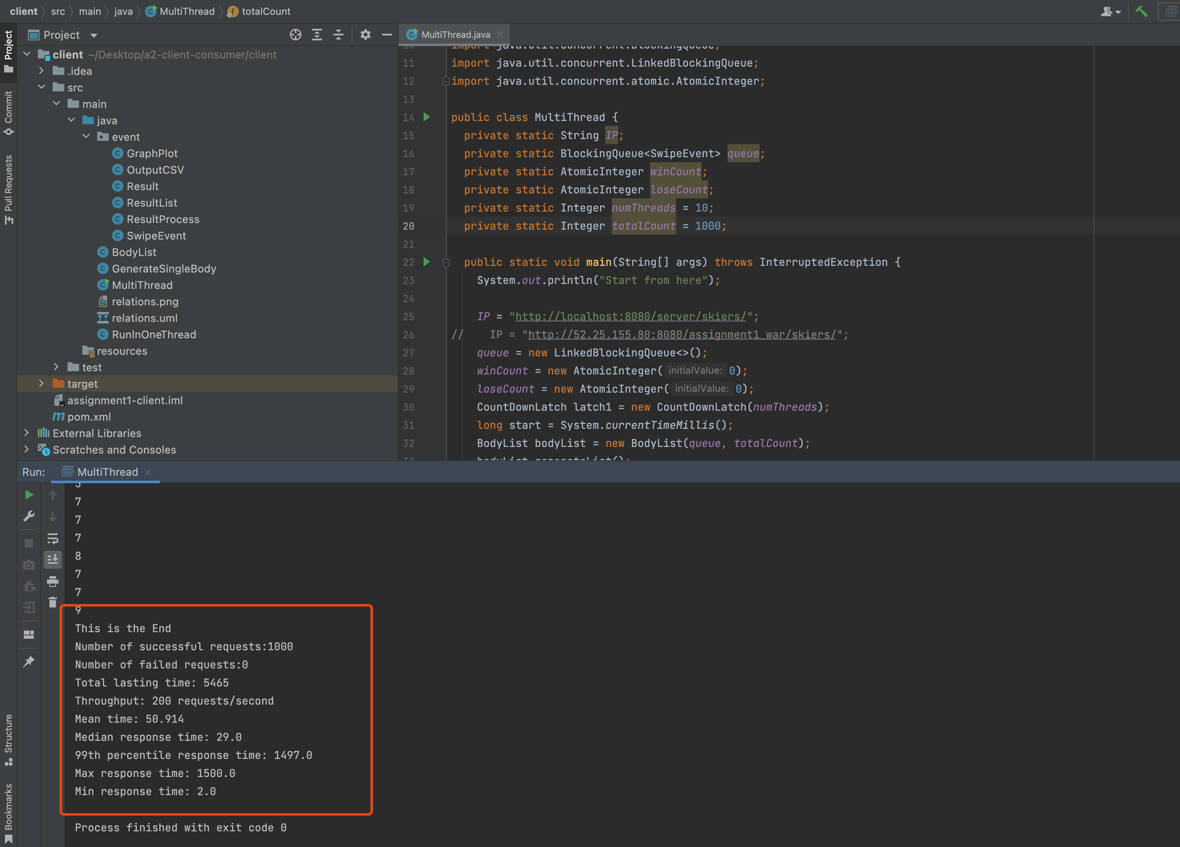

If we start the consumer from the very beginning

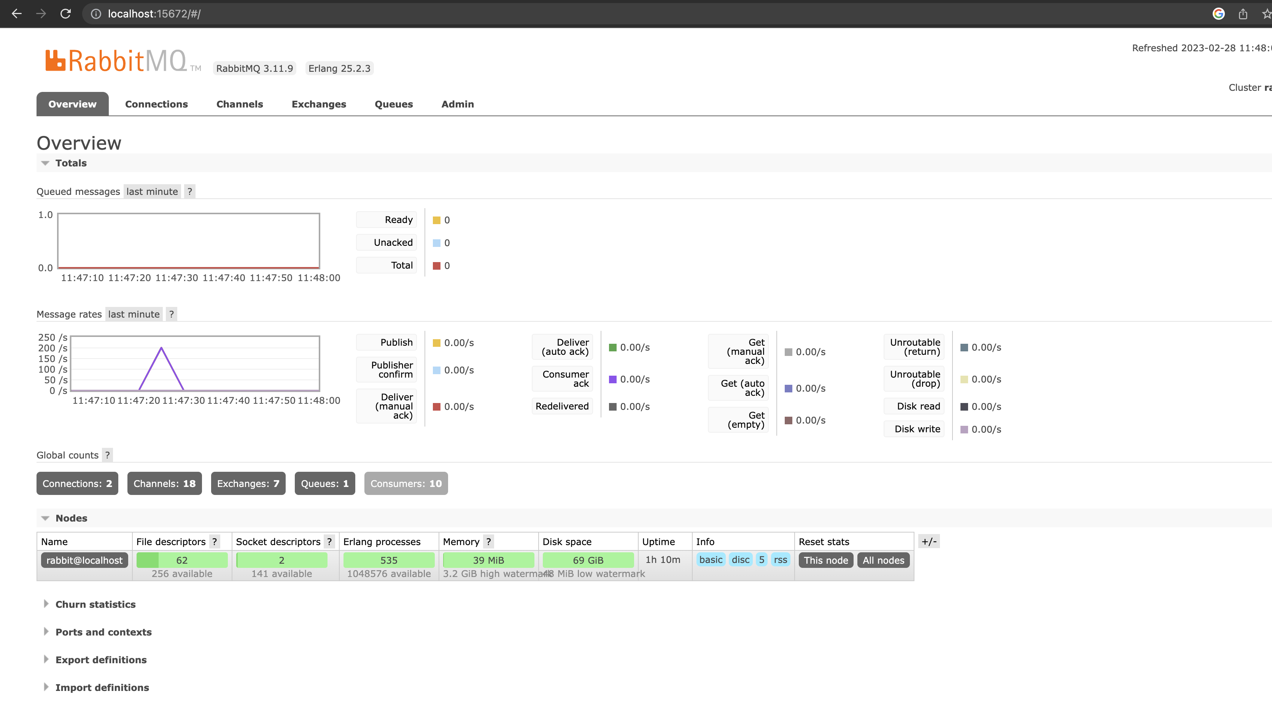

If we start the consumer at first, which means we send messages and consume messages at the same time. And the peak would come earlier.

So we could rise the number of the messages to 500k:

If we send 500k messages and use 100 thread:

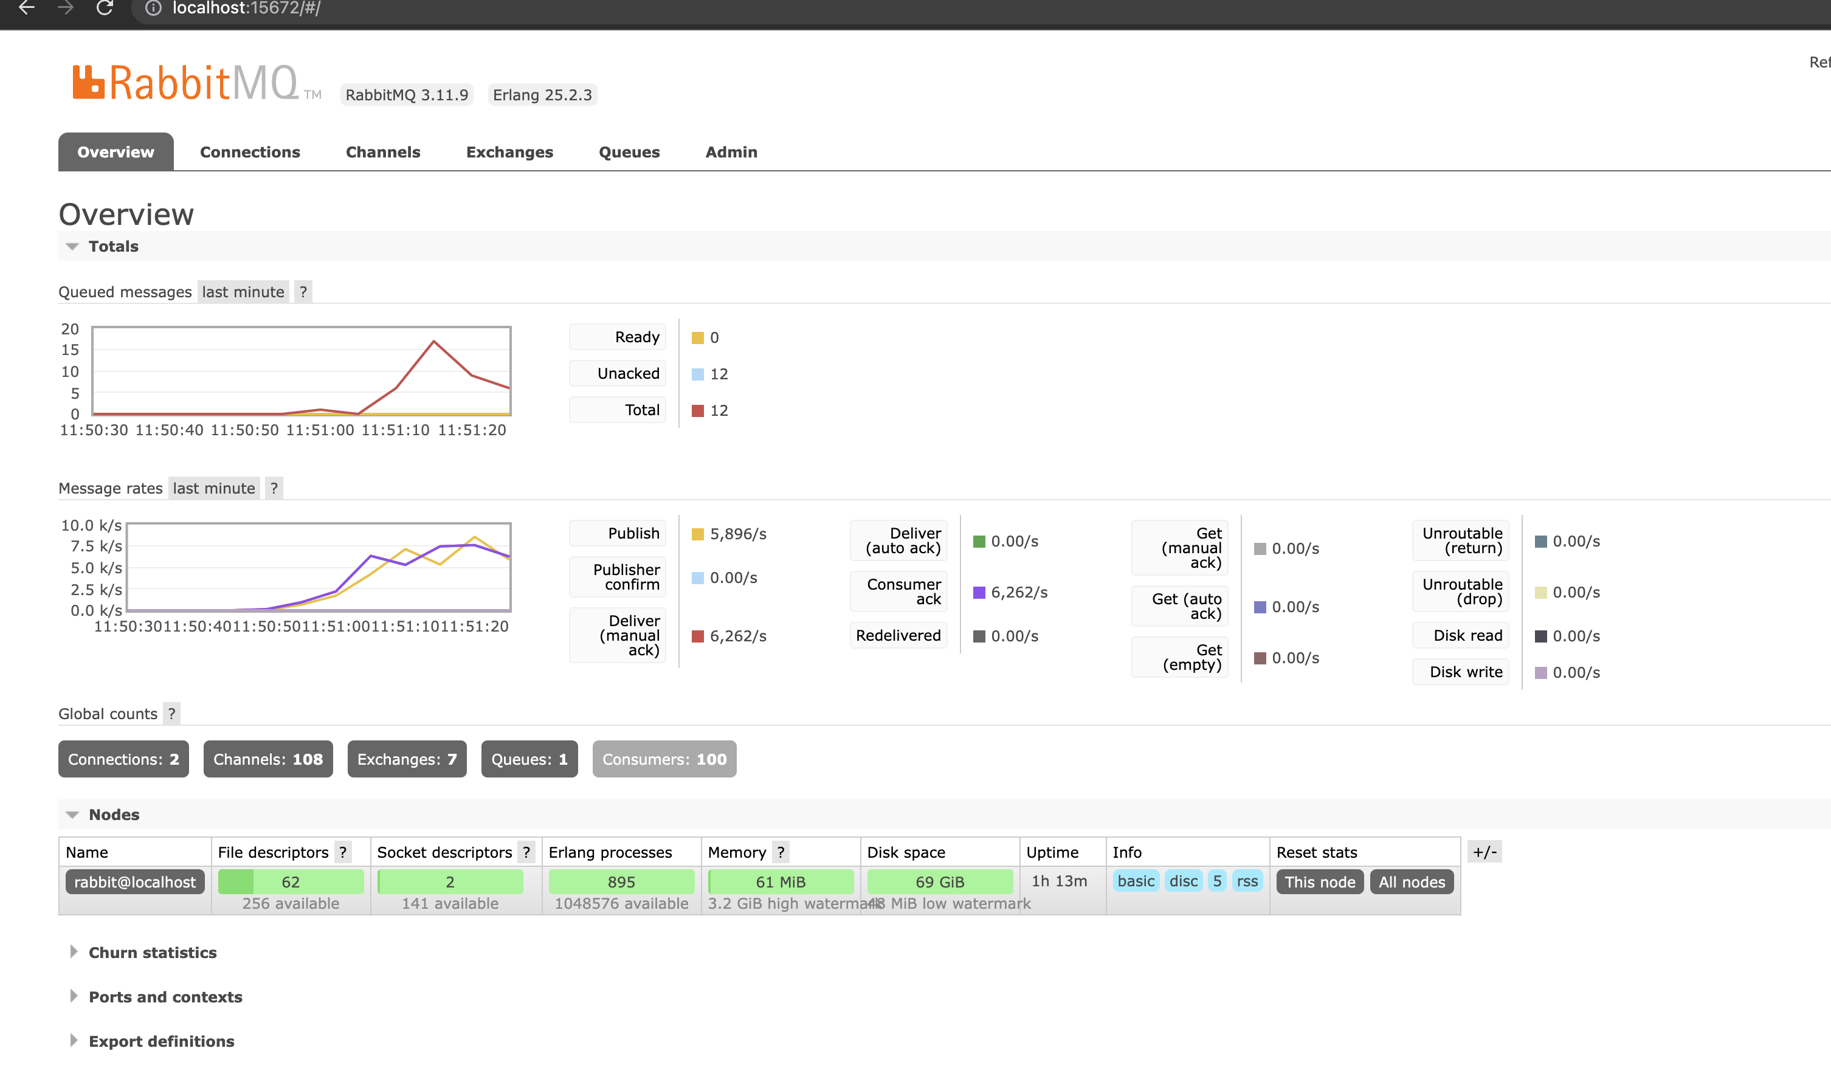

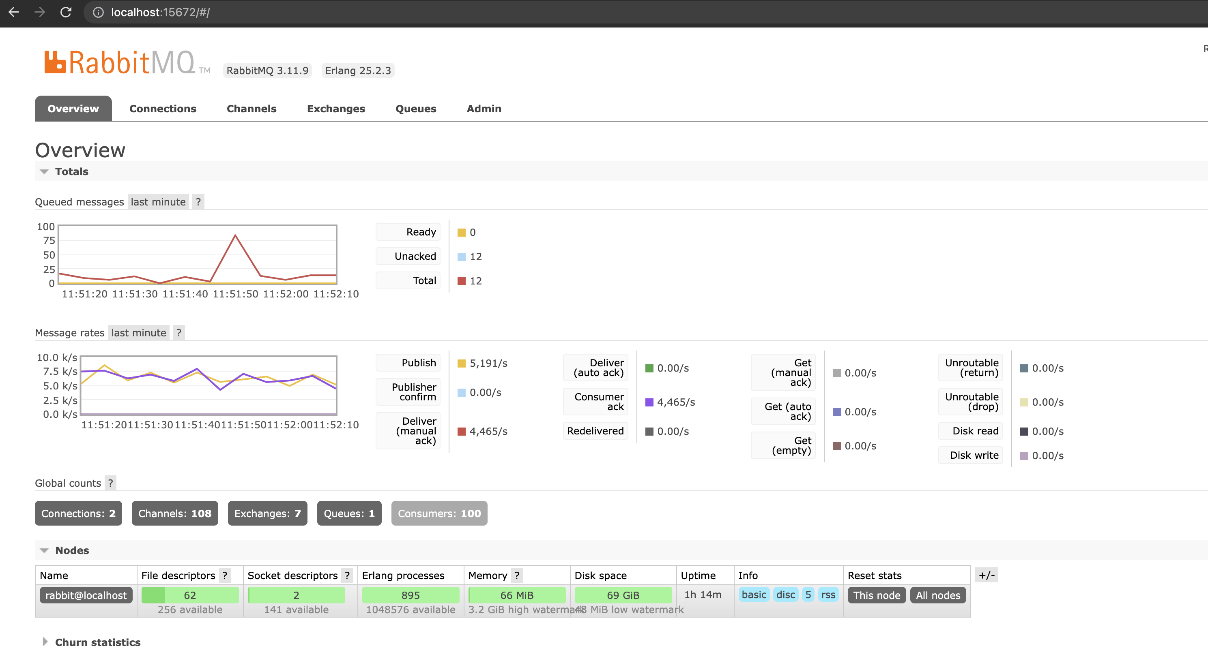

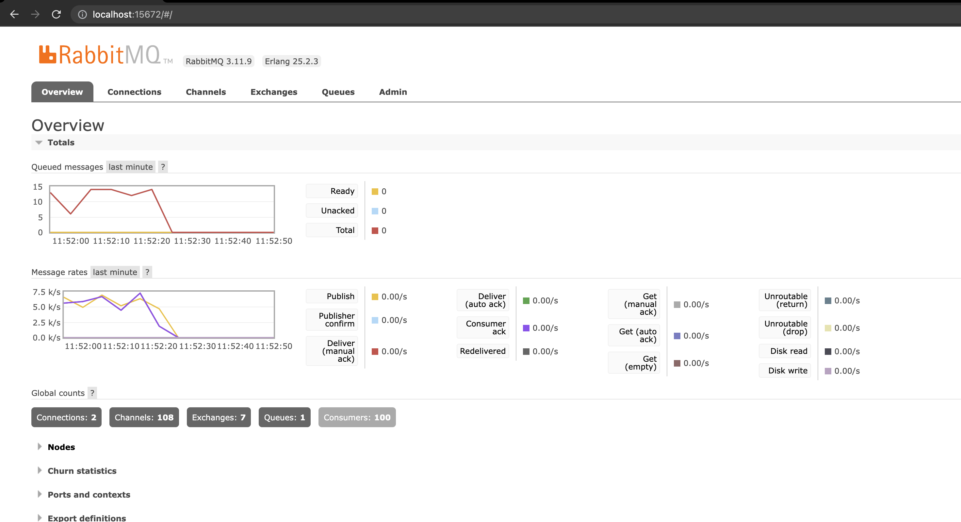

Result:

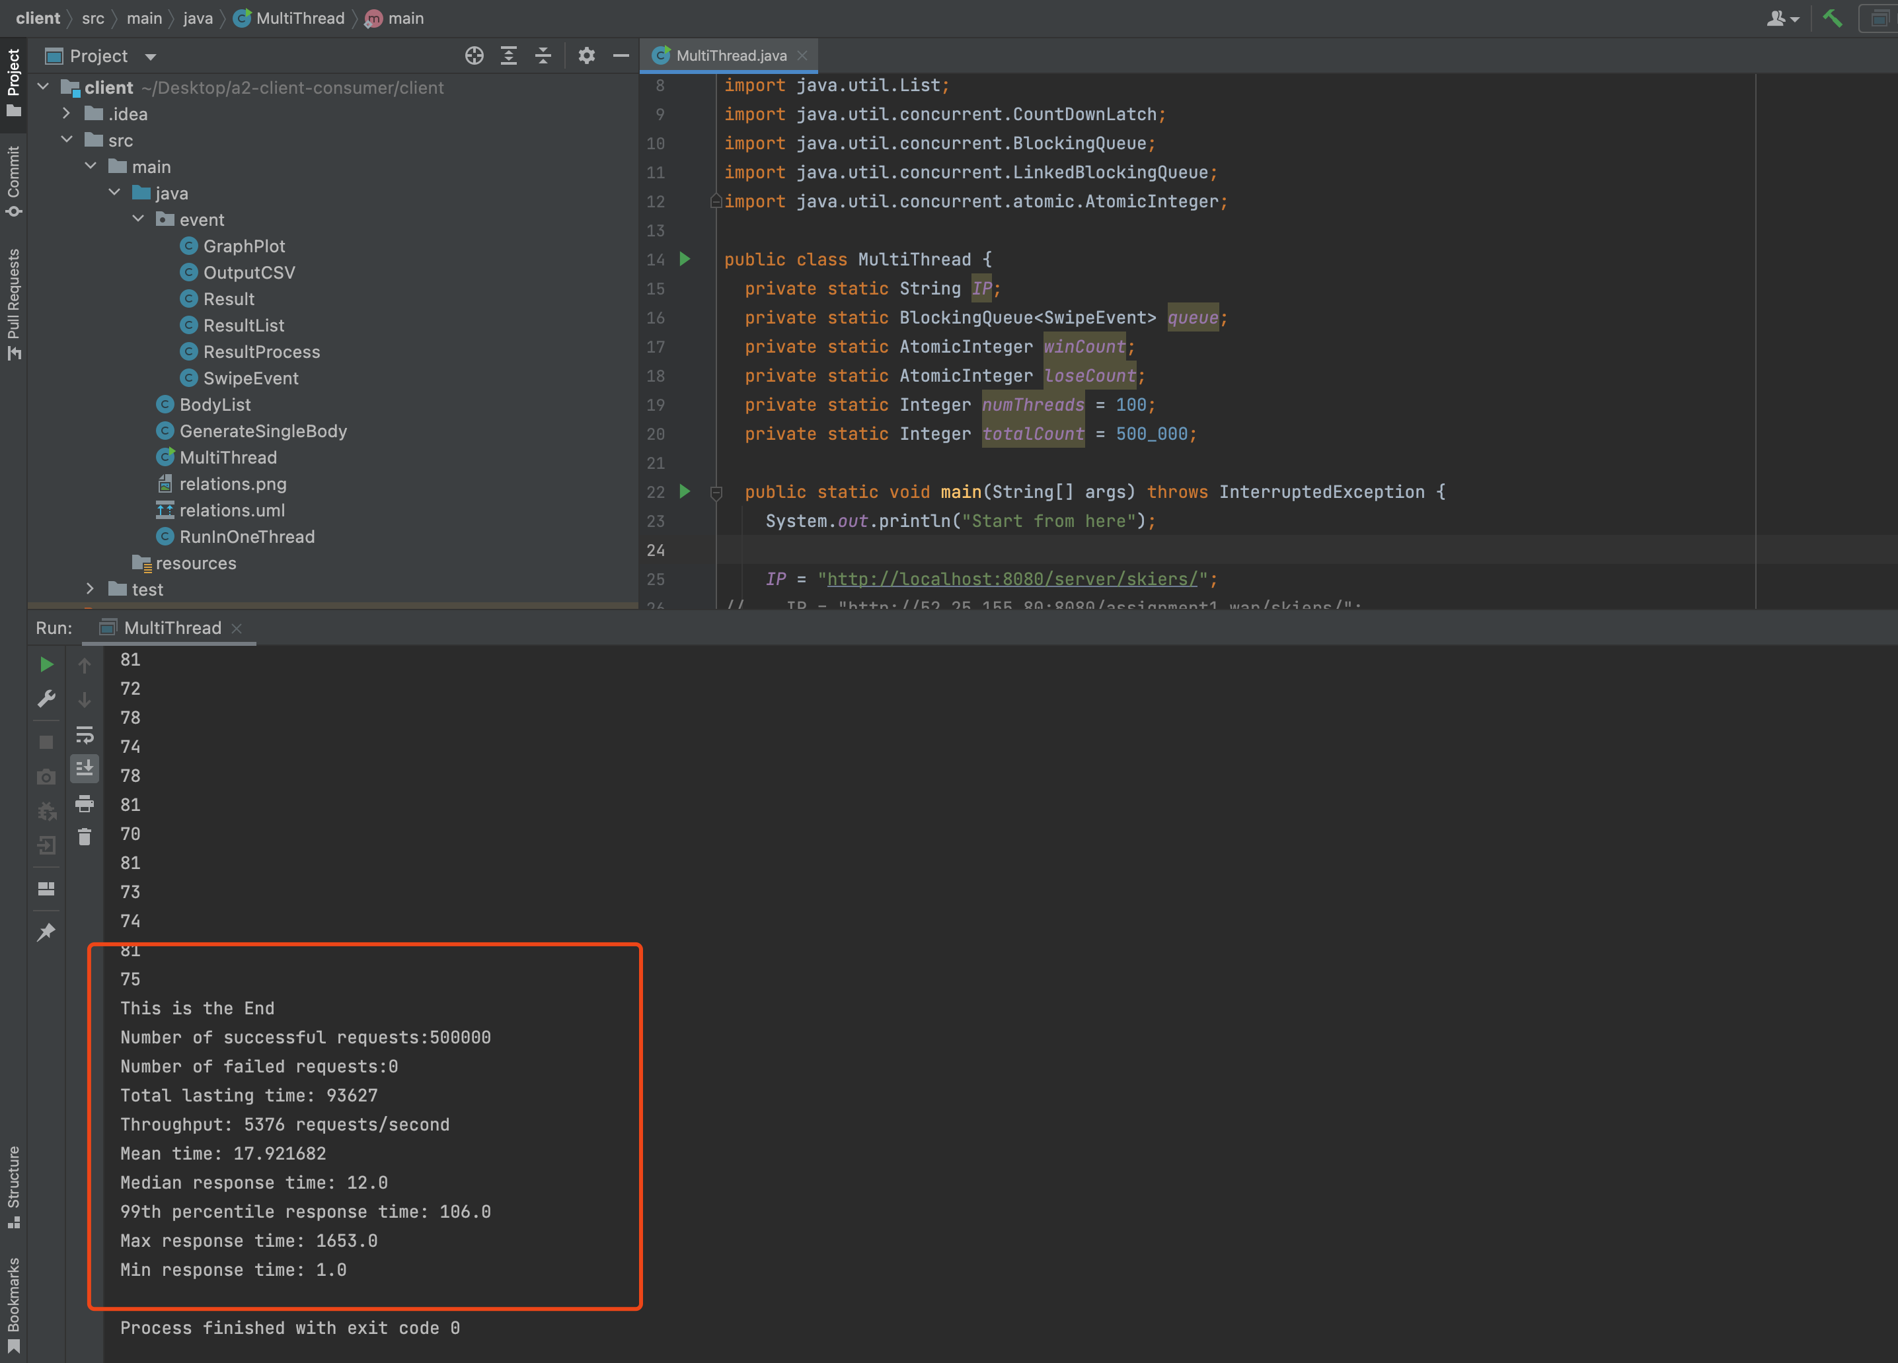

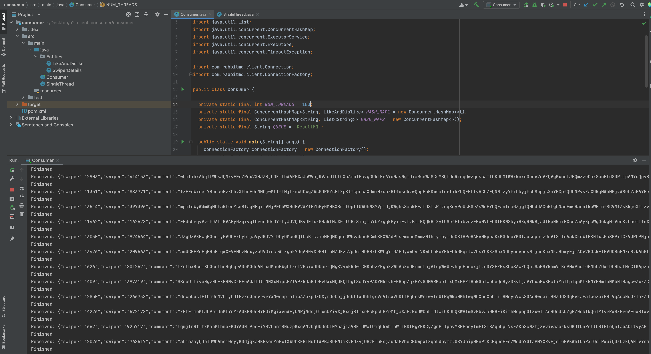

EC2 Part:

I deployed Rabbitmq on AWS Ubuntu

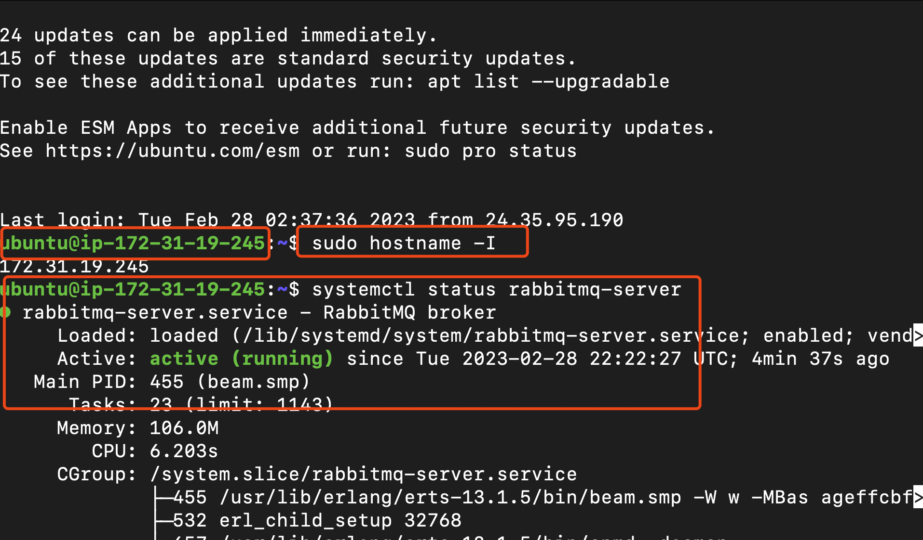

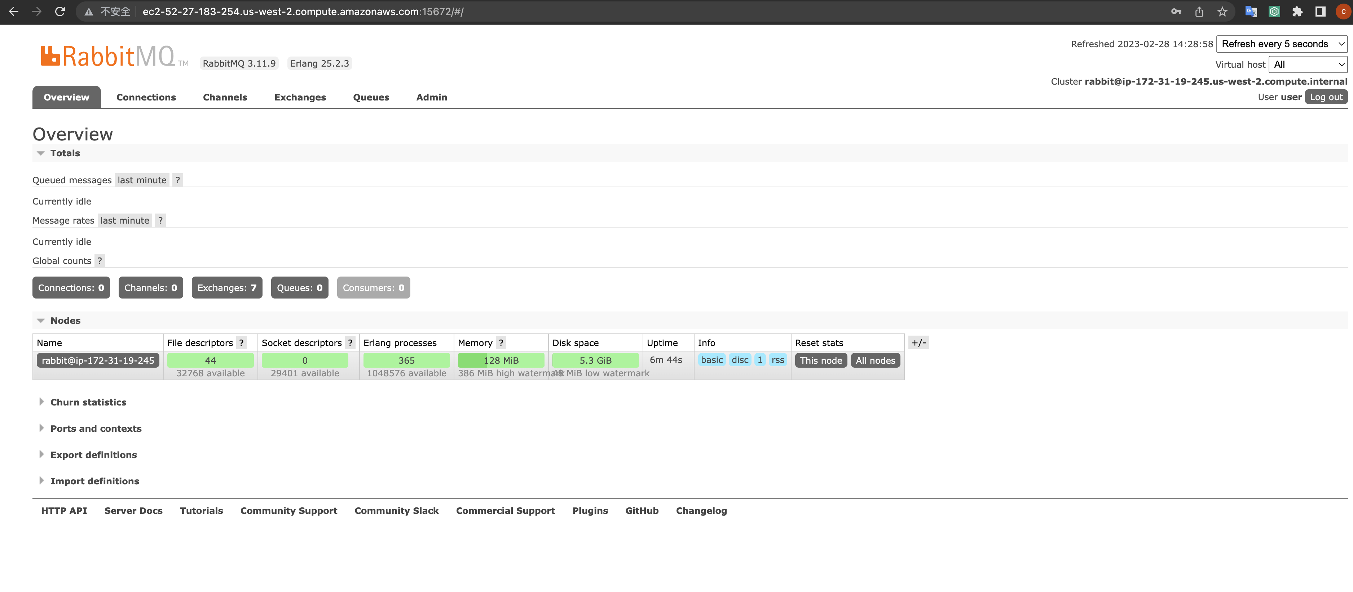

Client part:

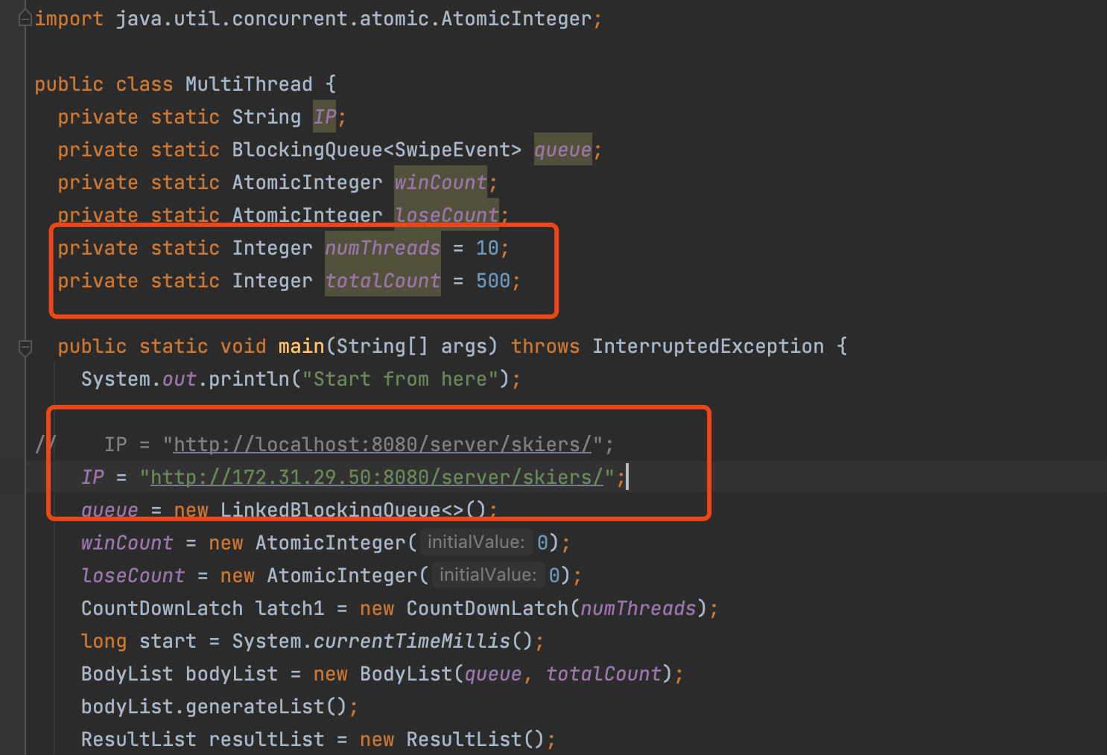

Server part

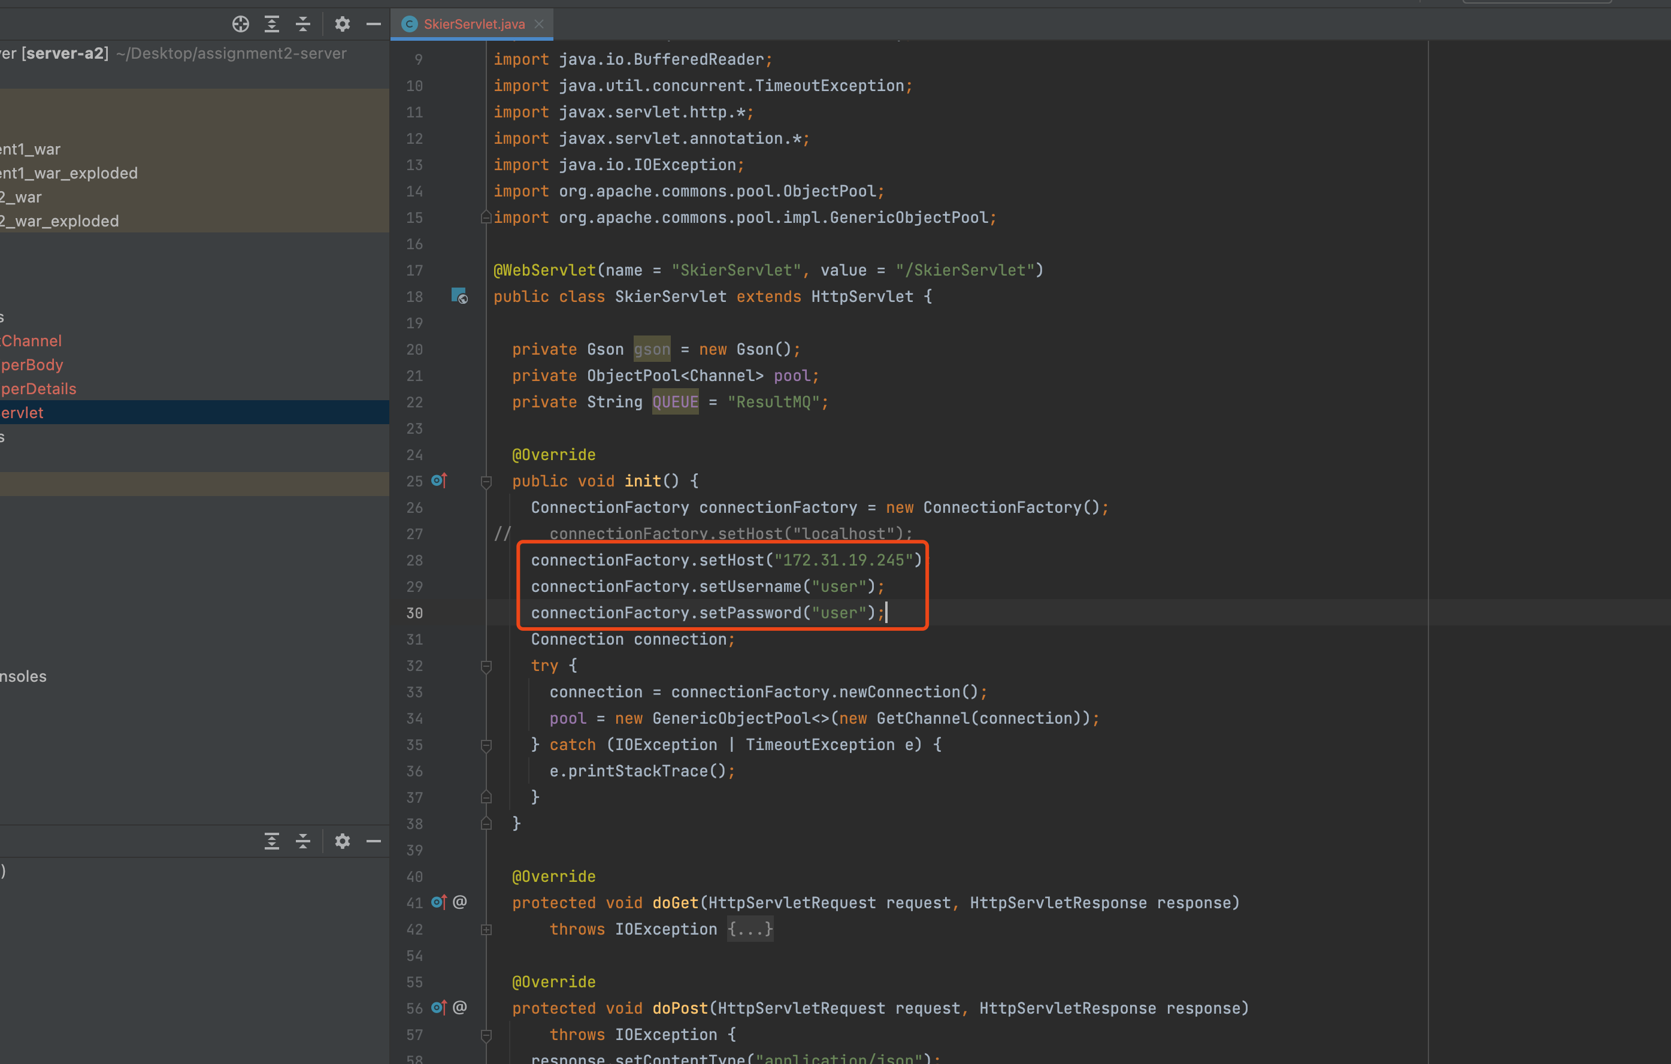

And I need to renew .war file

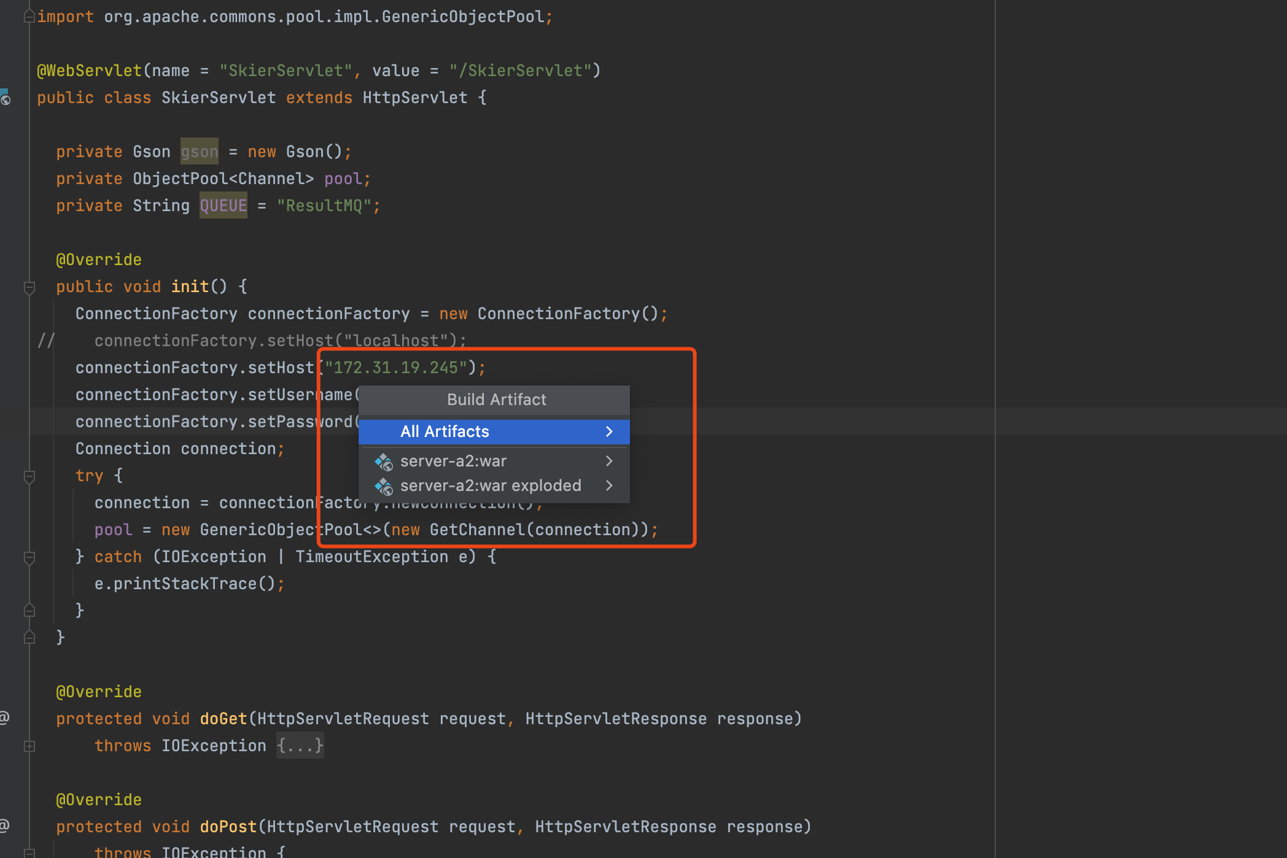

Pass .war file to ec2 to make it as a server

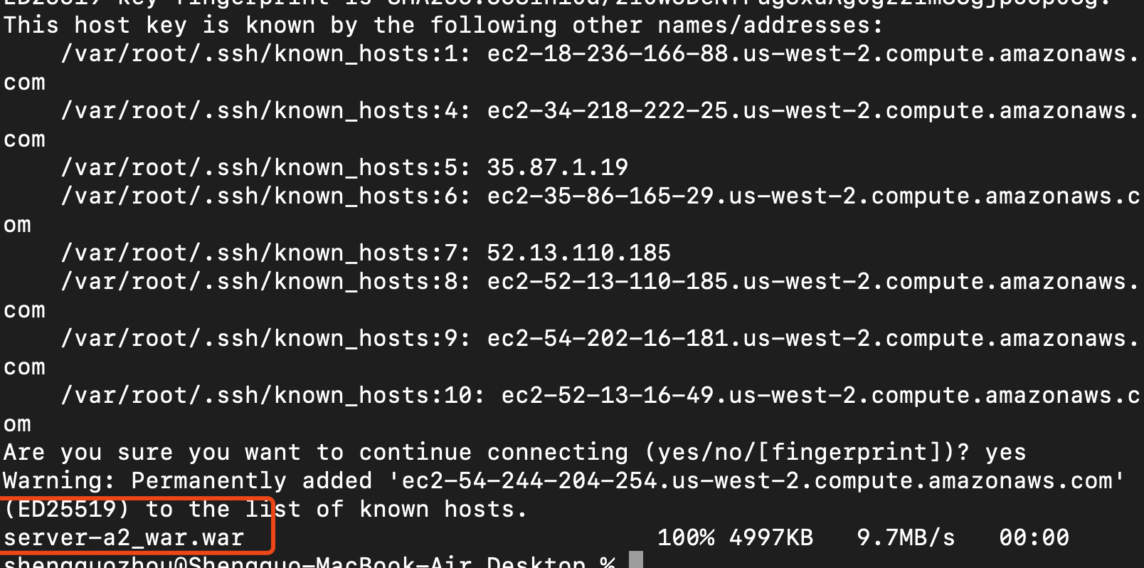

Consumer set the IP linked to RabbitMQ and set up the username on Ubuntu

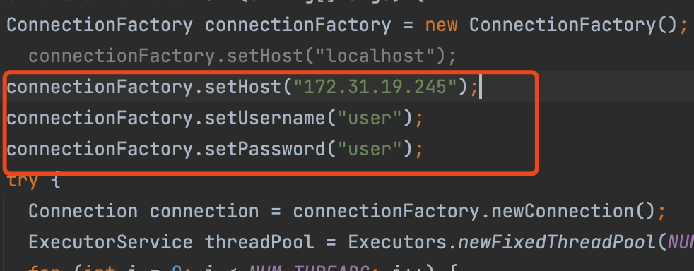

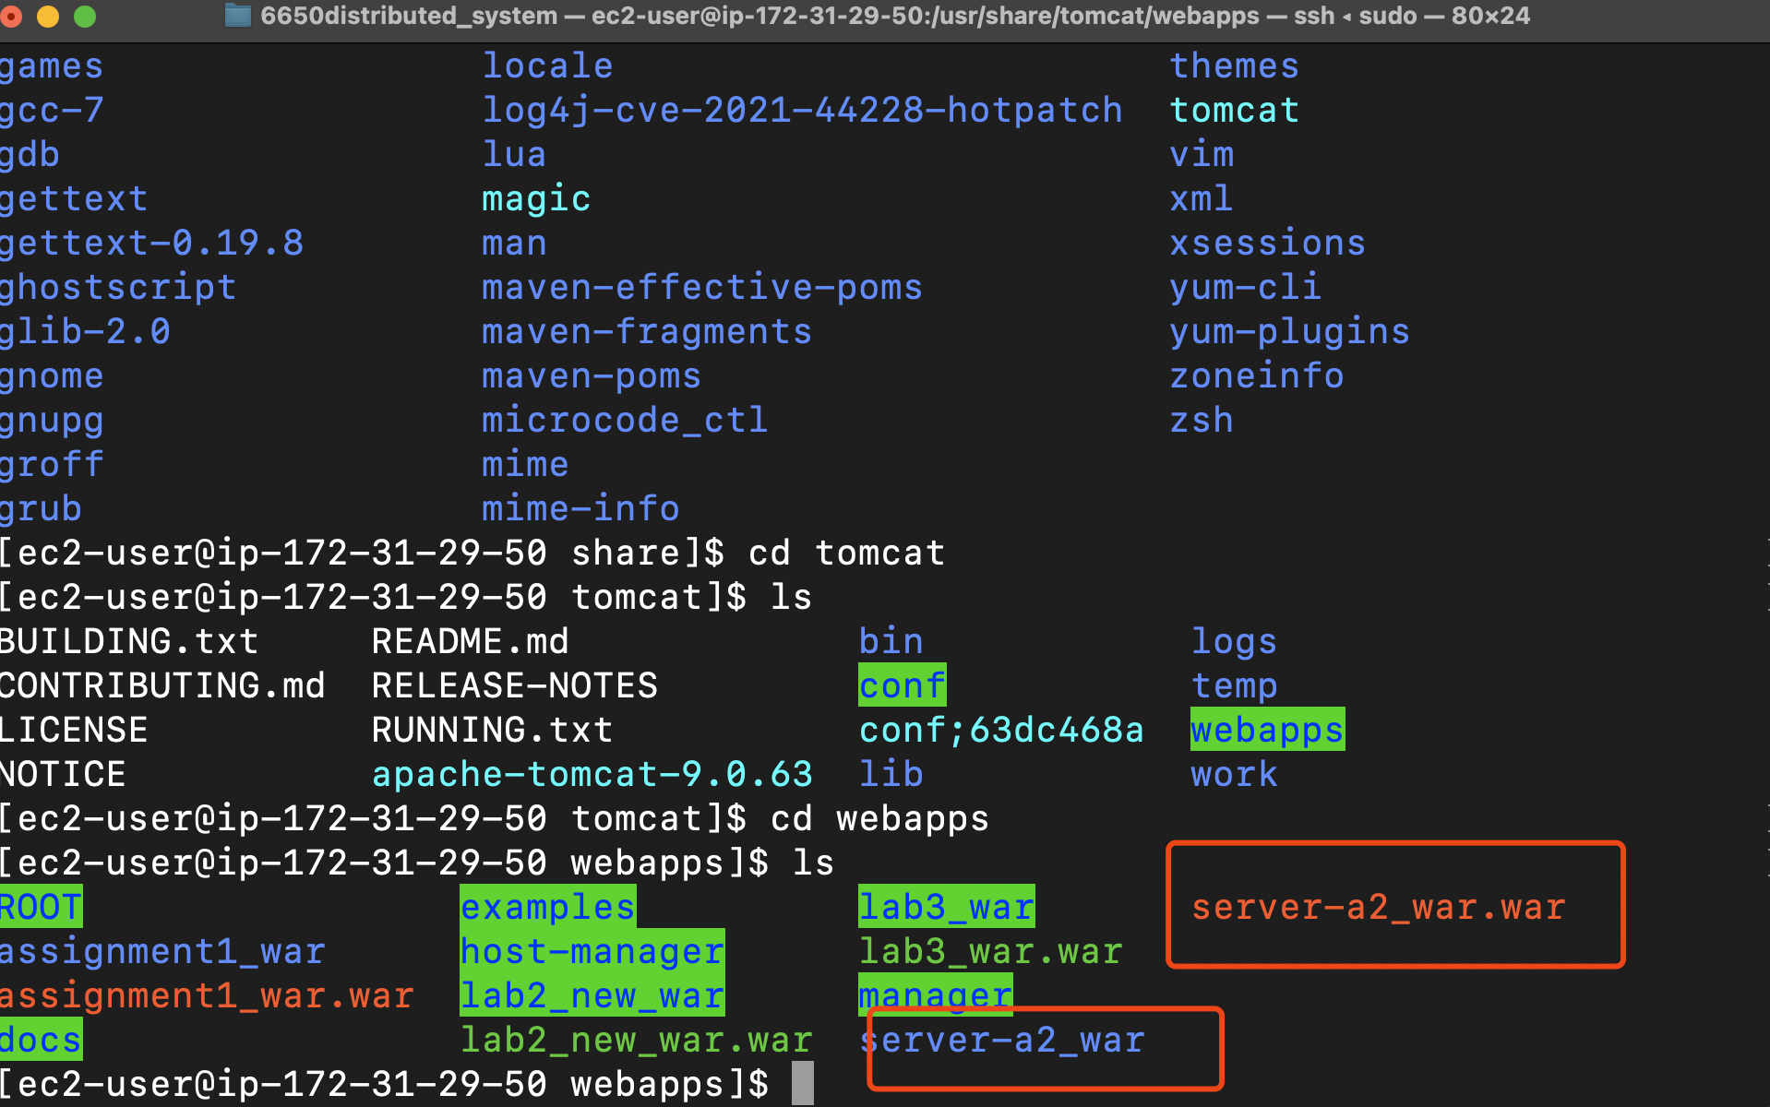

Some important parameters:

<http://localhost:8080/server_a2_war/skiers/swipe/left>

<http://ec2-54-244-204-254.us-west-2.compute.amazonaws.com:8080/server-a2_war/skiers/swipe/left/>

Postman works well, which means it can send 500k messages data to EC2 host

And the rabbitmq in the Ubantu can get this message

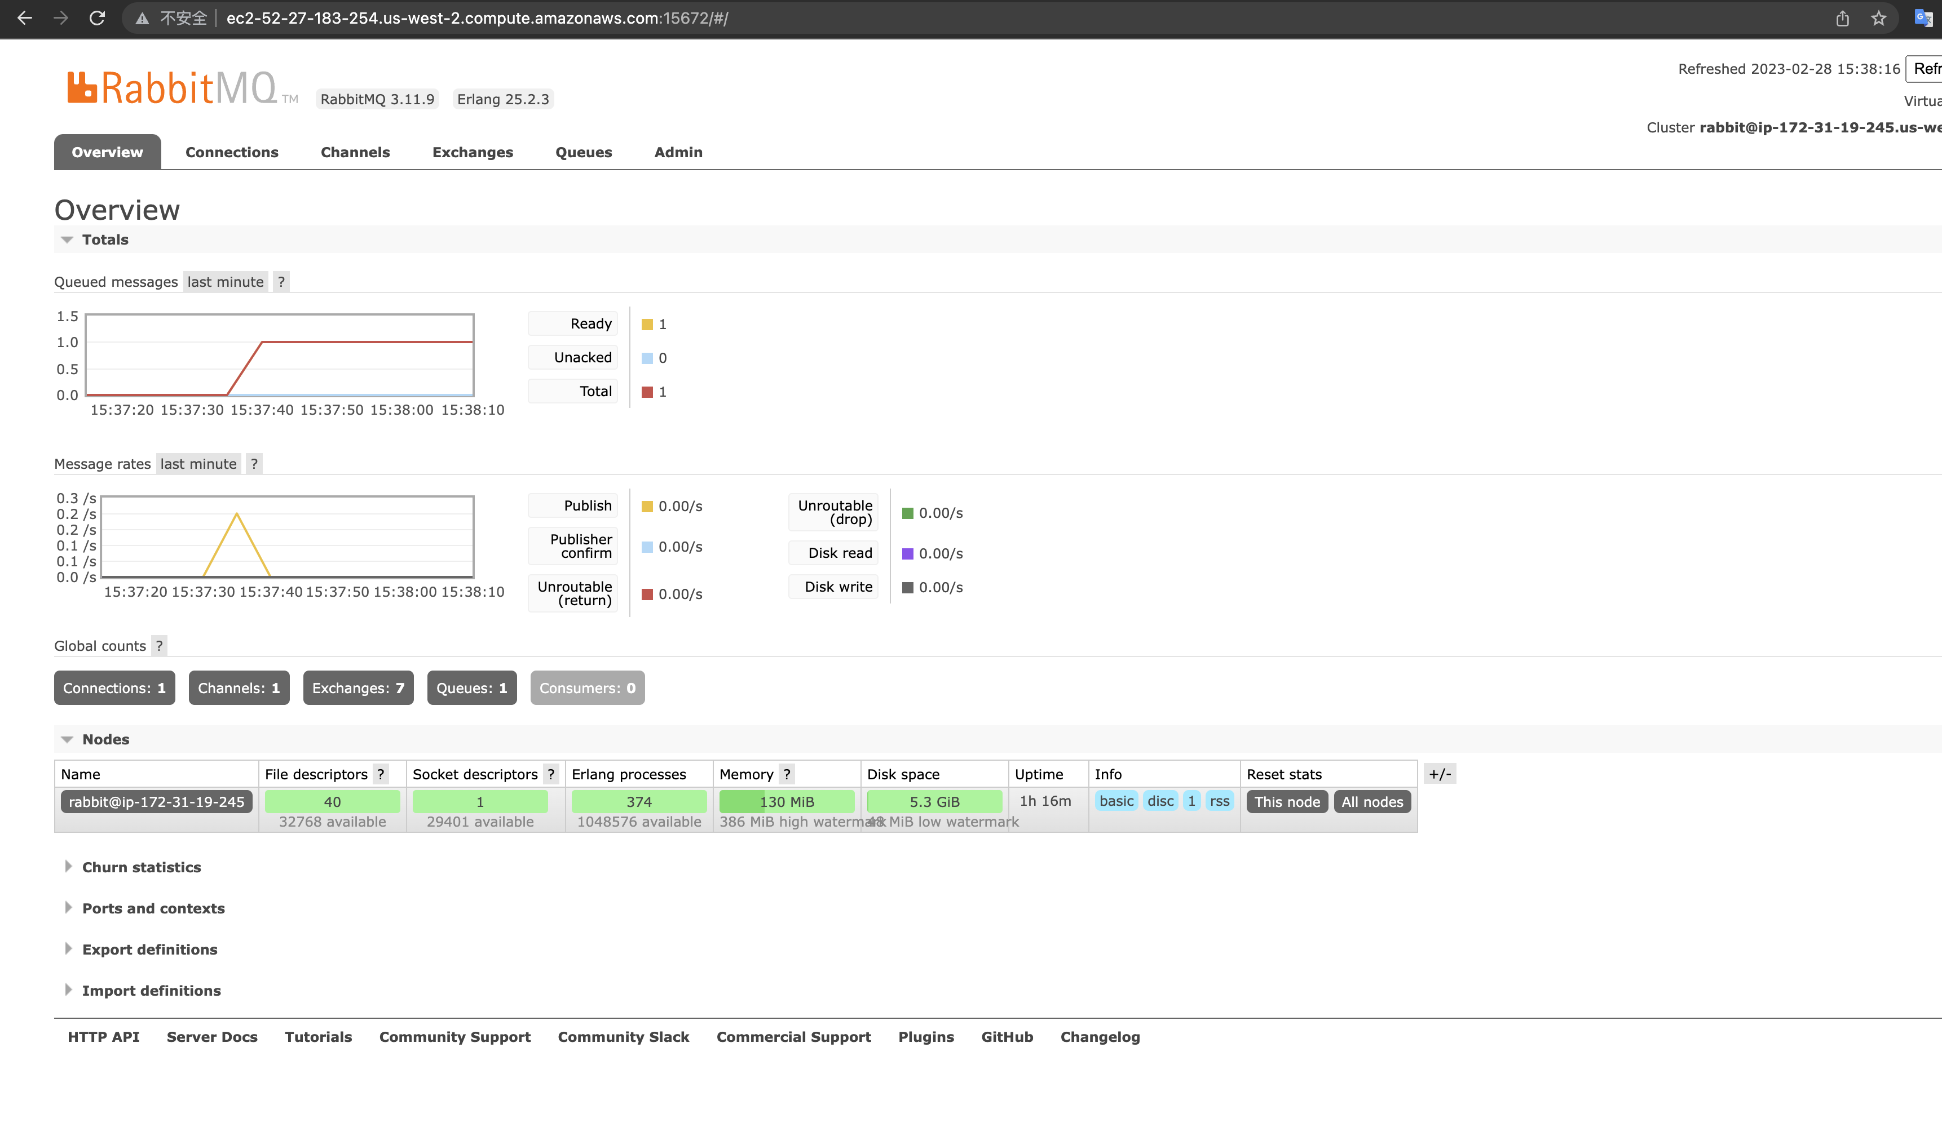

For the consumer part, if we want to consume it, after setting the IP, virtual machine, and package in into a jar file and send it to the consumer ec2

Build two consumer instances, for each of the consumer instance, put the corresponding .jar file into it.

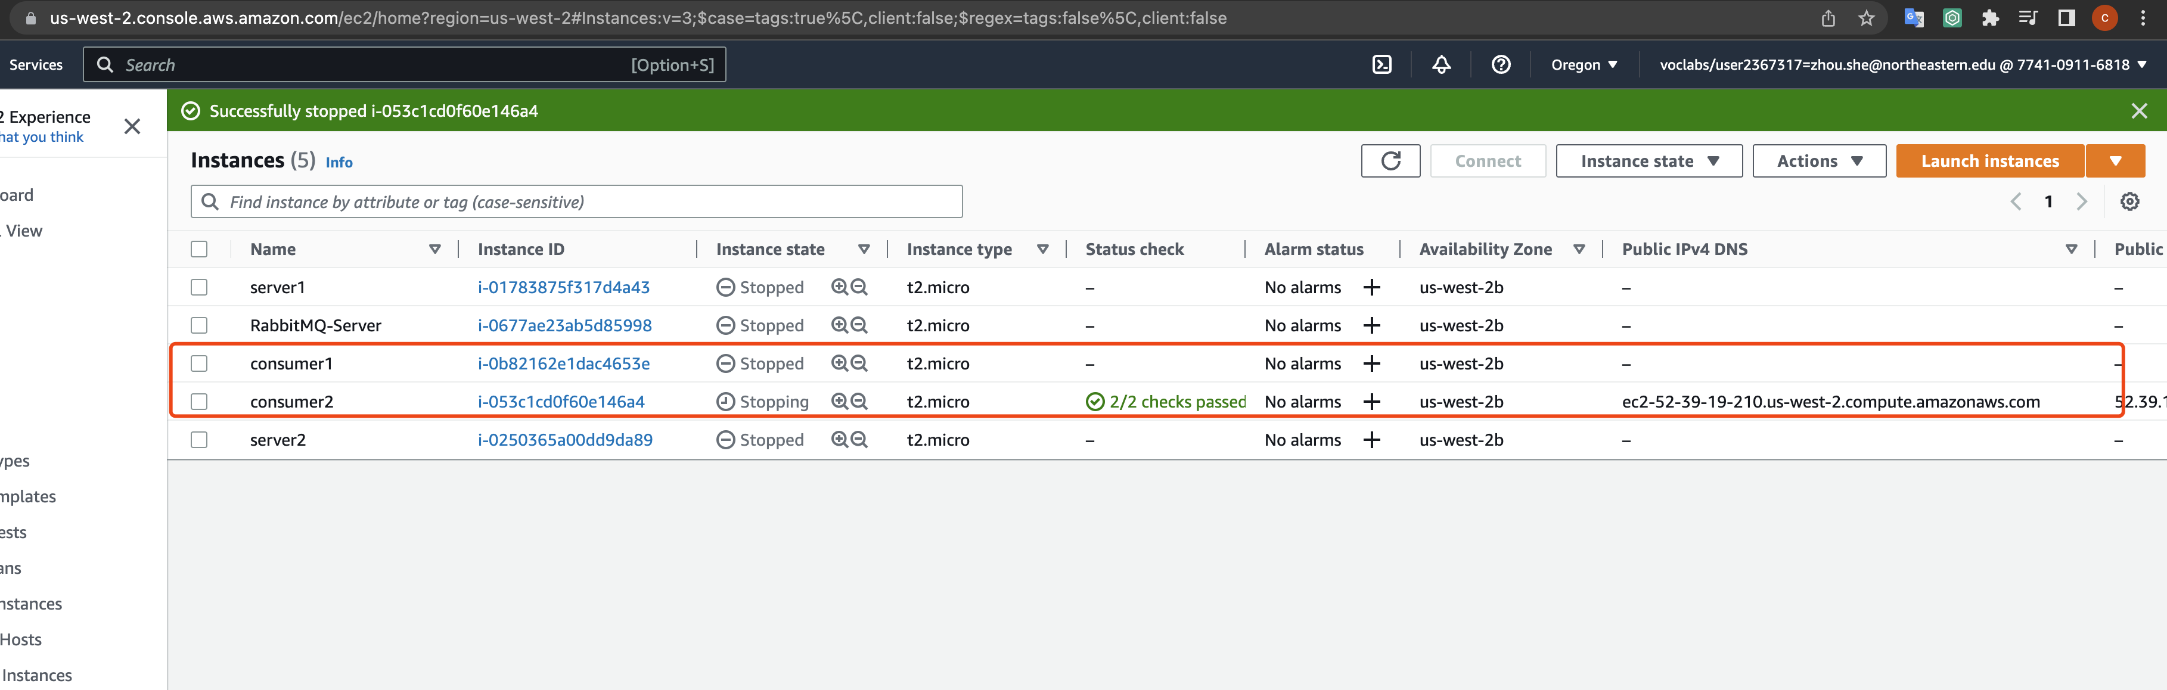

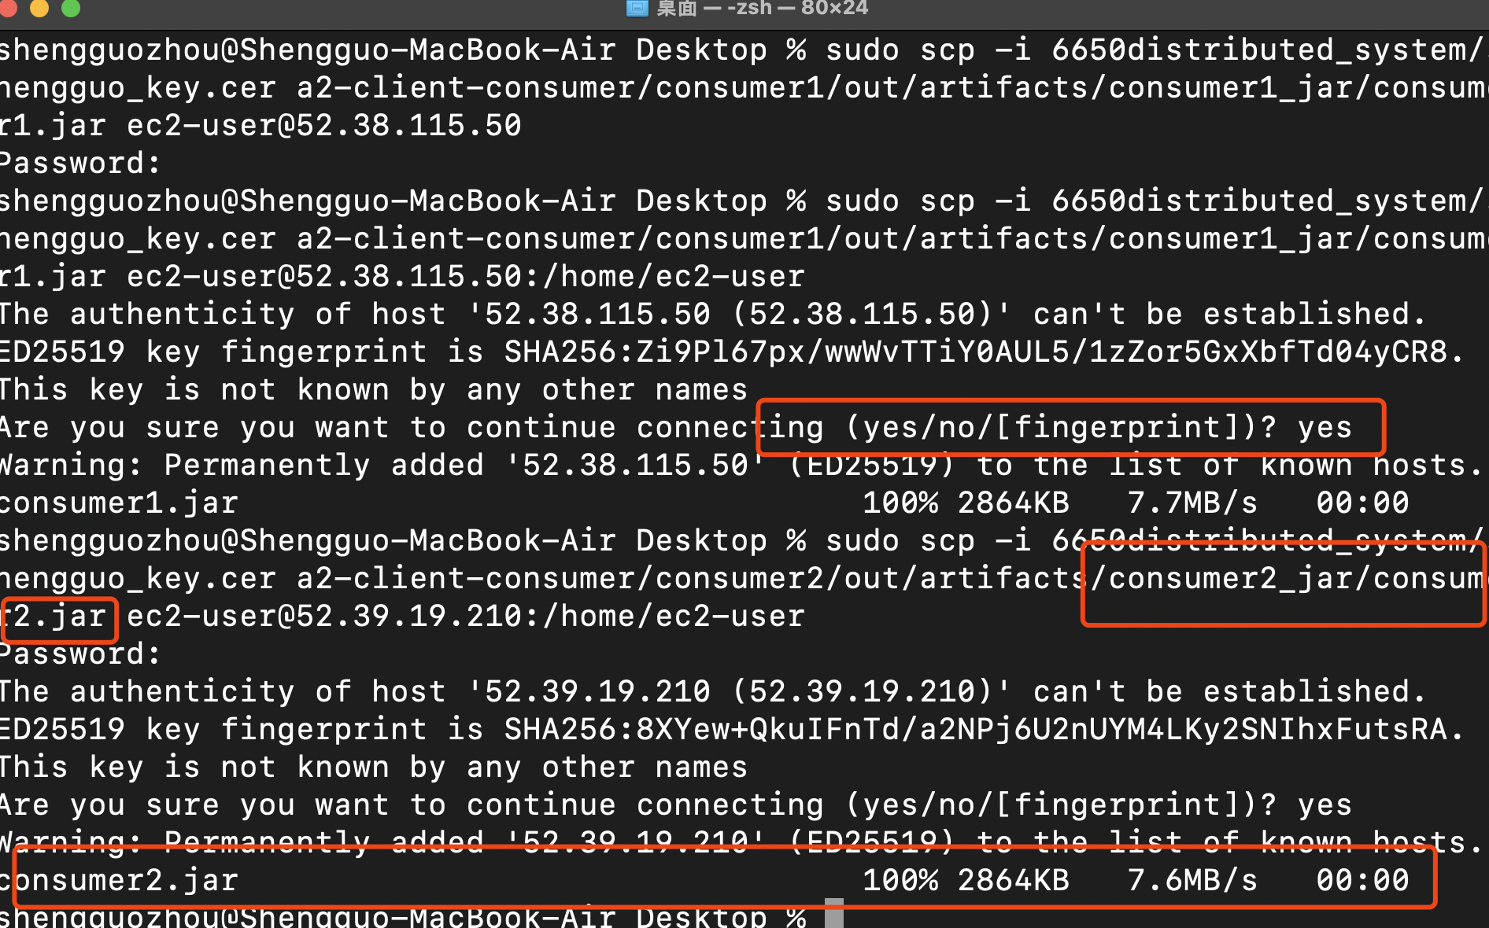

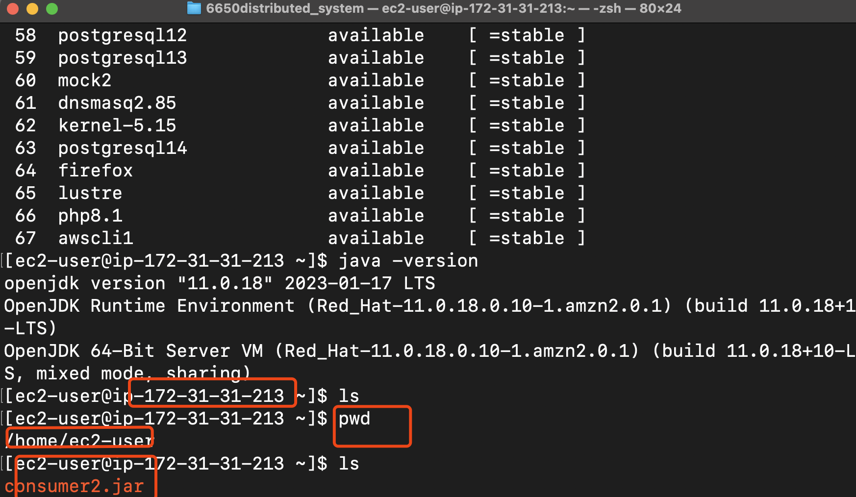

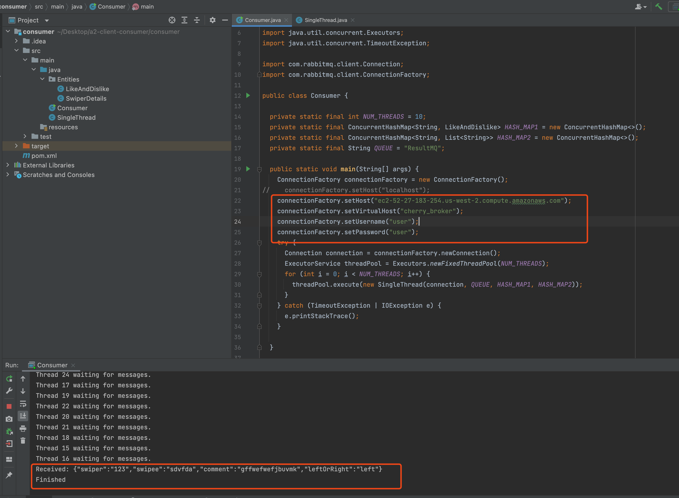

And all the data is store inside two hashmaps, and we can get the data we want from hashmap.

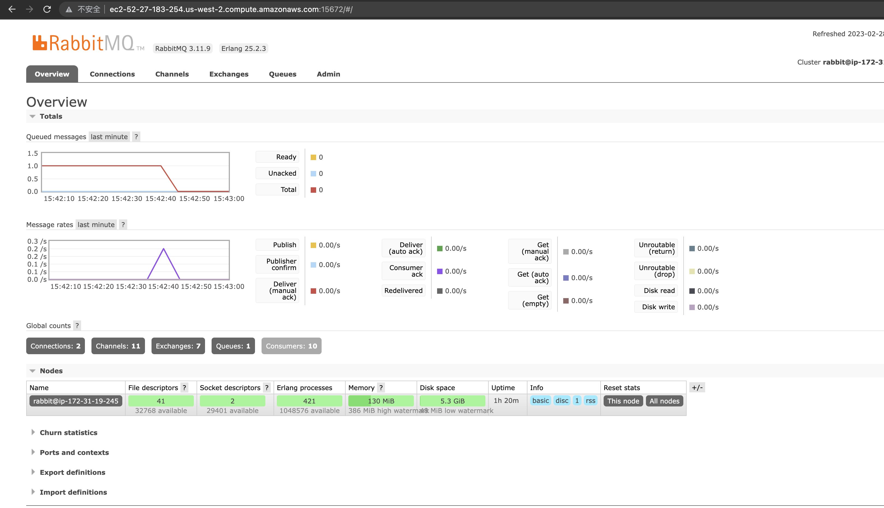

1 message works, and in a similar way I could send 500k data like assignment1 to AWS EC2

If 500k messages are sent in 50threads to AWS EC2:

send/receive rates: 2.3k messages/s

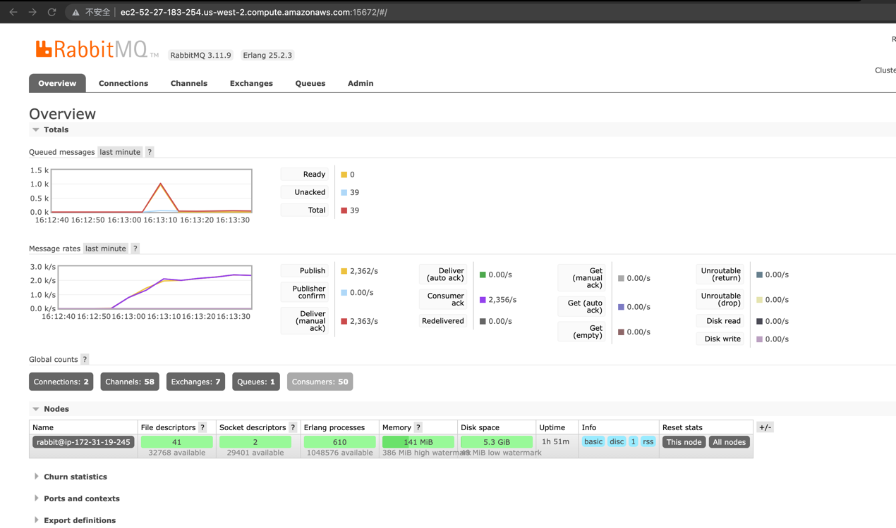

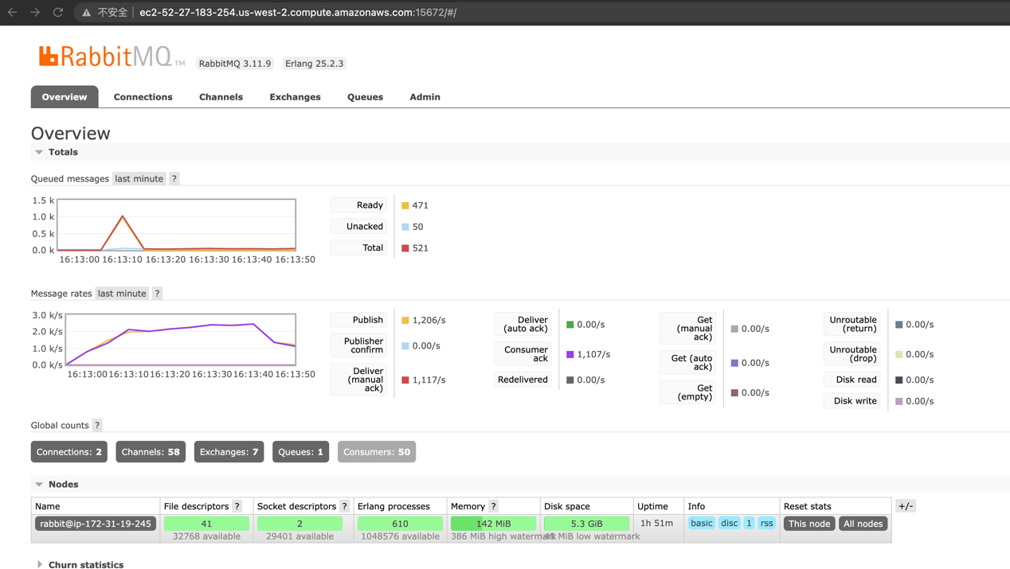

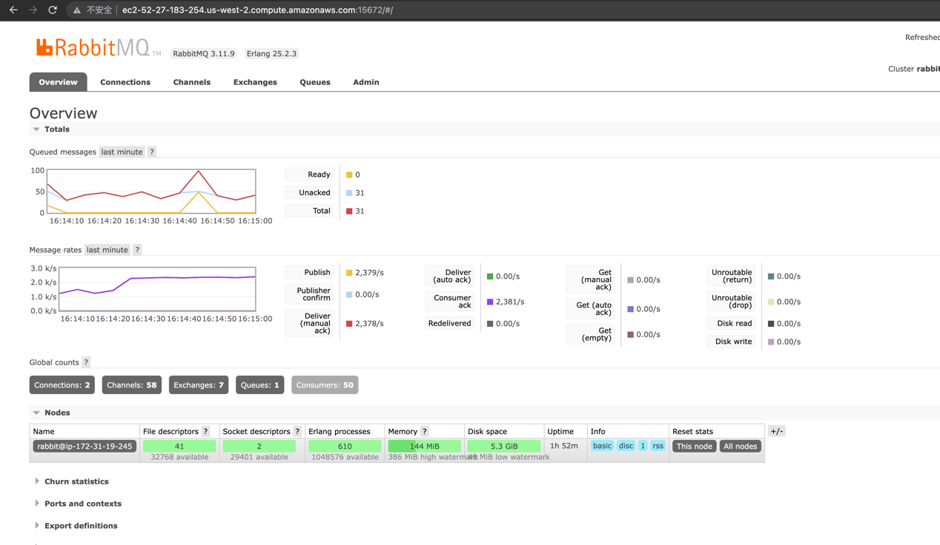

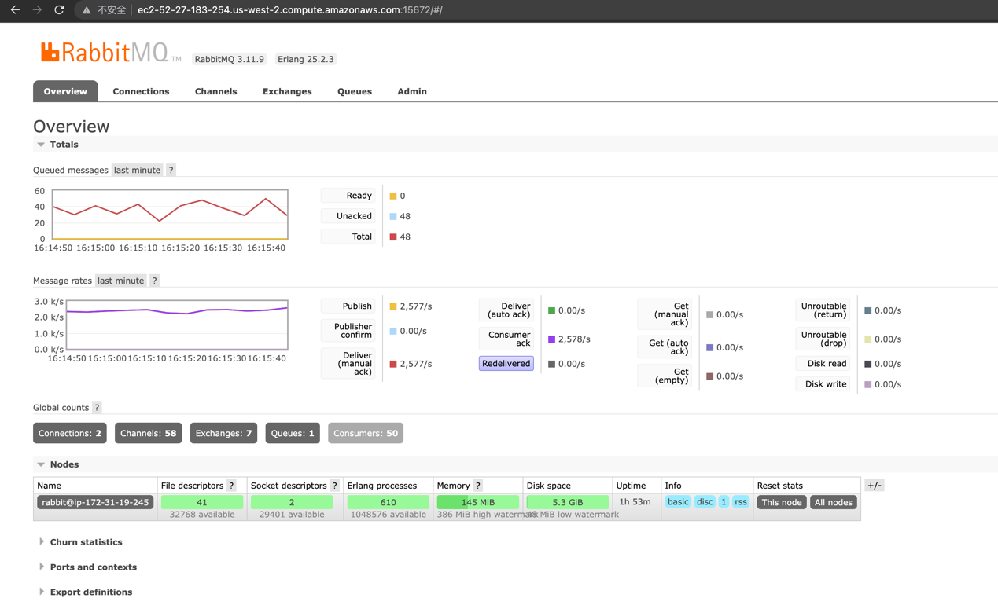

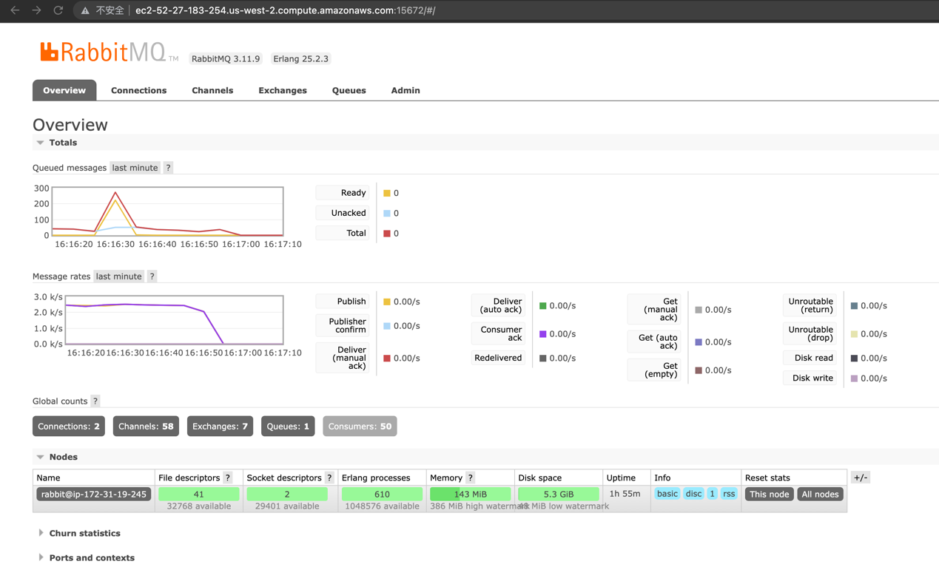

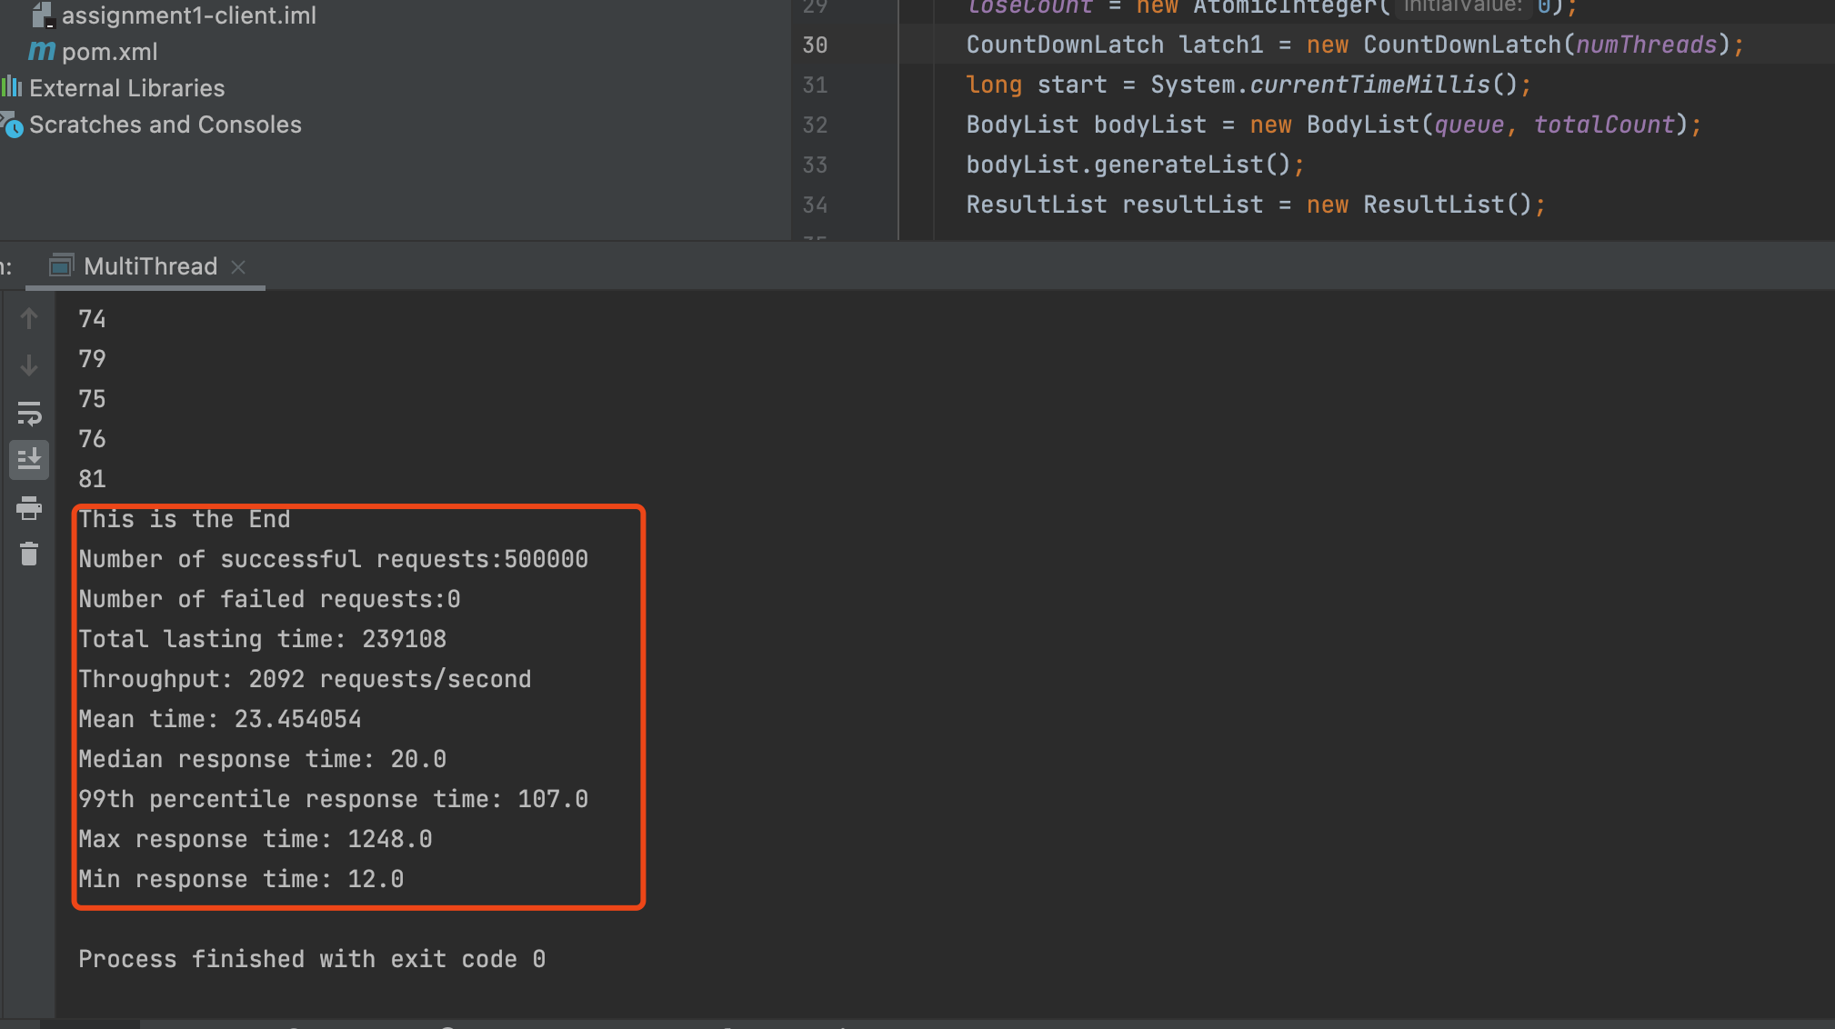

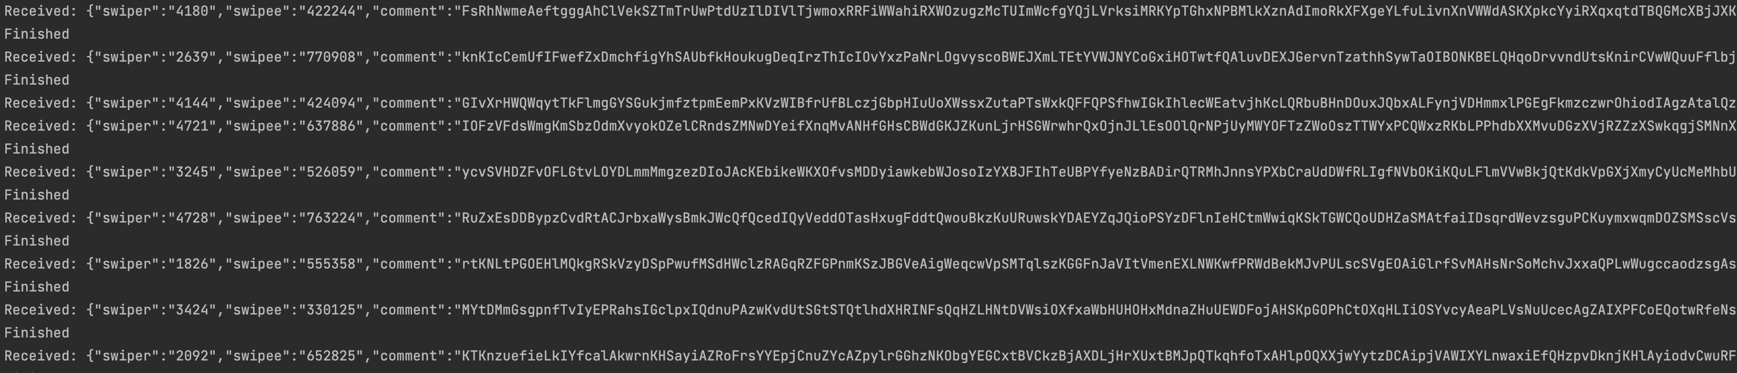

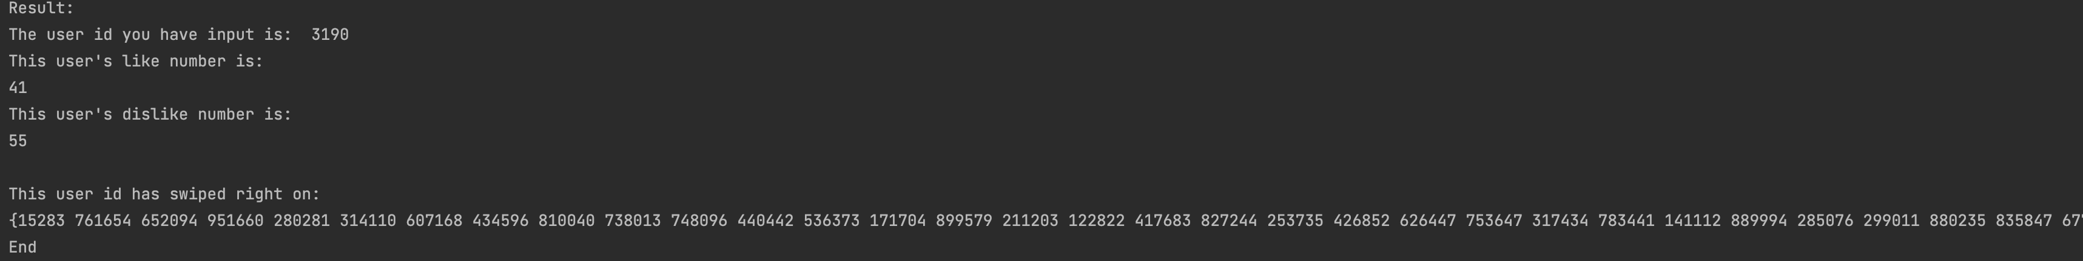

Sending 500k messages data in 100threads:

send/receive rates 3.05k messages/s

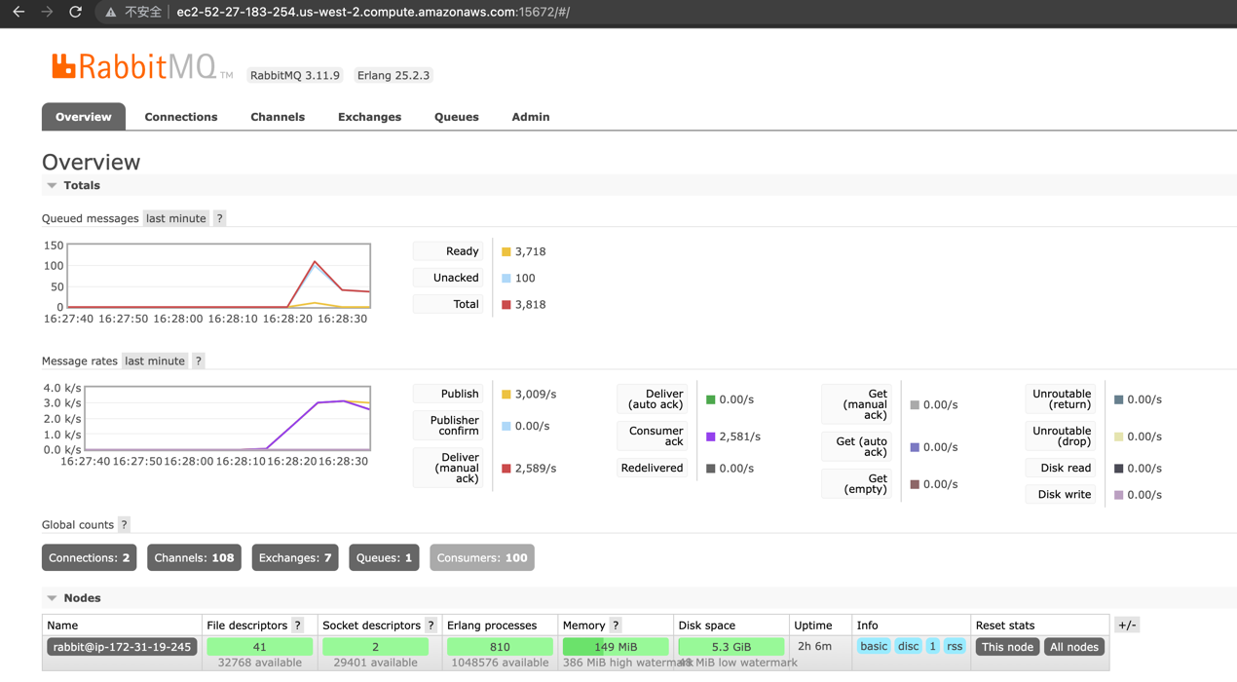

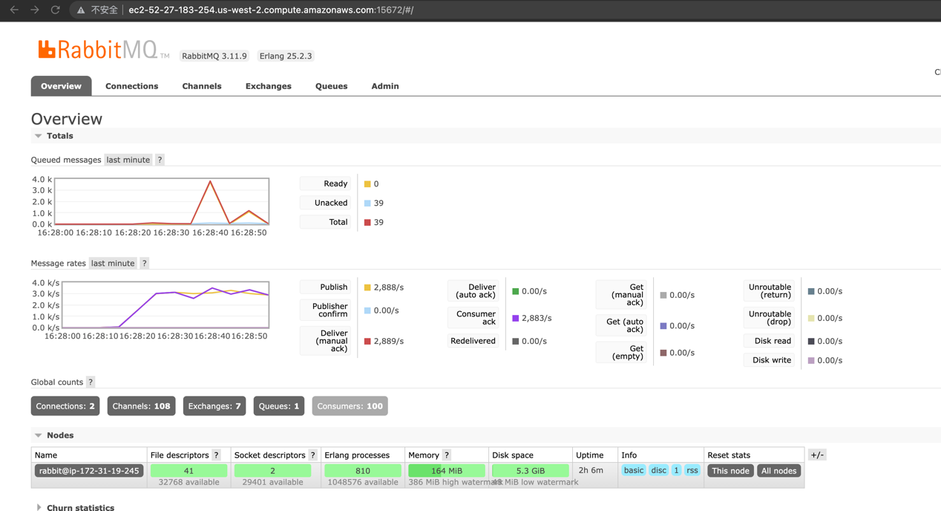

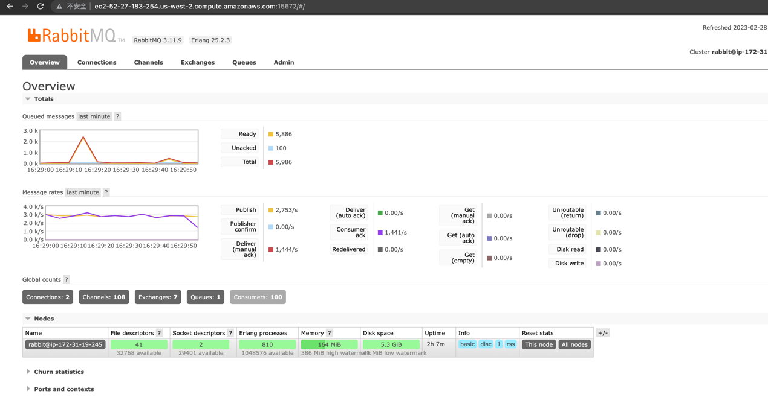

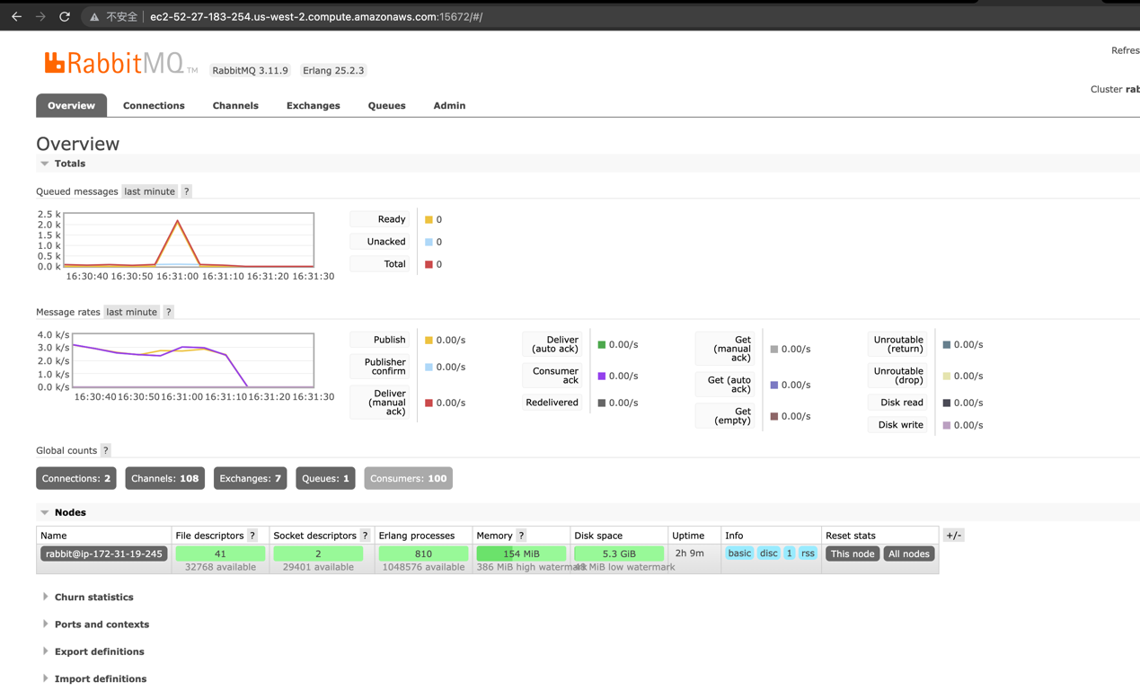

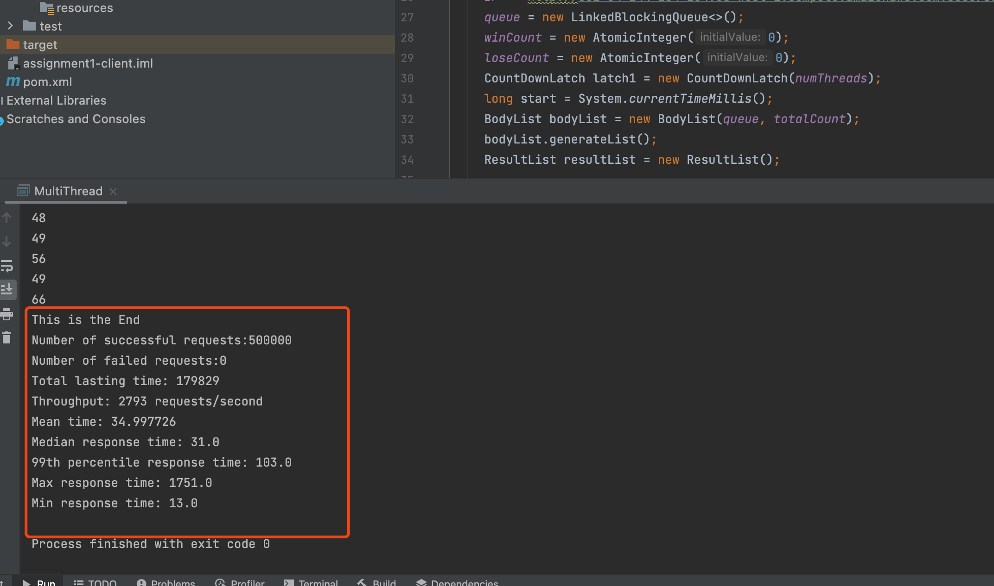

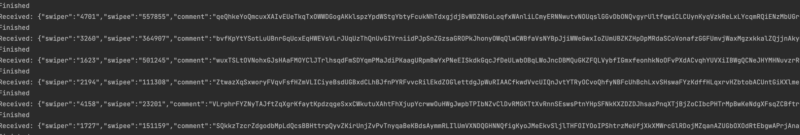

Sending 500k messages data in 200threads:

send/receive rates: 2.8k messages/s

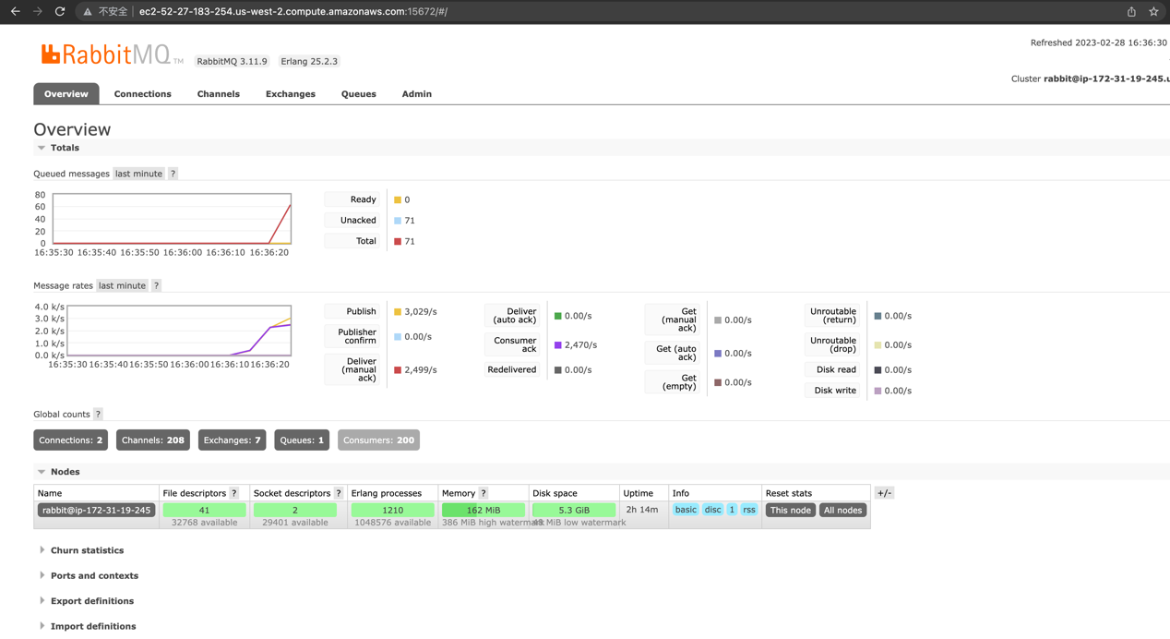

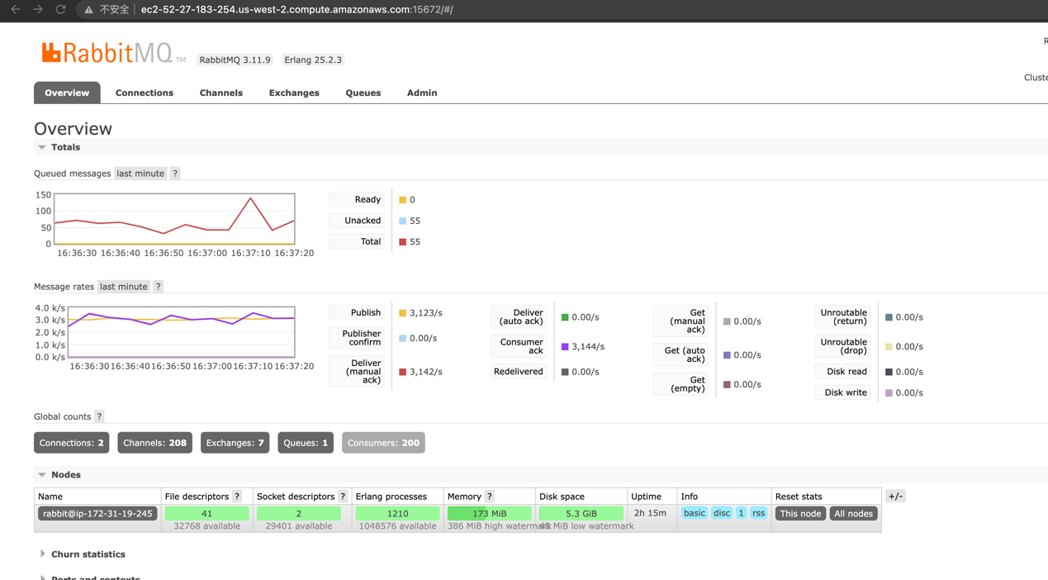

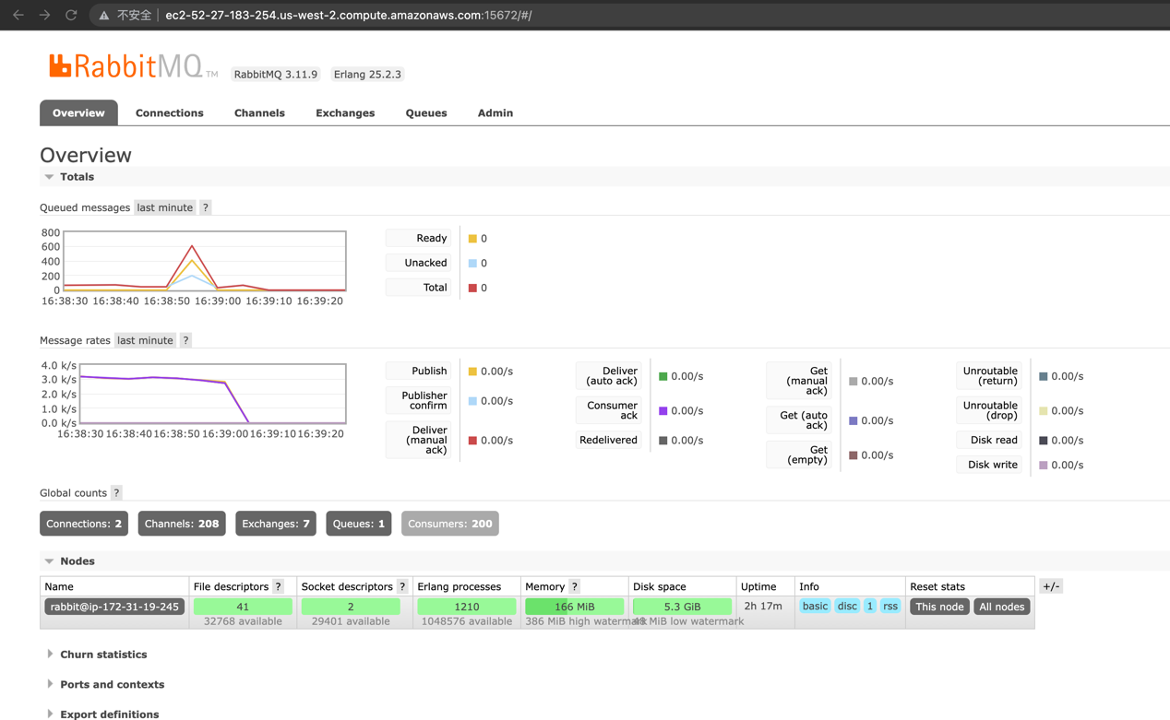

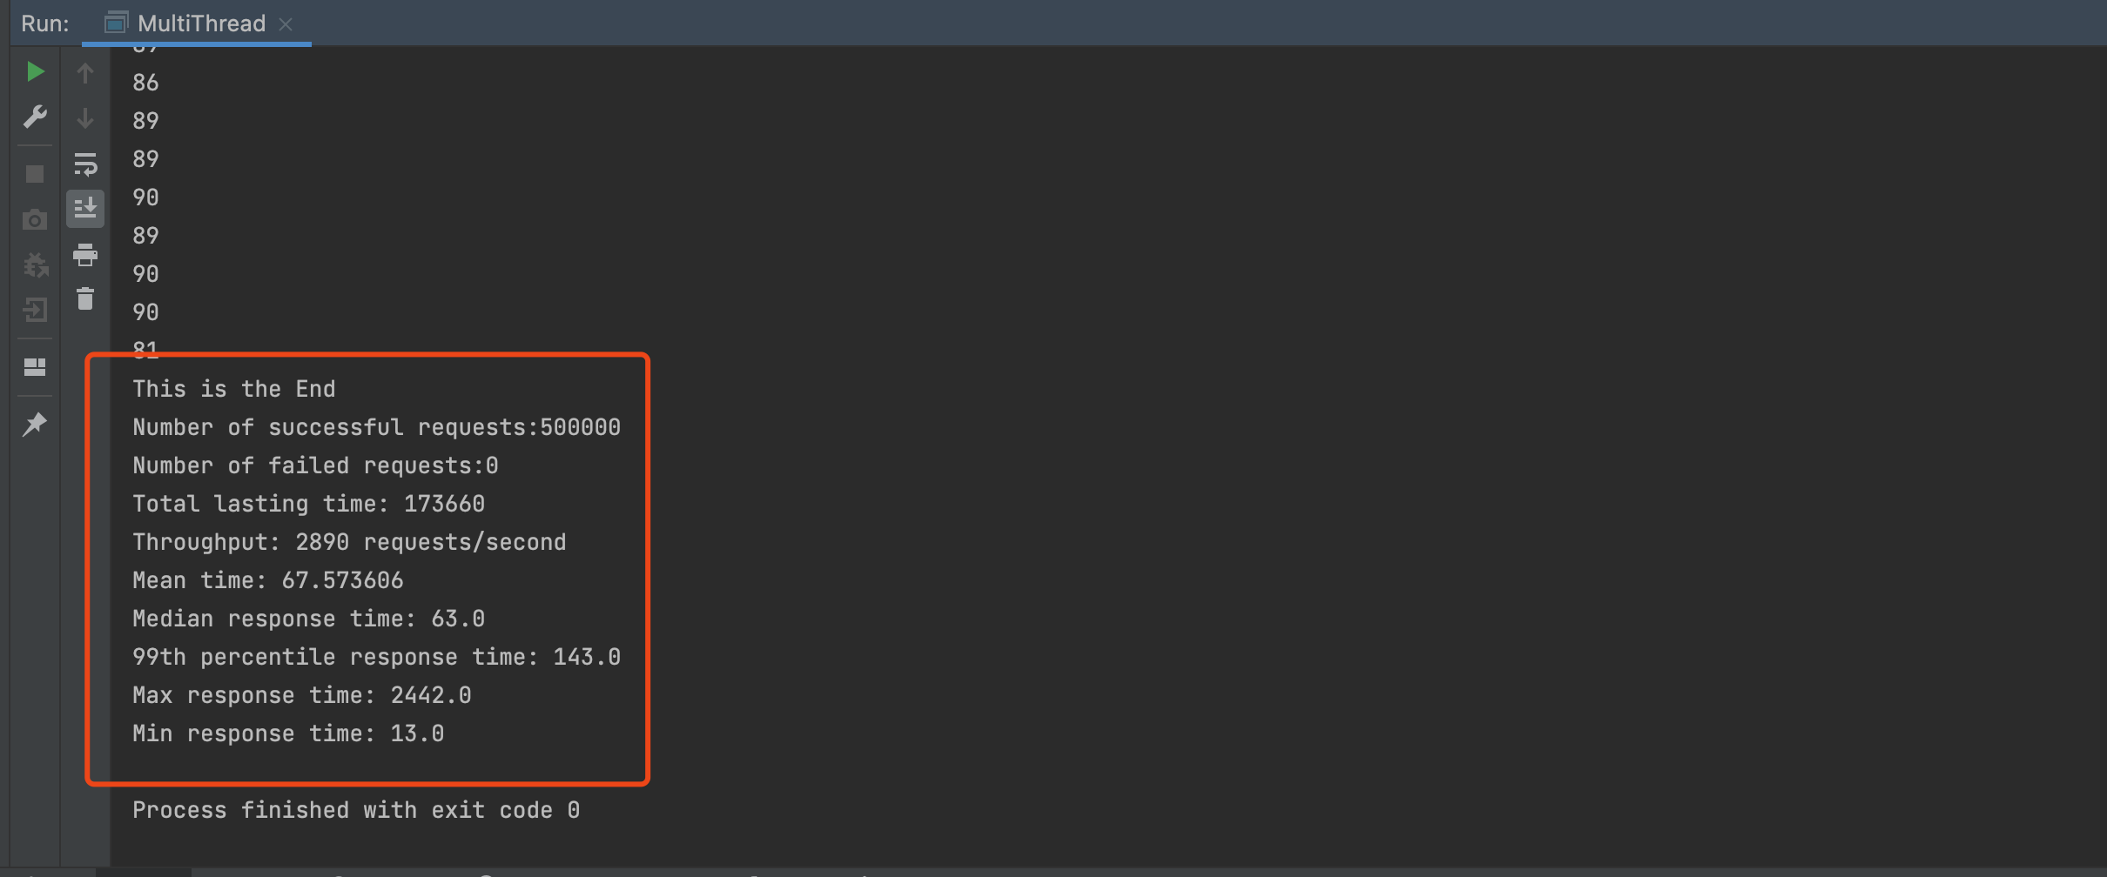

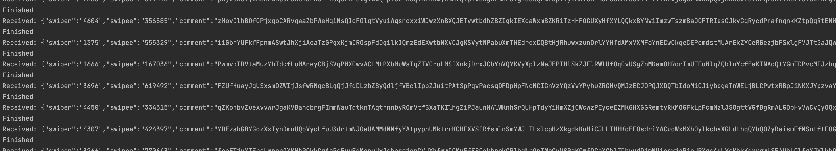

Get result:

The one with 100 threads has the best performance.

Load balancer:

In the following part, I would show the create and the use of a load balancer.

First both two servers can pass the messages to RabbitMQ.

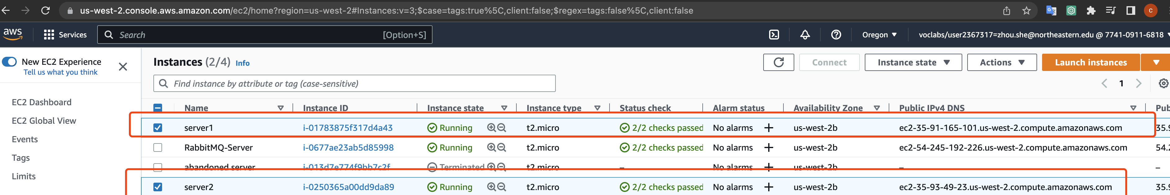

Create a load balancer:

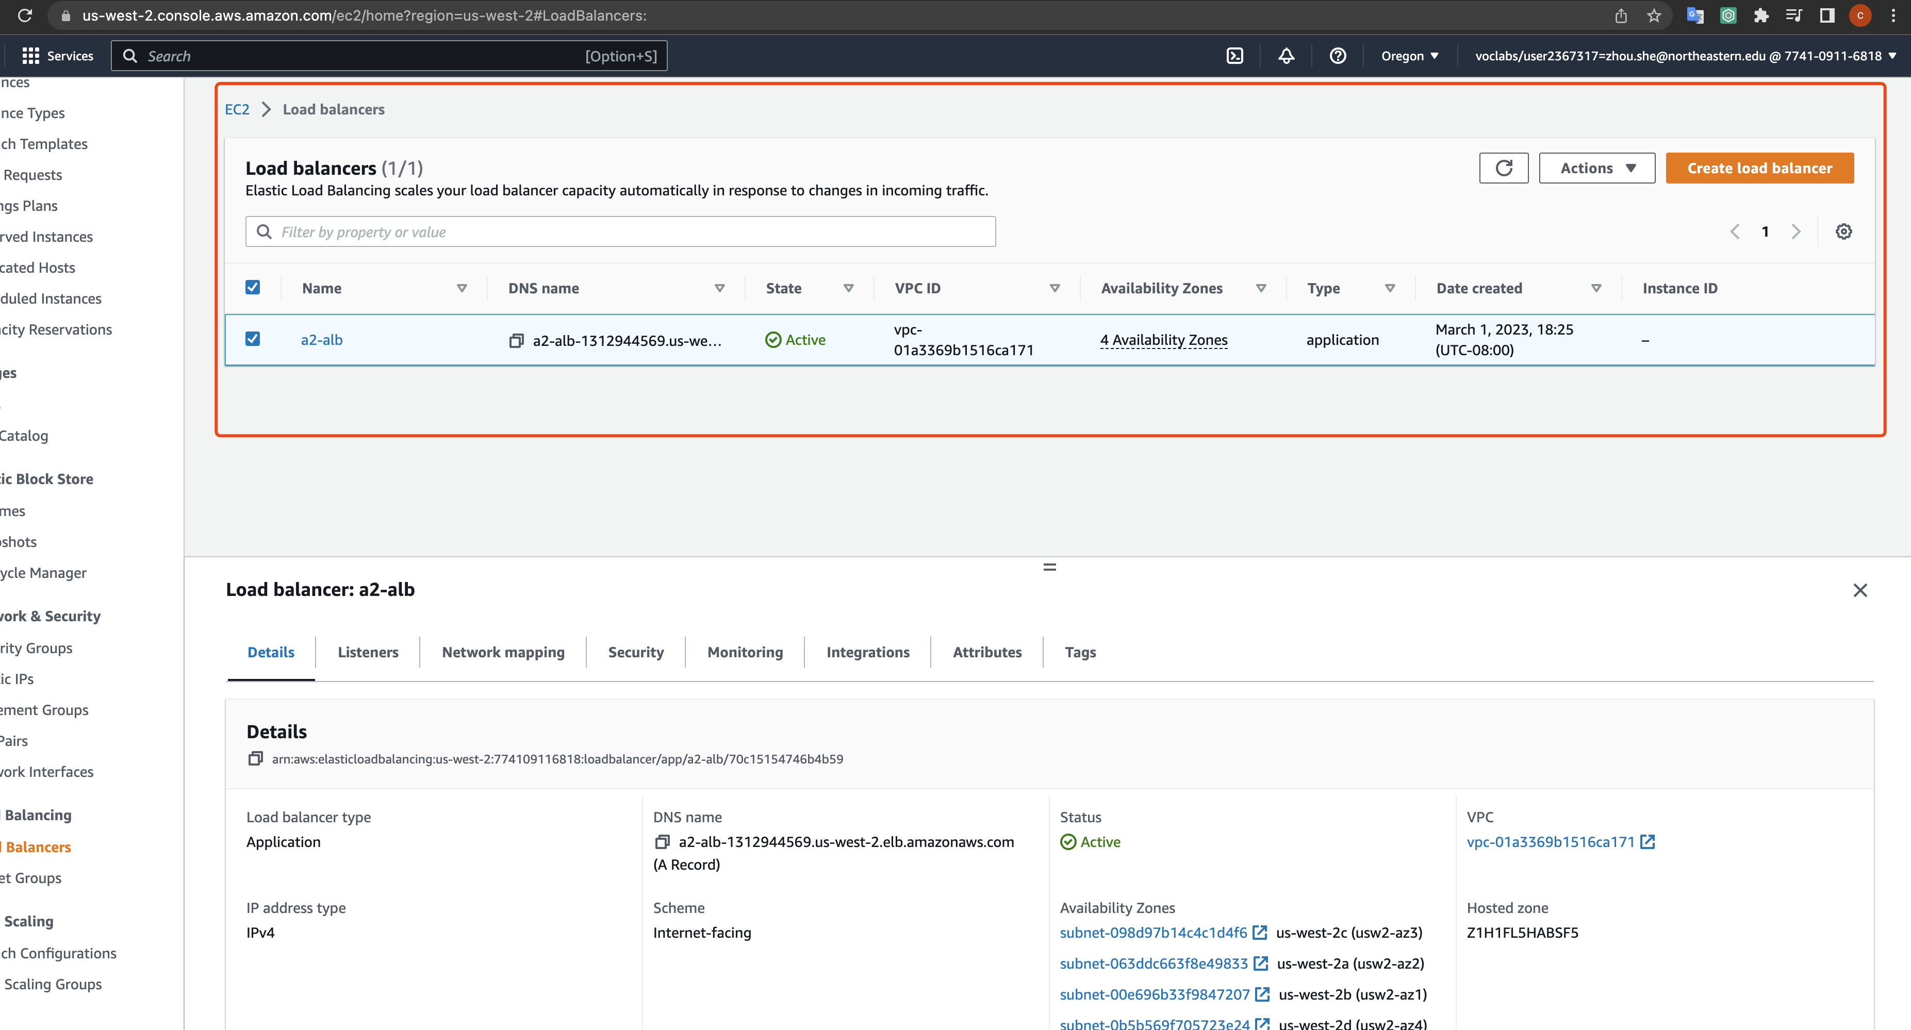

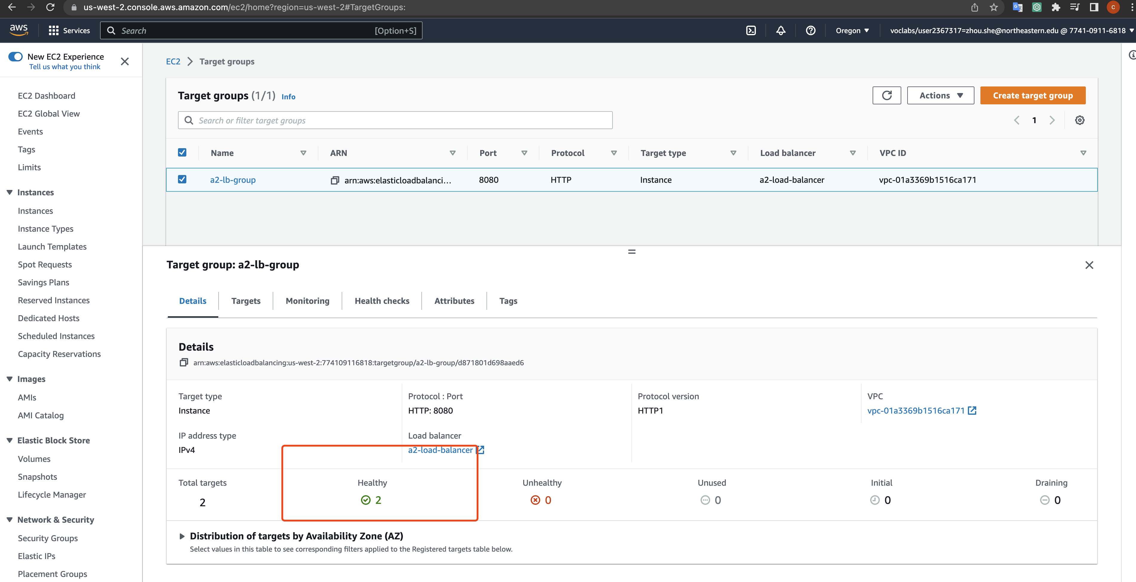

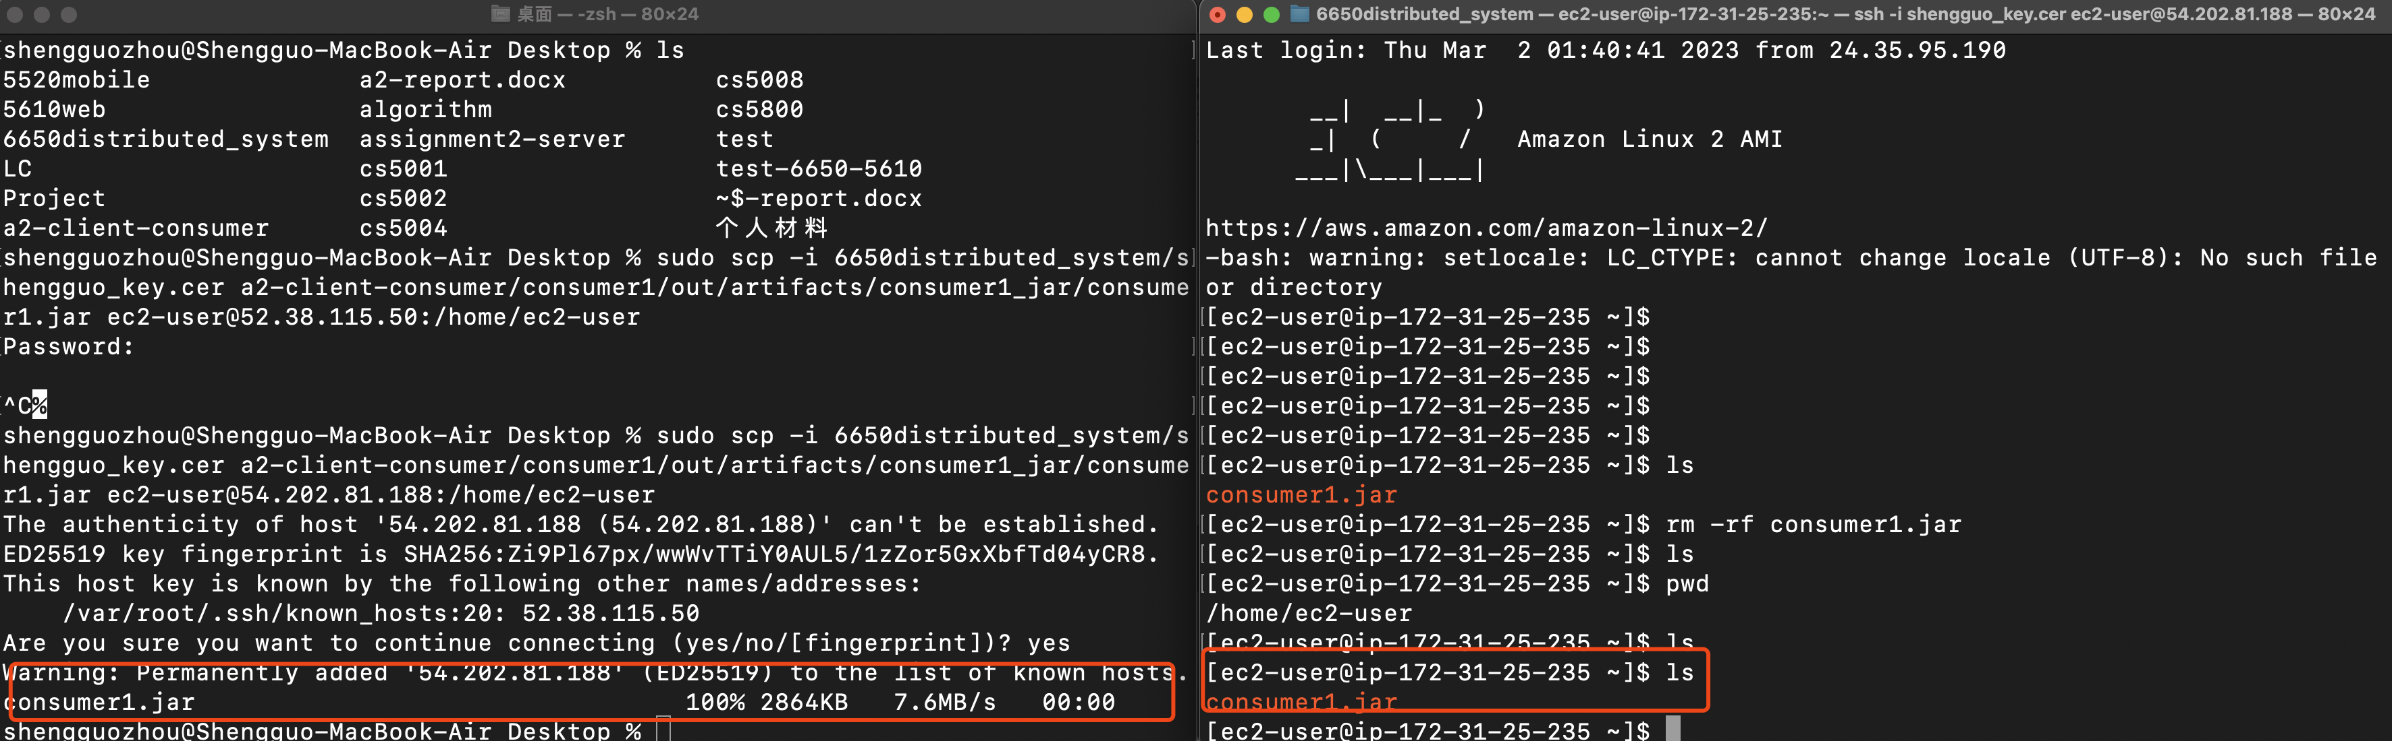

Consumer 1 is working on AWS EC2:

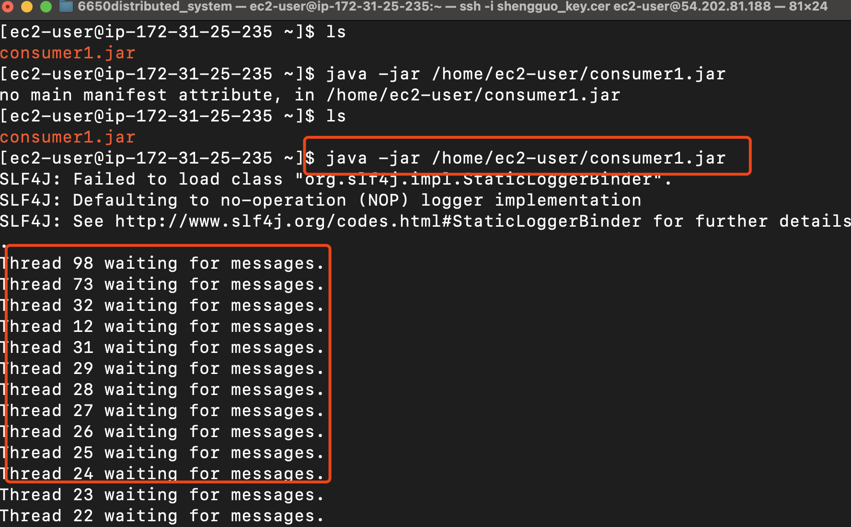

Consumer2’s .jar file is sent into the ec2 instance:

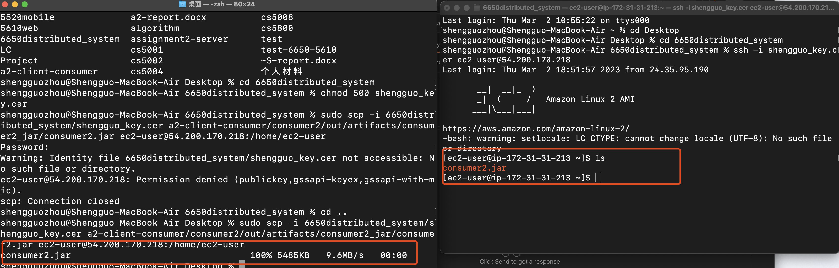

Postman works well

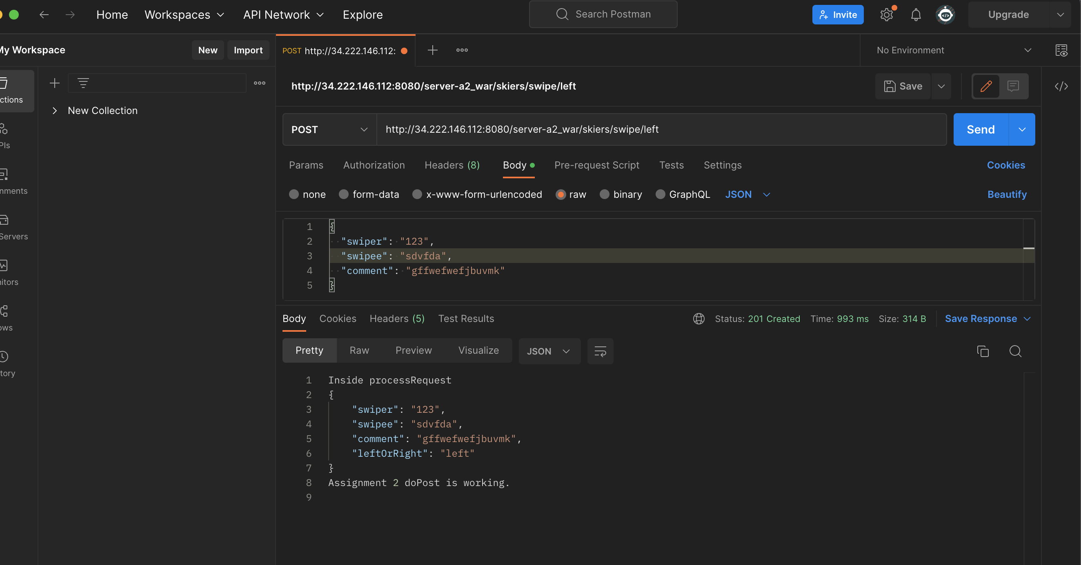

Pass .war file into another server

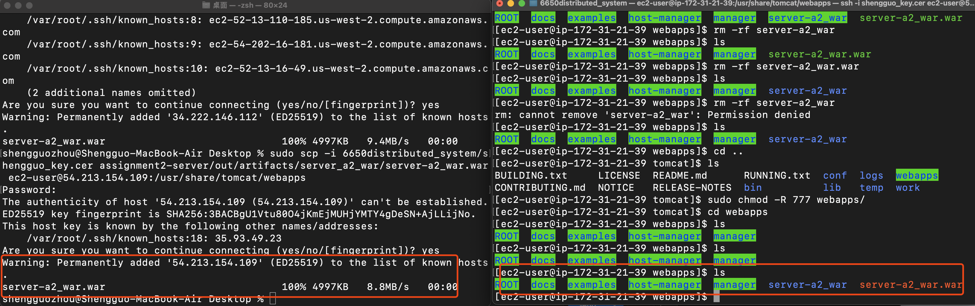

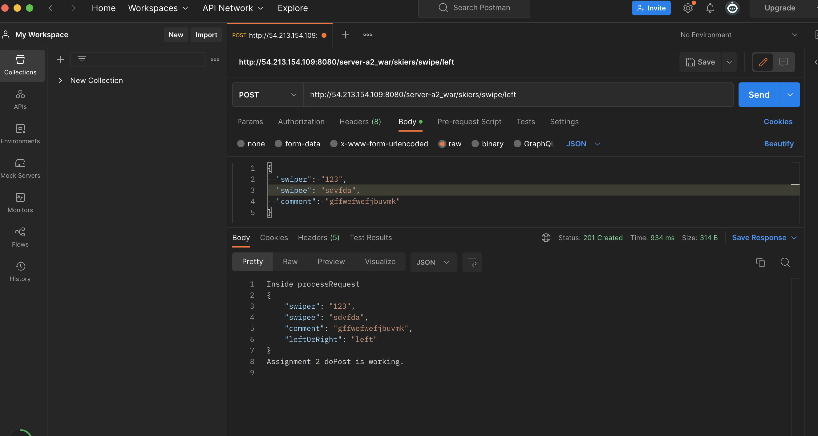

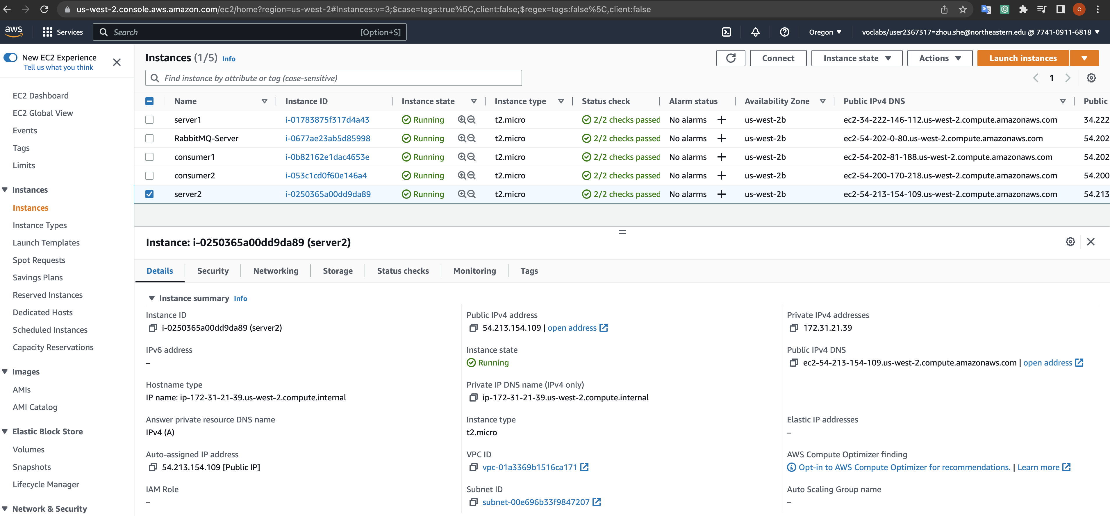

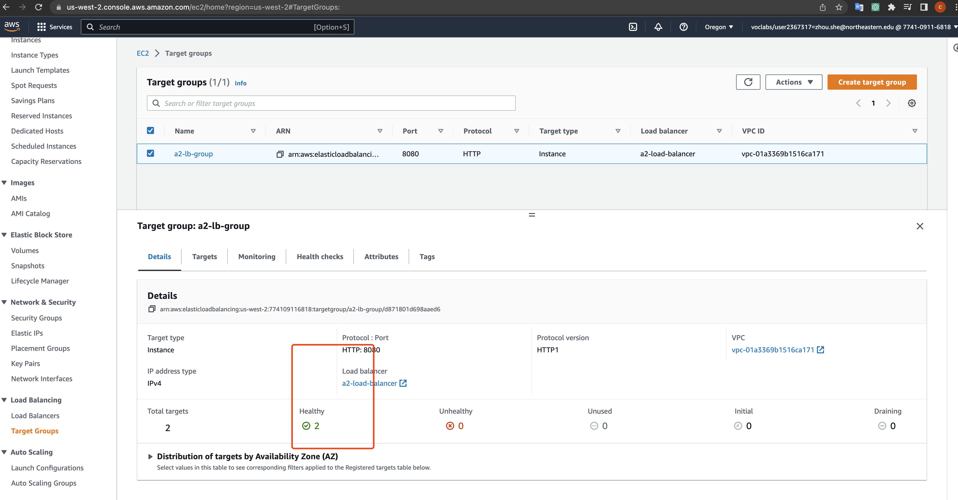

Before using the load balancer:

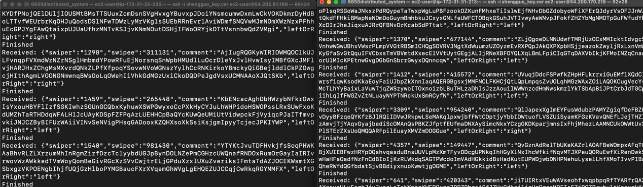

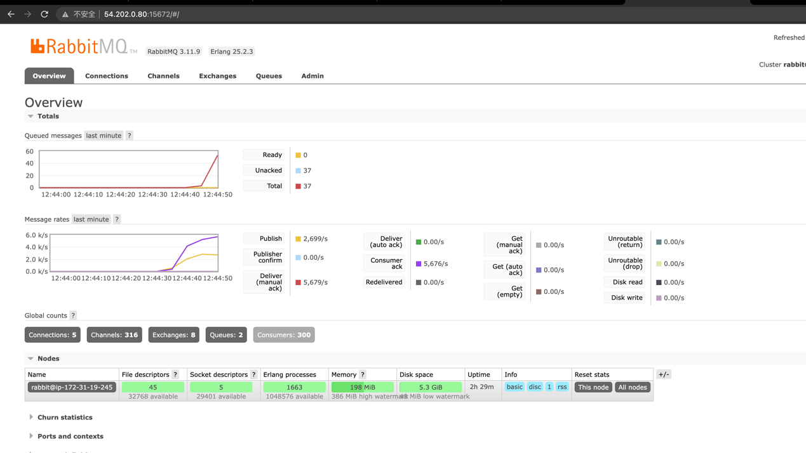

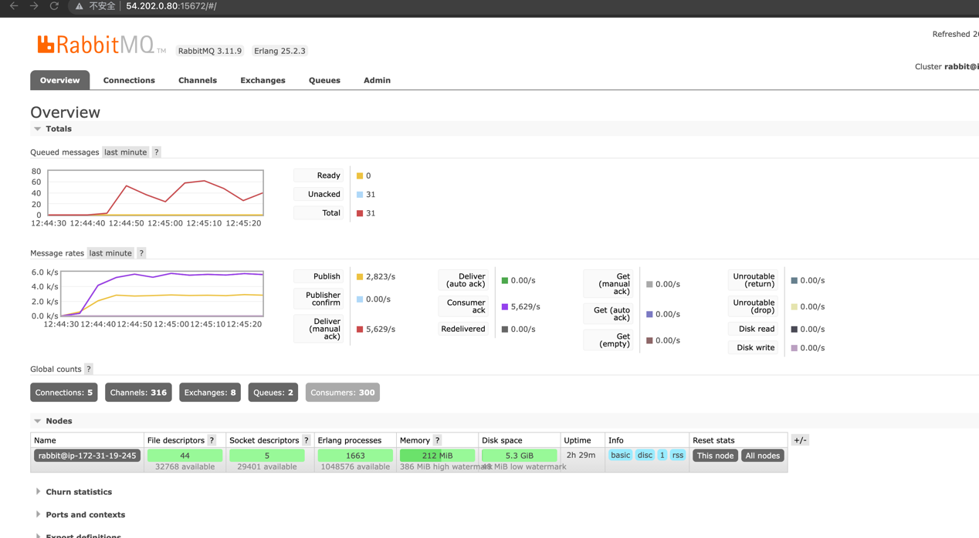

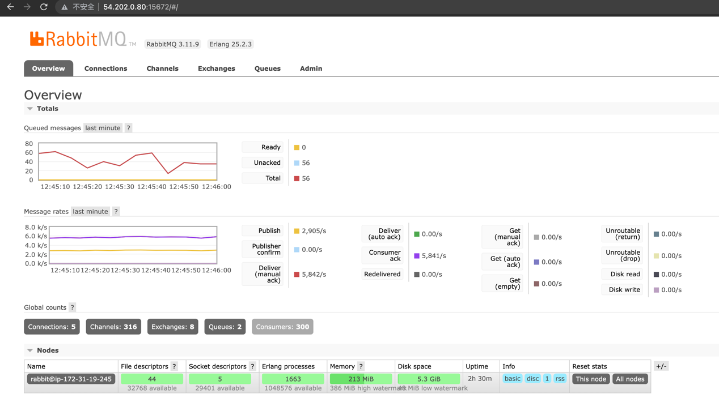

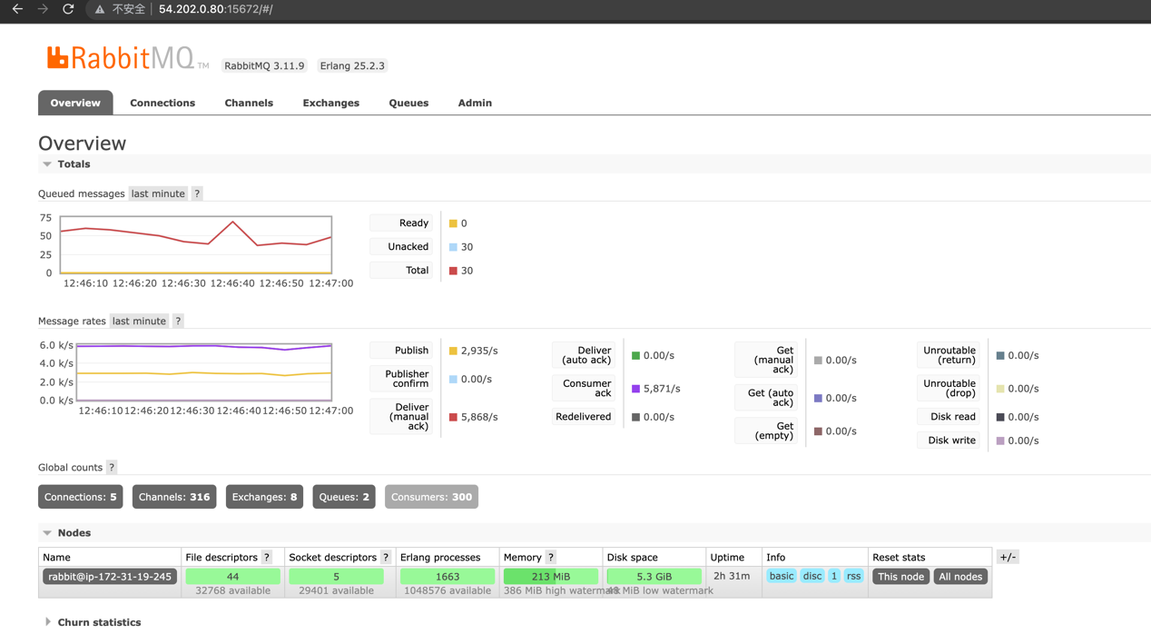

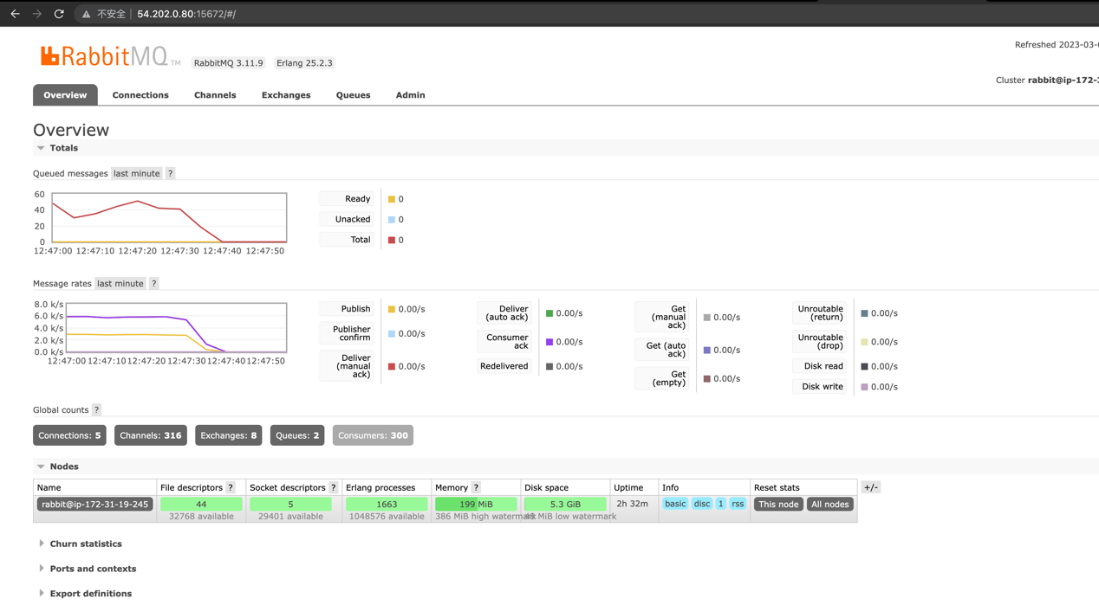

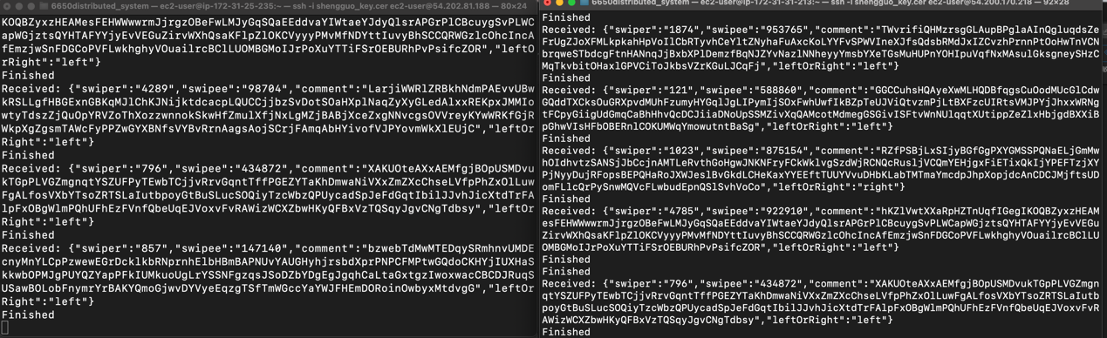

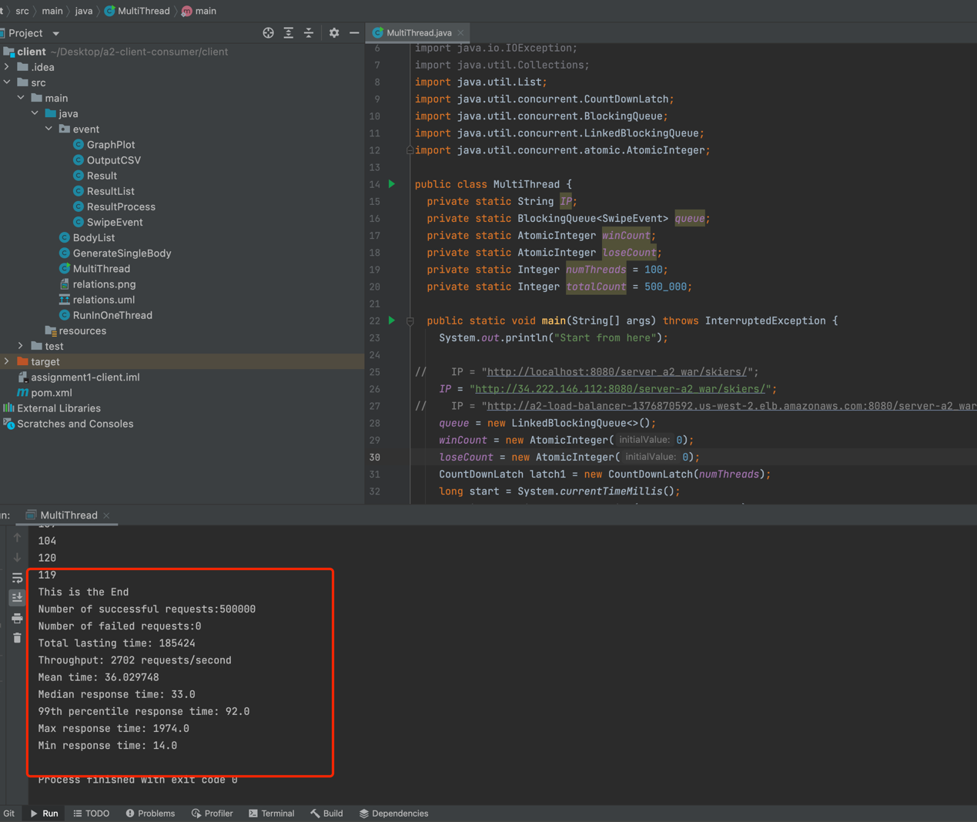

The speed of sending data is around 6k messages/s

2nd time test:

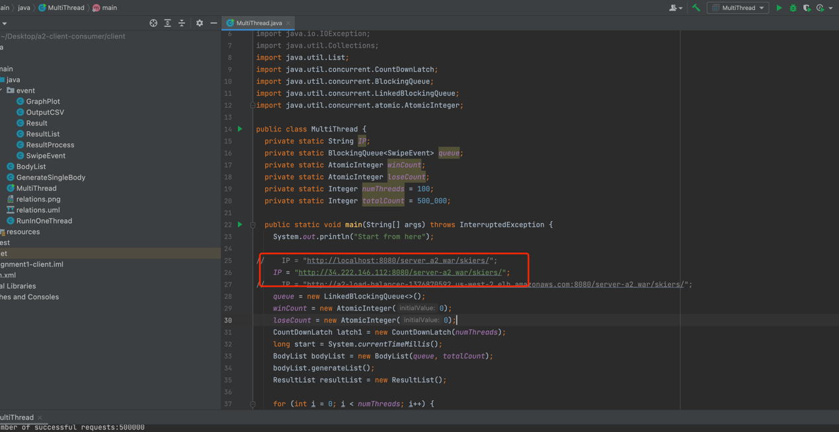

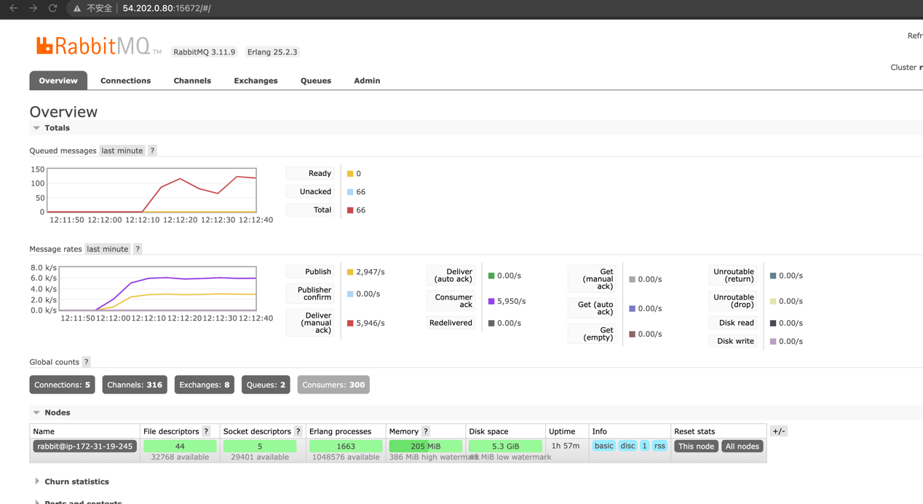

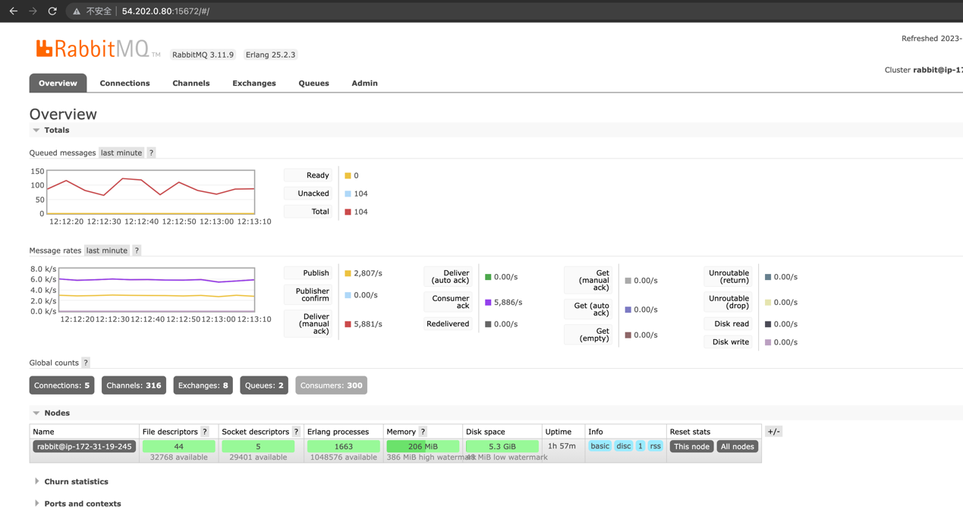

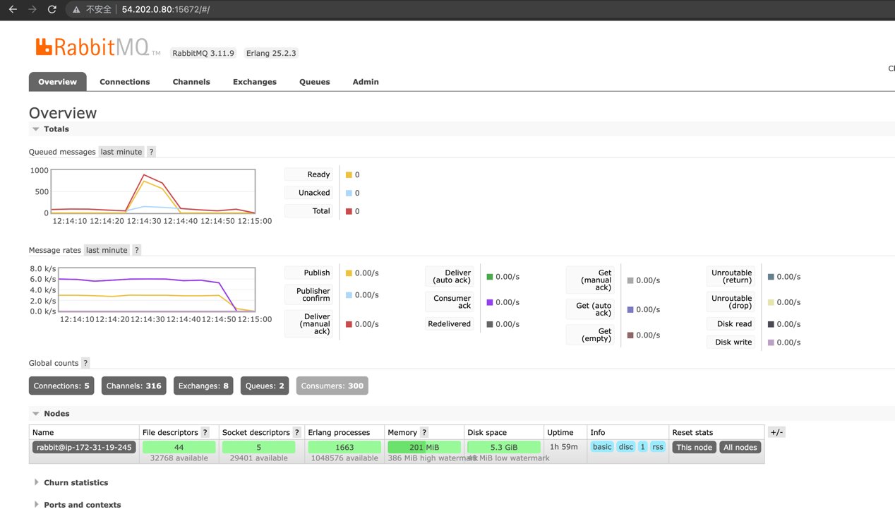

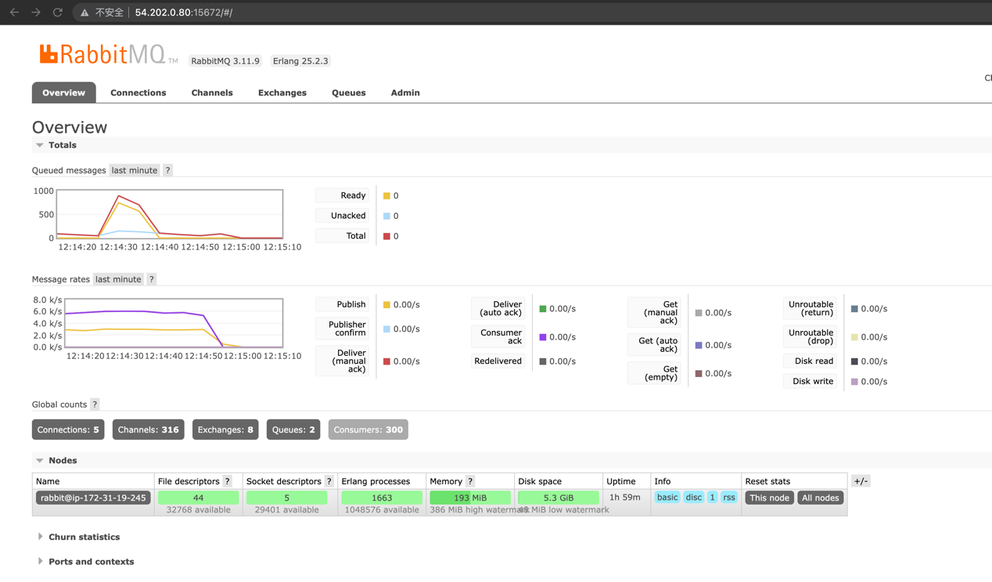

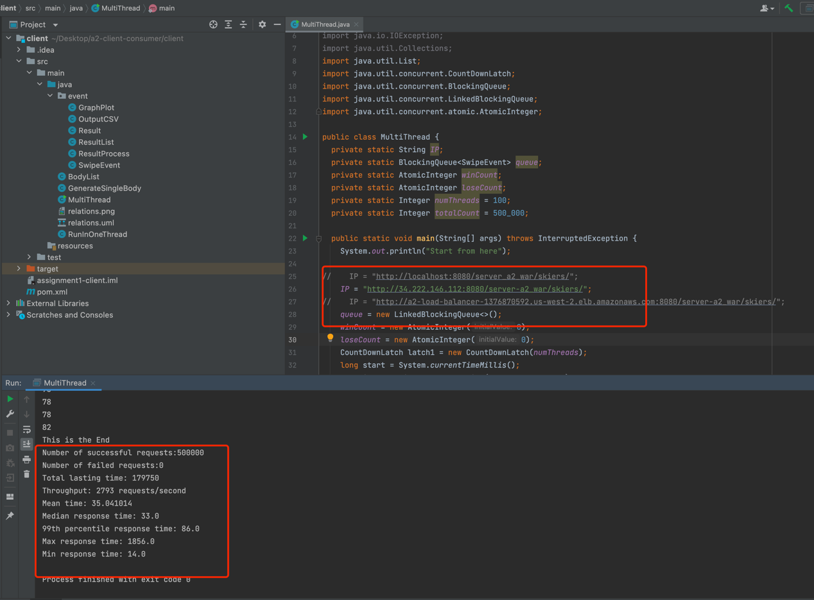

Still the same, the speed of sending messages is around 6k messgaes /s ,

and the number of messages inside the RabbitMQ is rather in a stable performance.

After using the load balancer:

Set client’s sending messages’ IP address to load balancer’s DNS IP address

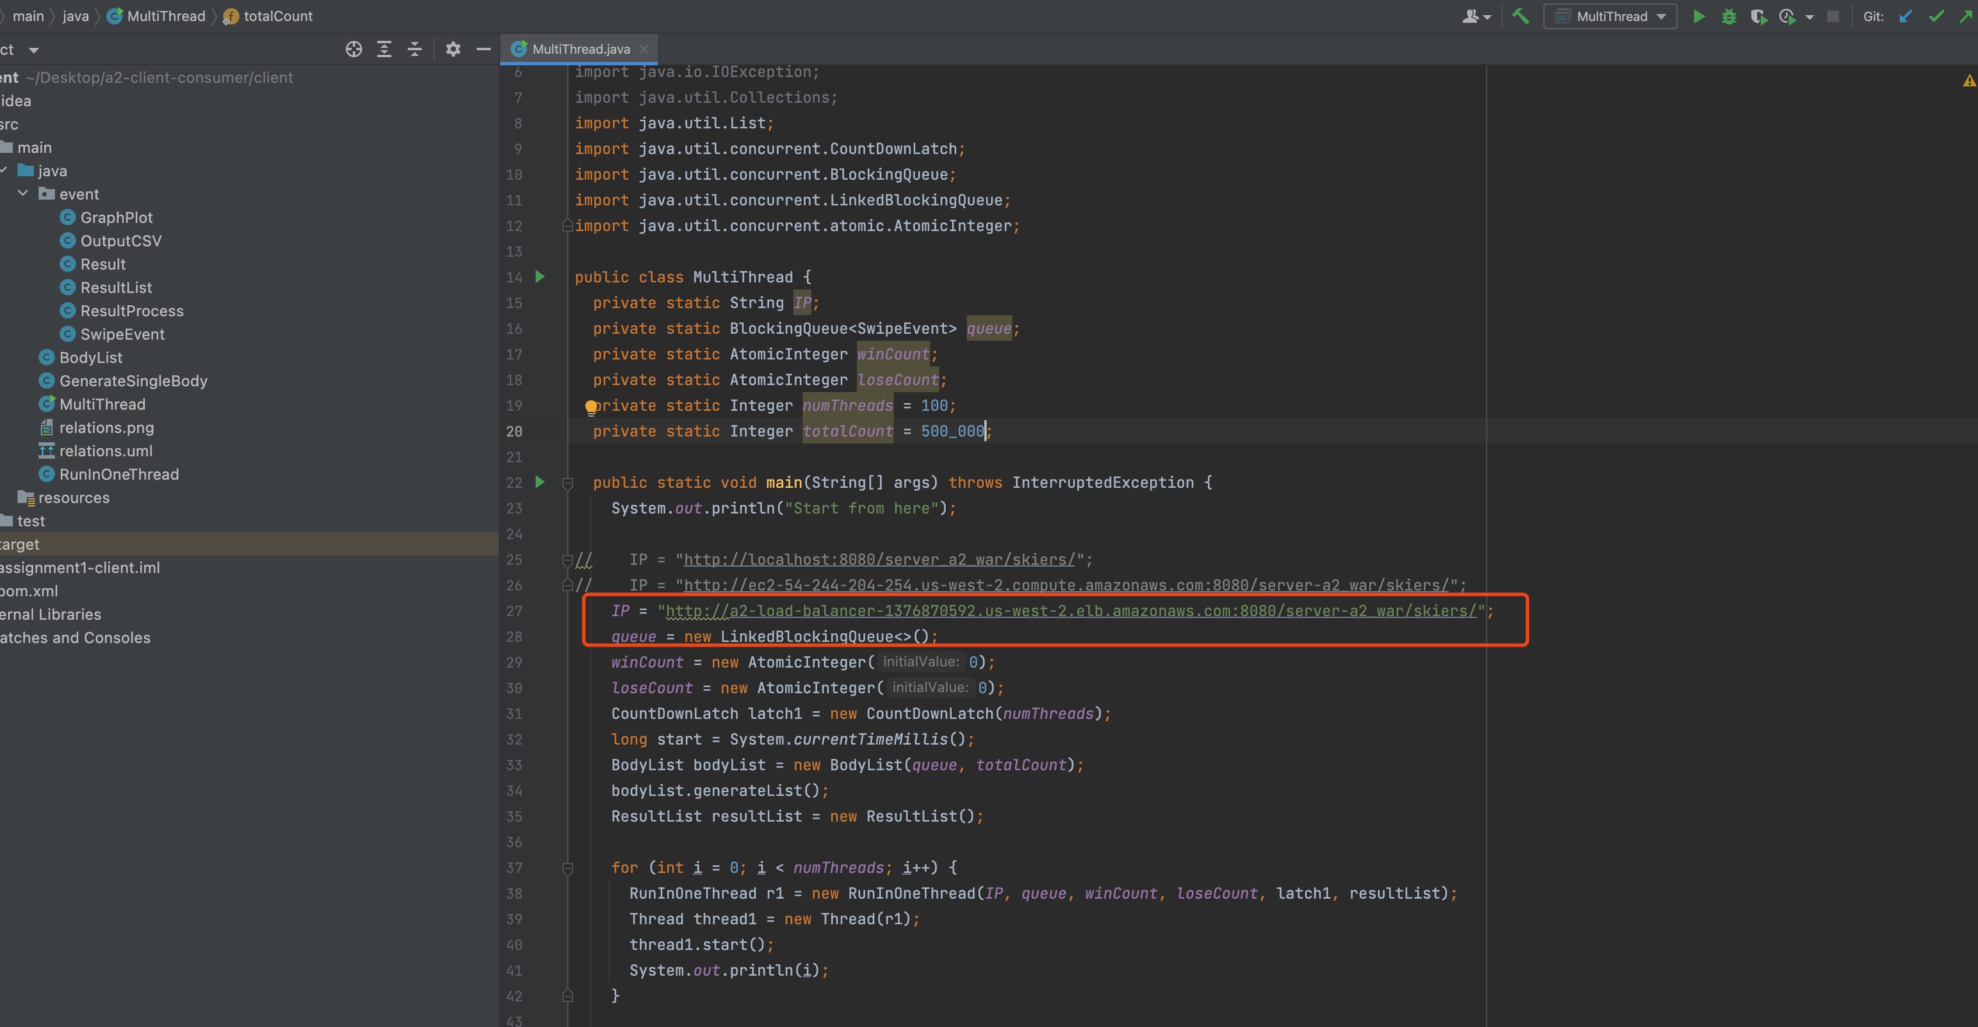

Tested on AWS EC2:

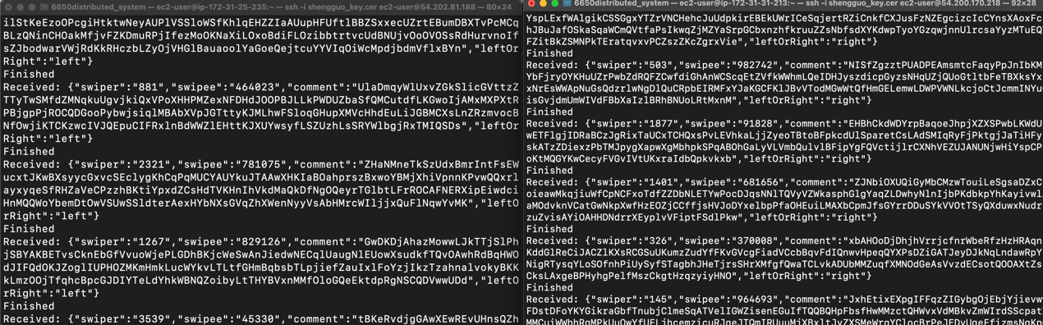

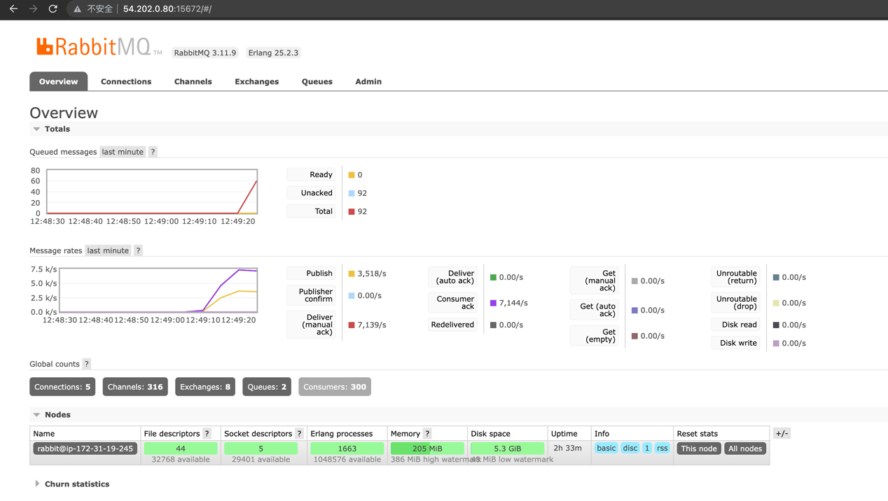

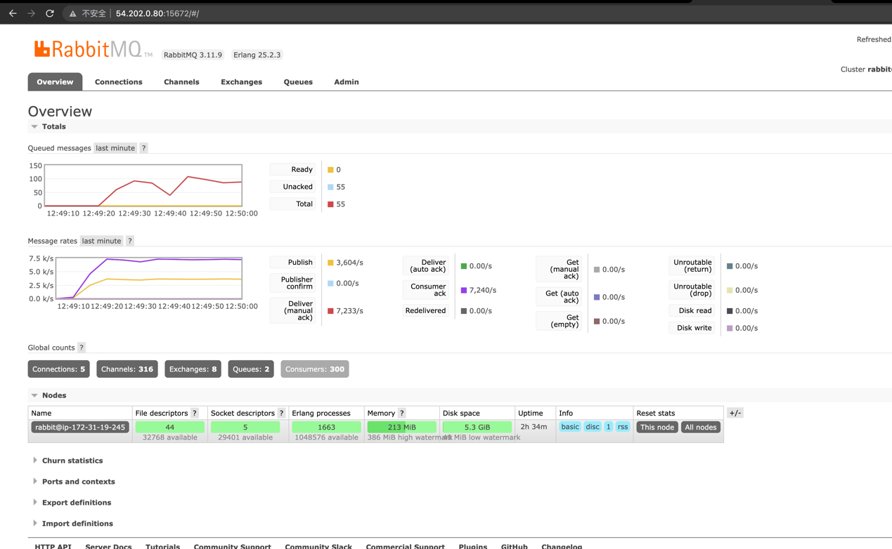

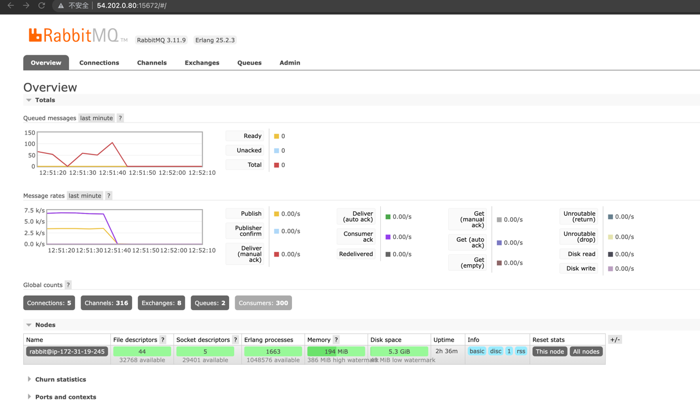

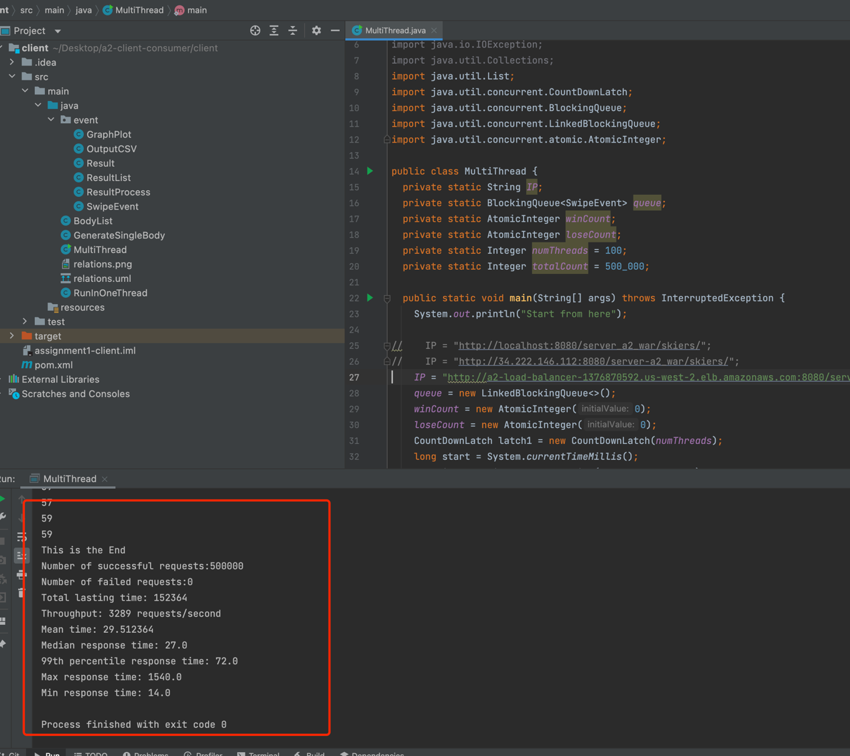

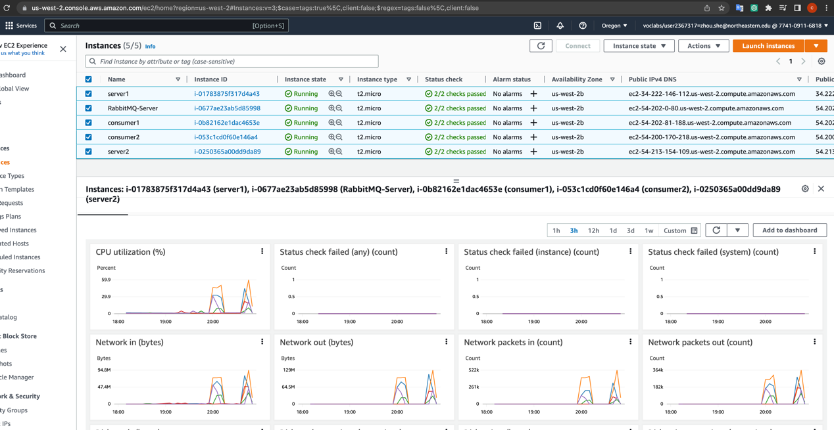

And the result shows that it is faster, the average speed of sending messages is around:

7.5k messages /s, improved by 25%.

And sometimes there would be more messages inside the RabbitMQ, because the server is faster, but the two consumers are slow compared with the relative speed of server, so in some few seconds, the messages would be blocked inside the queue.

But because of the load balancer, the speed of server does grow.

2nd time test:

On AWS EC2:

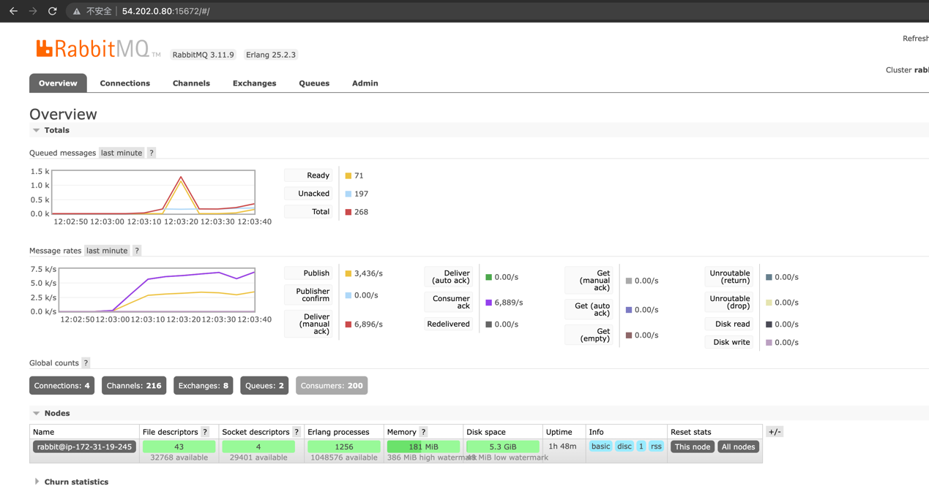

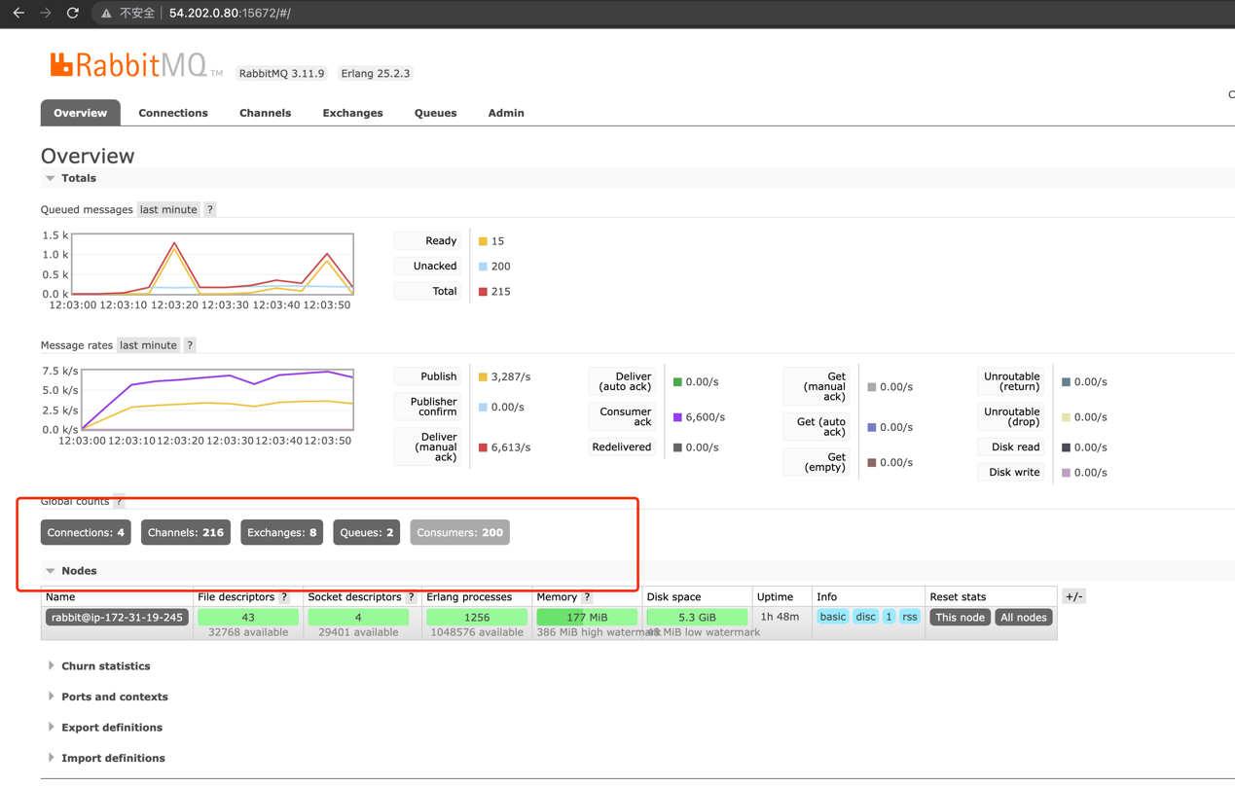

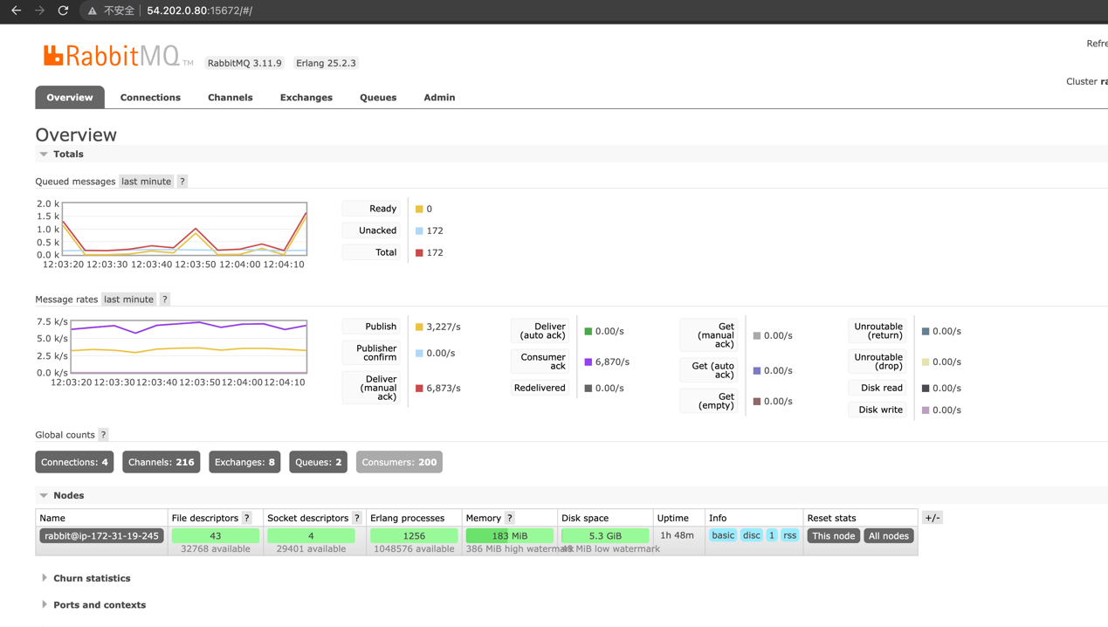

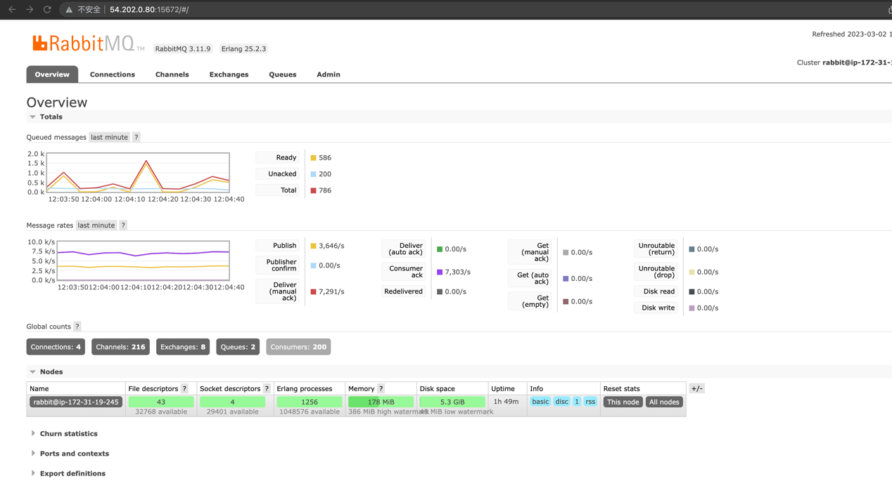

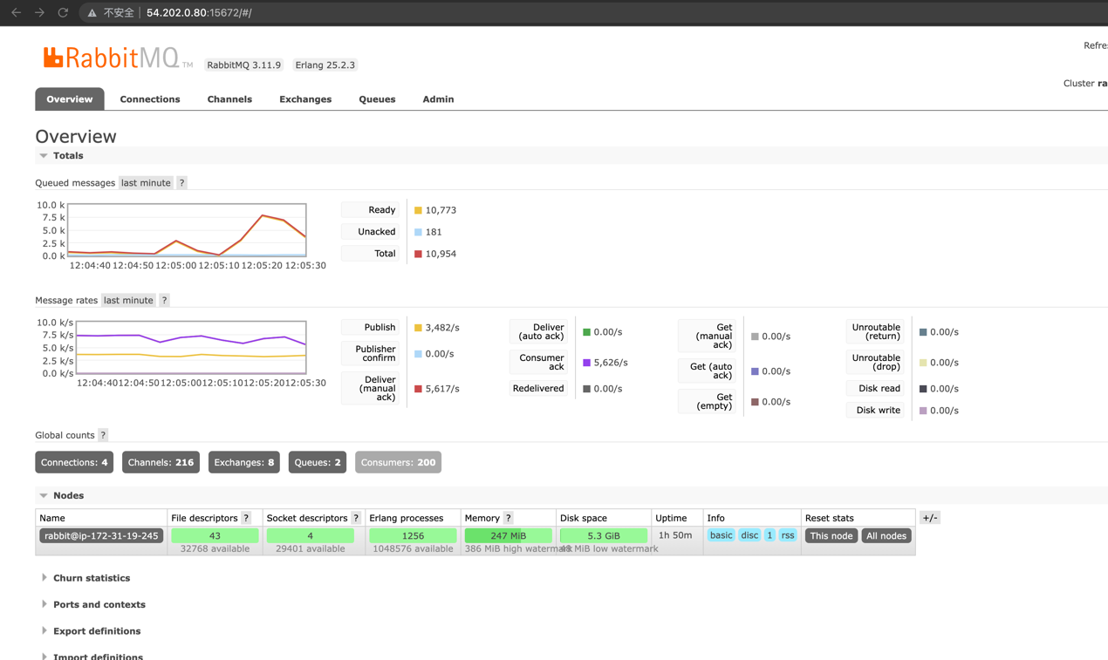

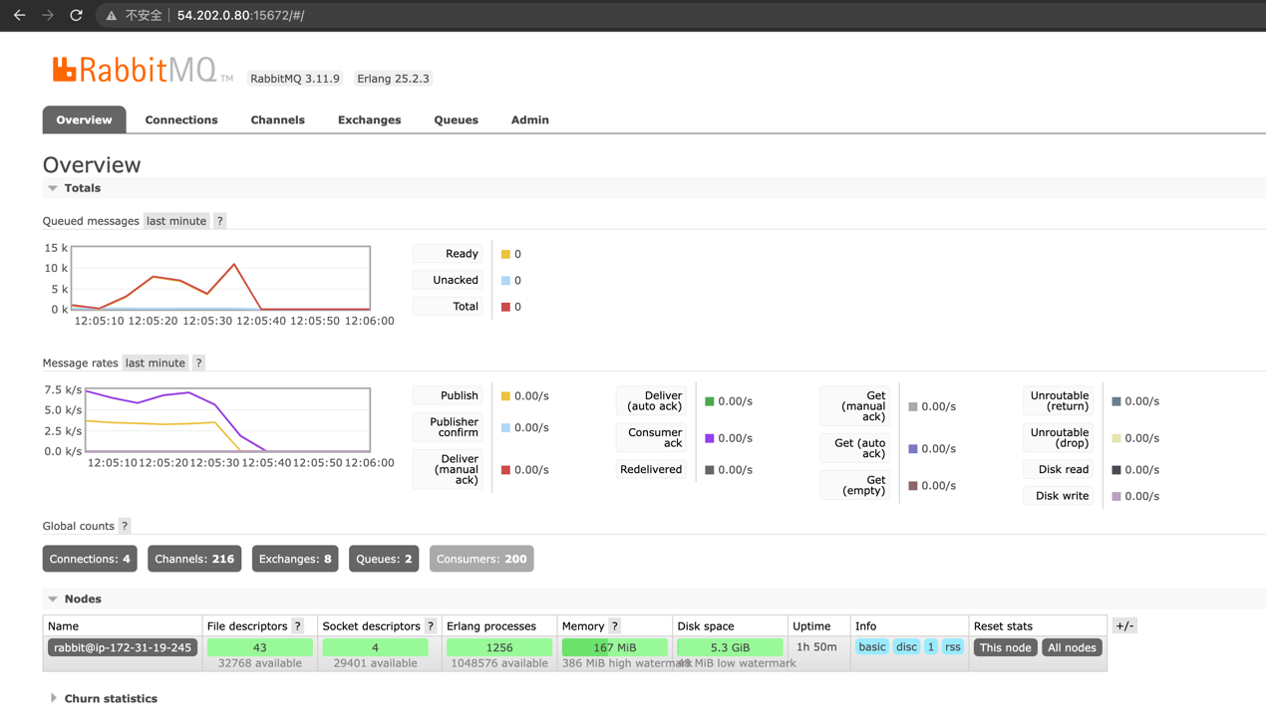

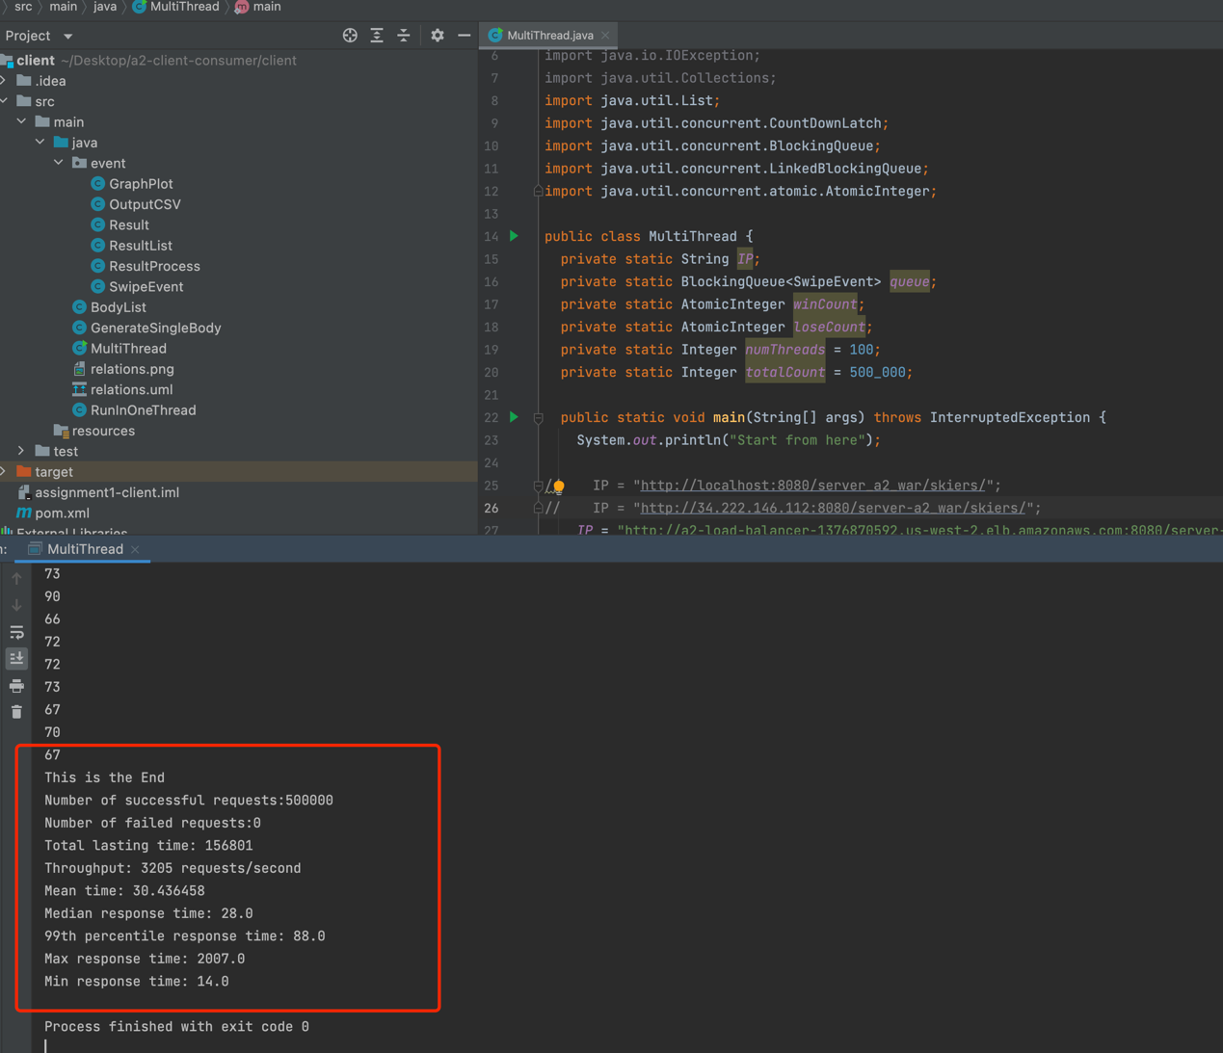

2nd time test on AWS EC2:

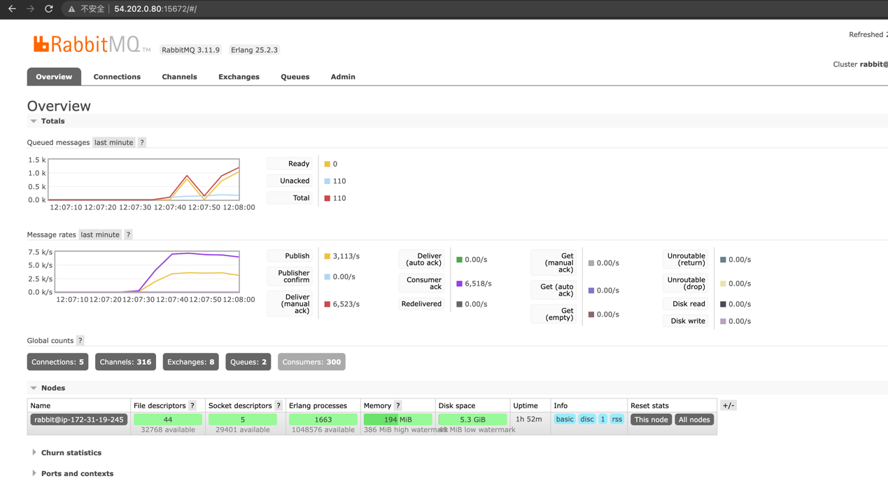

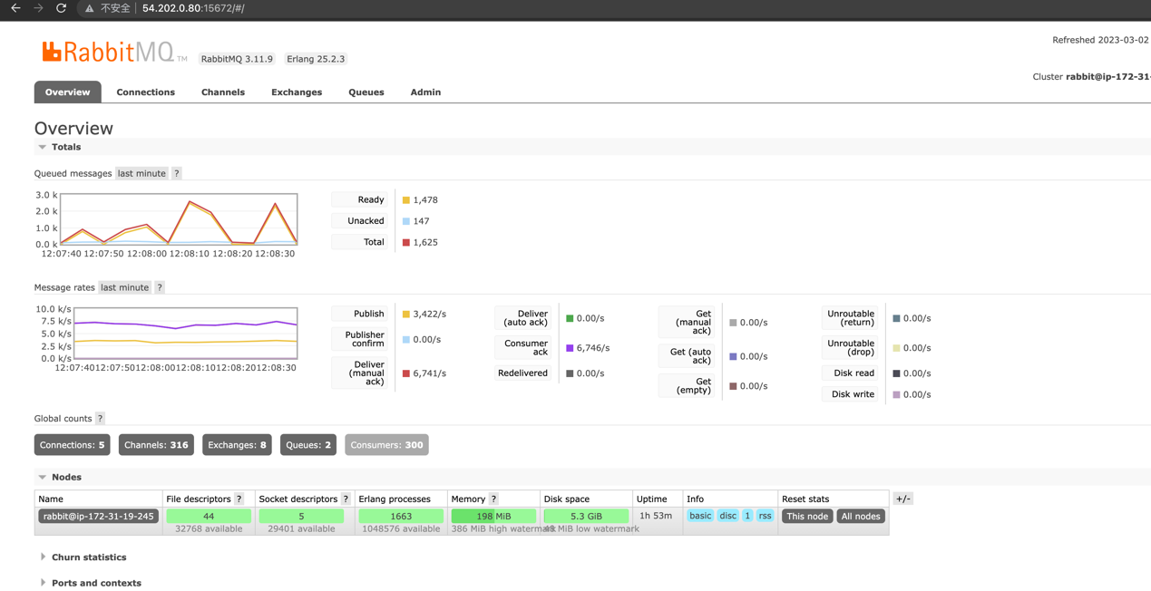

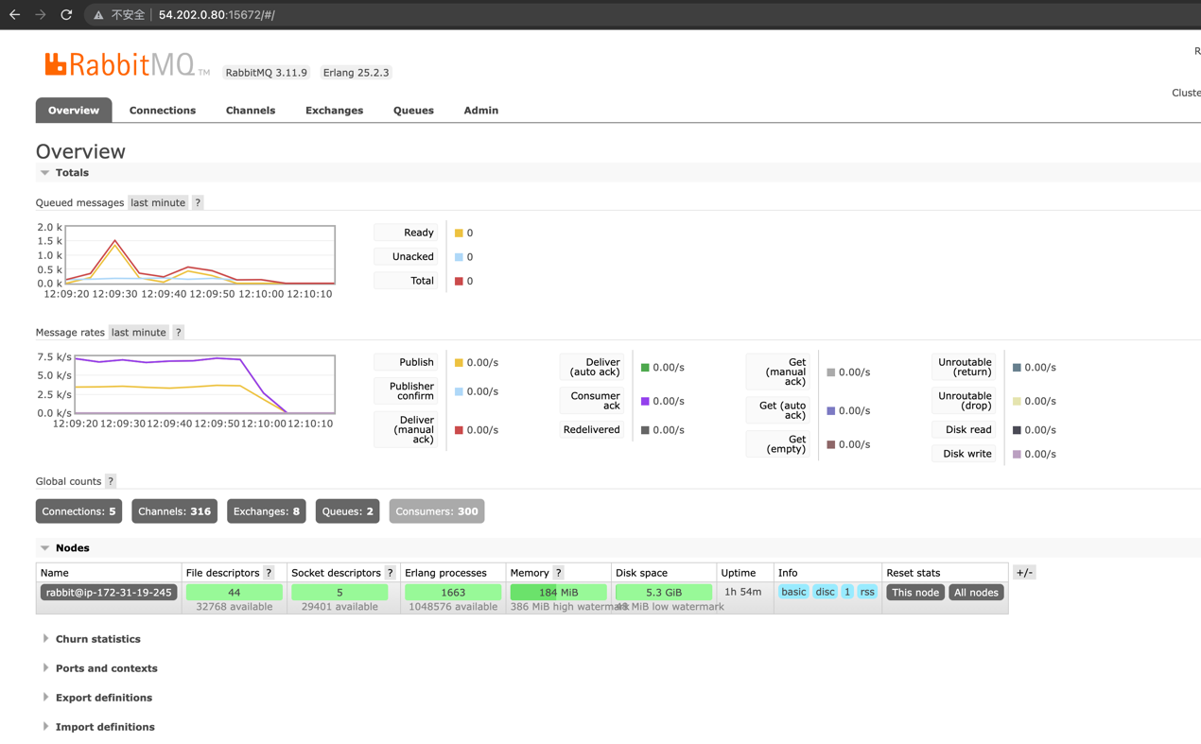

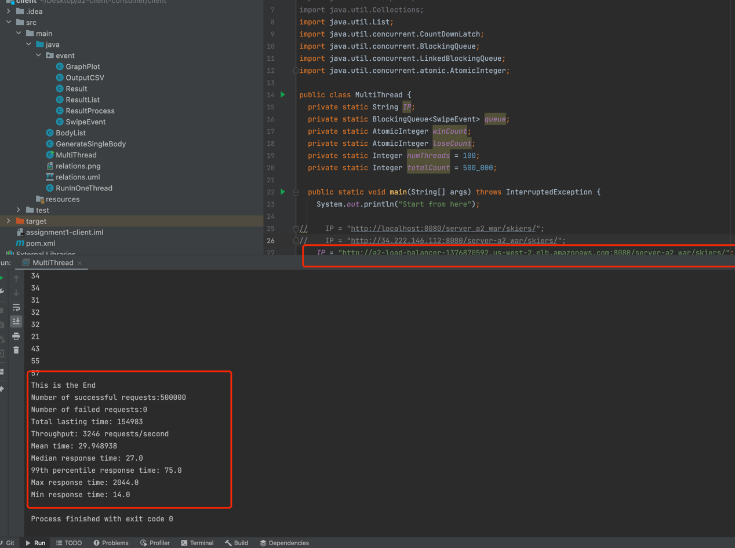

Result messages in consumer:

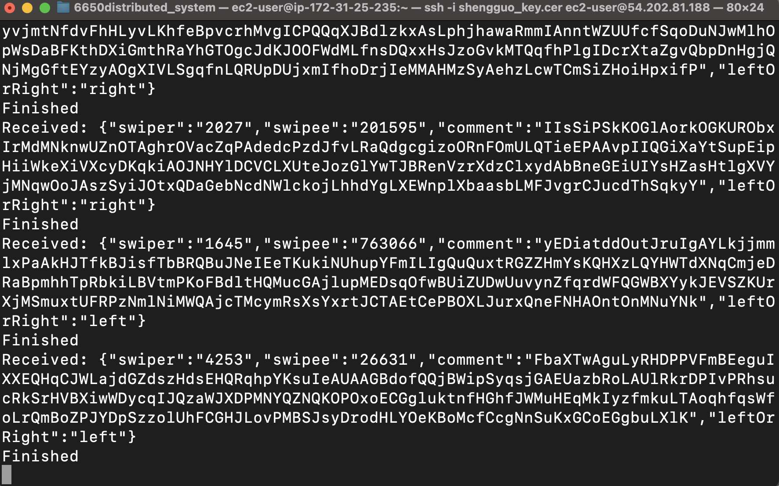

And the result is the same, we could still get a 25% increase of speed when sending out data from server. It shows that the load balancer can improve it.

In my test result, I can ensure the queue length doesn’t continually grow, then shrink, giving a ‘pointy’ queue length profile, ie /\. An increase to a plateau is fine, ie /¯¯¯¯\. The plateau is less than around a 1000, which means my curve is in great shape.